UNITED STATES

SECURITIES AND EXCHANGE COMMISSION
Washington, D.C. 20549

SCHEDULE 14A

Proxy Statement Pursuant to Section 14(a) of the
Securities Exchange Act of 1934

(Amendment No.

)

Filed by the Registrant ☒

Check the appropriate box:

Filed by a party other than the Registrant ☐

- Preliminary Proxy Statement

- Confidential, for Use of the Commission Only (as permitted by Rule 14a-6(e)(2))

- Definitive Proxy Statement

- Definitive Additional Materials

- Soliciting Material Pursuant to §240.14a-12

LENNOX INTERNATIONAL INC.

(Name of Registrant as Specified In Its Charter)

(Name of Person(s) Filing Proxy Statement, if Other Than The Registrant)

Payment of Filing Fee (Check the appropriate box):

- No fee required.

- Fee paid previously with preliminary materials.

- Fee computed on table in exhibit required by Item 25(b) per Exchange Act Rules 14a-6(i)(1) and 0-11.

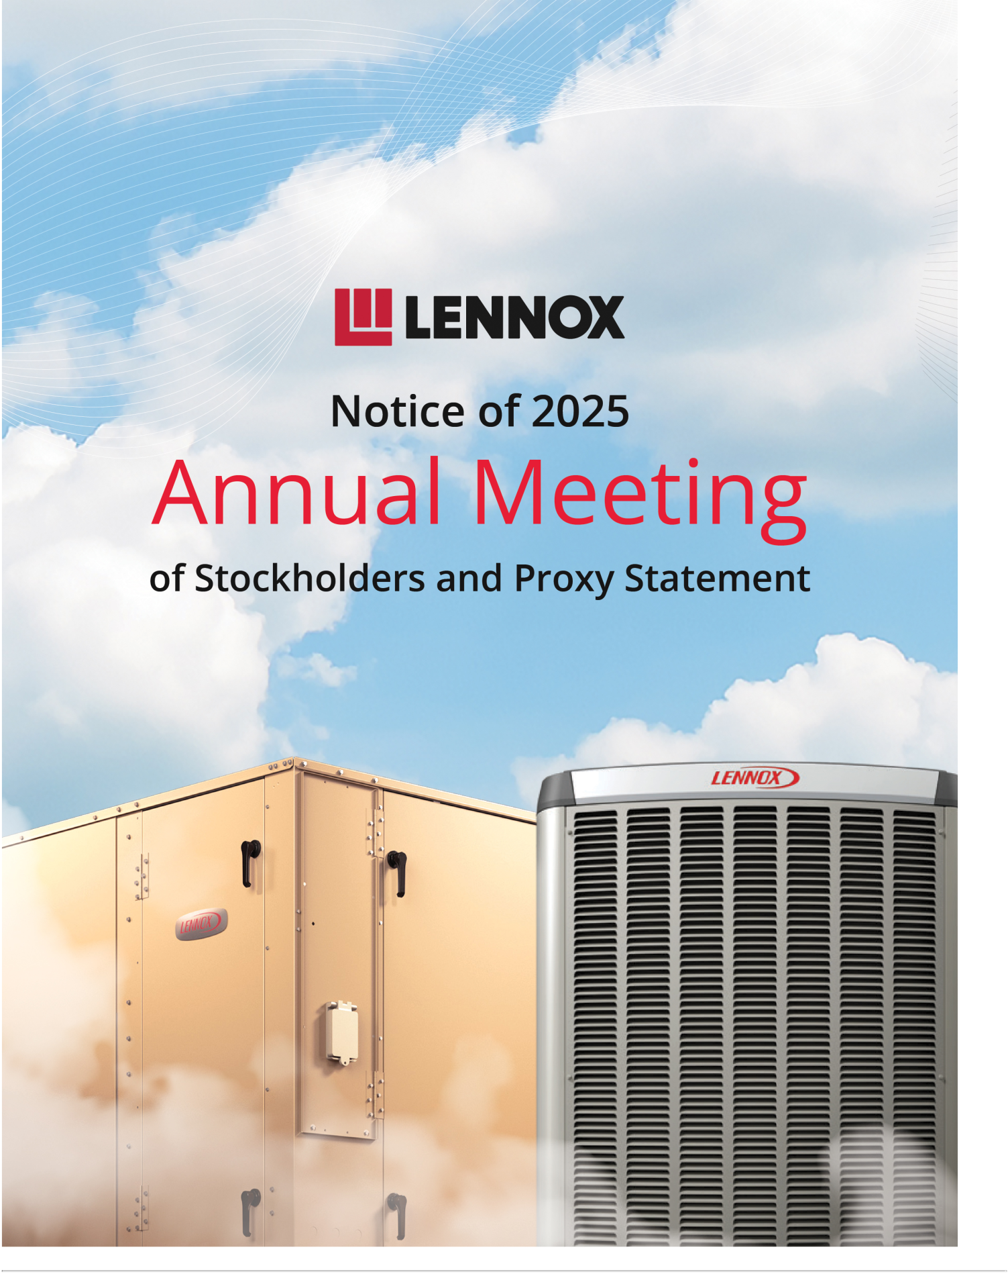



NOTICE OF 2025 ANNUAL MEETING OF

STOCKHOLDERS

Meeting Information

DATE AND TIME Thursday, May 22, 2025 | 10:30 a.m., Central Daylight Time

LOCATION Virtual Meeting. You must register in advance at www.proxydocs.com/LII to attend. After registering, you will receive further instructions by email, including a unique link to access the 2025 Annual Meeting.

Agenda | Board Recommendation
Proposal 1 To elect two Class III directors for a three-year term expiring at the | ☑ FOR each director nominee
2028 Annual Meeting of Stockholders | ☑ FOR each director nominee
Proposal 2 To conduct an advisory vote to approve the compensation of our | ☑ FOR
named executive officers as disclosed in this Proxy Statement | ☑ FOR
Proposal 3 To ratify the appointment of Ernst & Young LLP as our independent | ☑ FOR
registered public accounting firm for the 2025 fiscal year | ☑ FOR
Transact any other business that may properly come before the 2025 Annual
Meeting in accordance with the terms of our Bylaws
Voting Methods Available to You

INTERNET Visit the website on your Proxy Card

BY MAIL Mark, sign, date, and return your Proxy Card in the postage-paid envelope

Your vote is important. Please submit your

proxy or voting instructions as soon as possible

TELEPHONE Call the number on your Proxy DURING THE MEETING You must register in

Card advance at www.proxydocs.com/LII to virtually

attend and vote during the 2025 Annual

Meeting

Important Notice Regarding the Availability of Proxy Materials for the for the

Stockholder Meeting to be Held on May 22, 2025:
The Proxy Statement, Proxy Card, and Annual Report on Form 10-K for the fiscal year ended December 31, 2024, accompany this Notice and are available at www.lennox.com and www.proxydocs.com/LII.

Who May Vote Our stockholders of record at the close of business on March 28, 2025, are entitled to notice of, and to vote at, the 2025 Annual Meeting

By Order of the Board of Directors,
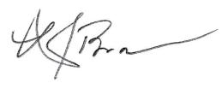

Monica M. Brown

Corporate Secretary

TABLE OF CONTENTS

 | Page
GENERAL INFORMATION REGARDING THE 2025 ANNUAL MEETING OF STOCKHOLDERS | 1
EXECUTIVE SUMMARY | 2
PROPOSALS REQUIRING YOUR VOTE | 8
PROPOSAL 1 ELECTION OF DIRECTORS | 8
PROPOSAL 2 ADVISORY VOTE TO APPROVE THE COMPENSATION OF OUR NAMED EXECUTIVE OFFICERS | 19
PROPOSAL 3 RATIFICATION OF THE APPOINTMENT OF ERNST & YOUNG LLP AS OUR INDEPENDENT | 21
REGISTERED PUBLIC ACCOUNTING FIRM FOR THE 2025 FISCAL YEAR | 21
AUDIT COMMITTEE REPORT | 23
CORPORATE GOVERNANCE | 24
DIRECTOR COMPENSATION | 30
EXECUTIVE OFFICERS | 32
EXECUTIVE COMPENSATION | 33
COMPENSATION DISCUSSION AND ANALYSIS | 33
COMPENSATION COMMITTEE REPORT | 47
2024 SUMMARY COMPENSATION TABLE | 48
2024 GRANTS OF PLAN-BASED AWARDS | 50
OUTSTANDING EQUITY AWARDS AT 2024 FISCAL YEAR-END | 52
2024 OPTION/SAR EXERCISES AND STOCK VESTED | 54
RETIREMENT PLANS | 54
2024 PENSION BENEFITS | 56
2024 NONQUALIFIED DEFERRED COMPENSATION | 57
POTENTIAL PAYMENTS UPON TERMINATION OR CHANGE IN CONTROL | 58
CEO PAY RATIO | 64
PAY VERSUS PERFORMANCE DISCLOSURE | 65
EQUITY COMPENSATION PLAN INFORMATION | 68
CERTAIN RELATIONSHIPS AND RELATED PARTY TRANSACTIONS | 69
DELINQUENT SECTION 16(A) REPORTS | 69
BENEFICIAL OWNERSHIP OF COMMON STOCK | 70
OTHER INFORMATION | 72
ATTENDING AND VOTING AT THE ANNUAL MEETING OF STOCKHOLDERS | 72
PROXY MATERIALS AND SOLICITATION | 74
STOCKHOLDER PROPOSALS FOR THE 2026 ANNUAL MEETING OF STOCKHOLDERS | 75
CAUTIONARY STATEMENT REGARDING FORWARD-LOOKING STATEMENTS | 75
APPENDIX A—GAAP RECONCILIATION | A-1

-i-

GENERAL INFORMATION

REGARDING THE 2025 ANNUAL

MEETING OF STOCKHOLDERS

Virtual Annual Meeting Date and Time

The 2025 Annual Meeting of Stockholders (the “Annual Meeting”) of Lennox International Inc. (NYSE: LII) (the “Company,” “Lennox,” “LII,” “us,” “we,” or “our”) will be held on Thursday, May 22, 2025, at 10:30 a.m., Central Daylight Time (“CDT”), in a virtual-only meeting format, using live webcast, which provides stockholders the ability to participate in the annual meeting, vote their shares, and ask questions via the voting site. You will not be able to attend the Annual Meeting in person.


We began mailing or making available this Proxy Statement and the accompanying Notice of 2025 Annual Meeting of Stockholders, Proxy Card, and Annual Report on Form 10-K to our stockholders on or about April 9, 2025, for the purpose of soliciting proxies on behalf of our Board of Directors (the “Board”).

How To Register For The Virtual Annual Meeting

 |  |  | A link will be |  |  | Enter the control
 | Ü |  | A link will be | Ü |  | number on your
Register at |  |  | emailed to you |  |  | Proxy Card, voting
www.proxydocs.com/LII |  |  | to access the |  |  | instruction form or
 |  |  | Annual Meeting |  |  | Notice of Internet
 |  |  |  |  |  | Availability

Matters to be Voted On

At the Annual Meeting, you will be asked to vote on three proposals. Our Board recommends you vote “for” each of the director nominees in Proposal 1 and “for” Proposals 2 and 3. The proposals to be voted on at the Annual Meeting are:


PROPOSAL | PROPOSAL |  | PROPOSAL

1 |  | 2 | To conduct an advisory vote to approve | 3 | To ratify the appointment of Ernst &
 | To elect two Class III directors for a |  | To conduct an advisory vote to approve |  | Young LLP as our independent
 | To elect two Class III directors for a |  | the compensation of our named |  | Young LLP as our independent
 | three-year term expiring at the 2028 |  | the compensation of our named |  | registered public accounting firm for the
 | three-year term expiring at the 2028 |  | executive oﬃcers (“NEOs”) as |  | registered public accounting firm for the
 | Annual Meeting of Stockholders; |  | executive oﬃcers (“NEOs”) as |  | 2025
 | Annual Meeting of Stockholders; |  | disclosed in this Proxy Statement; and |  | 2025
 |  |  | disclosed in this Proxy Statement; and |  | fiscal year.

-1-

EXECUTIVE SUMMARY

About Lennox

Lennox (NYSE: LII) is a leader in energy-efficient climate-control solutions. Dedicated to sustainability and creating comfortable and healthier environments for our residential and commercial customers, we lead the field in innovation with our cooling, heating, indoor air quality, and refrigeration systems.
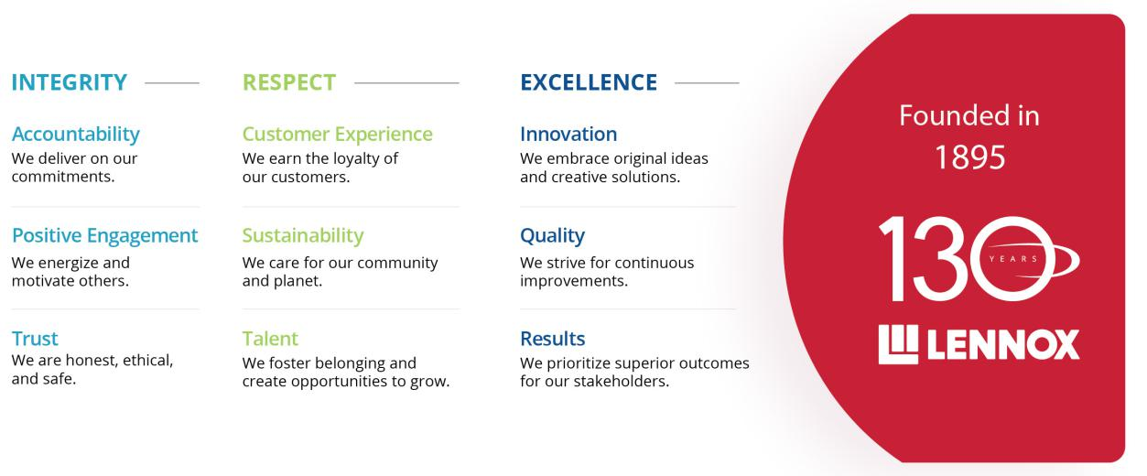

2024 Financial Highlights
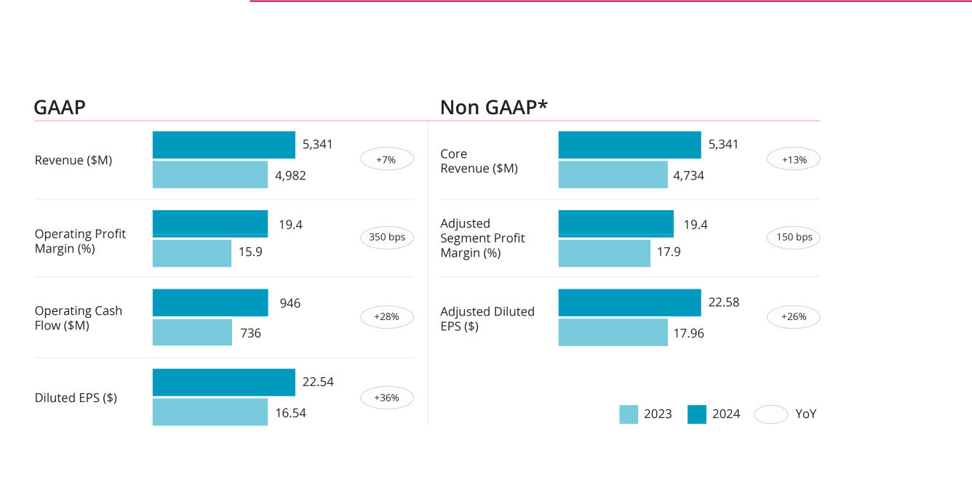

*See appendix for reconciliation to GAAP performance.

-2-

EXECUTIVE SUMMARY

Value Creation

Growth Acceleration with customer experience, higher attachment rate, and SOW gain
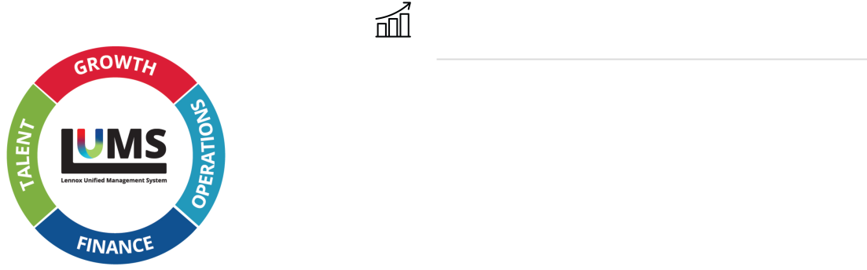

Resilient Margins through efficiency and productivity



Execution Consistency with Lennox Unified



Management System

Advanced Technology Portfolio to win heat



pumps, while exploring M&A

Talent & Culture, driven by Core Values/Guiding


Behaviors & Pay-for-performance philosophy

The Lennox Value Creation Framework leverages the GREAT focused strategy to drive stakeholder results paired with our Lennox Unified Management System to help deliver consistent execution and alignment with strategic goals.

Key Markets

Home Comfort Solutions
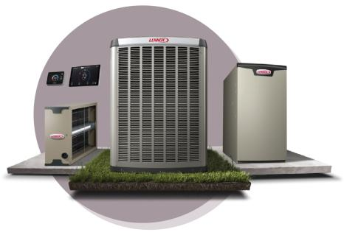

Heating and cooling systems provide top-tier comfort and efficiency for homeowners in the U.S. and Canada. Products include air conditioners, furnaces, heat pumps, thermostats, and air quality solutions.

Building Climate Solutions

HVAC and refrigeration solutions create comfortable environments in offices, schools, restaurants, and retail spaces. With rooftop units, chillers, commercial controls, and refrigeration systems, we help businesses maintain optimal climate conditions efficiently.


-3-

EXECUTIVE SUMMARY

Differentiations
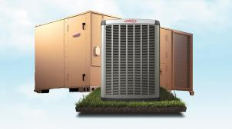


Direct network |  | Deep customer
Direct network |  | relationships



Best-in-class |  | Digital leadership
products |  | Digital leadership

Recognition


More Information @ www.lennox.com

SASB Reporting aligned with | TCFD Reporting aligned with Task | EEO-1 Report demographic
Sustainability Accounting | Force on Climate-related Financial | EEO-1 Report demographic
Sustainability Accounting | Force on Climate-related Financial | breakdown of workforce
Standards Board | Disclosures | breakdown of workforce

The information on our website is not, and will not be deemed to be, a part of this Proxy Statement or incorporated into any of our other filings with the SEC.

-4-

EXECUTIVE SUMMARY

Continuing Directors

 |  |  |  |  |  |  | Committee |  |  | Other
 |  |  |  |  |  |  | Memberships |  |  | Public
 |  |  |  |  |  |  |  |  |  | Company
Name | Age | Start Date | Background | Indep. | AC |  | BGC | CHRC | EC | Boards
 |  |  | Class III
Alok Maskara | 54 | 2022 | Chief Executive Officer, | CEO |  |  |  |  | ü | Franklin Electric
Alok Maskara | 54 | 2022 | Lennox International Inc. | CEO |  |  |  |  | ü | Co., Inc.
Sivasankaran ("Soma") | 59 | 2024 | President and CEO, | ü | ü |  | ü |  |  | ChampionX
Somasundaram | 59 | 2024 | ChampionX | ü | ü |  | ü |  |  | ChampionX
 |  |  | Class I
John W. Norris, III | 67 | 2001 | Chairman, Environmental Funders Network | ü |  |  | ü | ü
 |  |  | Former EVP and Chief | ü |  |  |  |  | ü
Karen H. Quintos | 61 | 2014 | Customer Officer, Dell | ü |  |  | C |  | ü | Cummins Inc.
 |  |  | Technologies Inc.
 |  |  | Former Chief Technology | ü |  |  |  |  | ü
Shane D. Wall | 60 | 2020 | Officer and Global Head, | ü |  |  |  | C | ü
 |  |  | HP Labs of HP Inc.
 |  |  | Class II
Sherry L. Buck | 61 | 2019 | CFO, W.L. Gore & | ü | C, F |  |  |  | ü
Sherry L. Buck | 61 | 2019 | Associates | ü | C, F |  |  |  | ü
 |  |  | Independent Chair of the Board
Todd J. Teske | 60 | 2011 | Former Chair, President | ü | F |  |  |  | C
 |  |  | and CEO, Briggs & Stratton
 |  |  | Corporation
Jon Vander Ark | 49 | 2024 | President and CEO, Republic Services, Inc. | ü | F |  |  | ü |  | Republic Services,
 |  |  |  |  |  |  |  | ü |  | Inc.
AC – Audit Committee; BGC – Board Governance Committee; CHRC – Compensation & Human Resources Committee;
EC – Executive Committee; C – Chair; F – Financial expert
TENURE |  |  | BOARD COMPOSITION |  | INDEPENDENCE
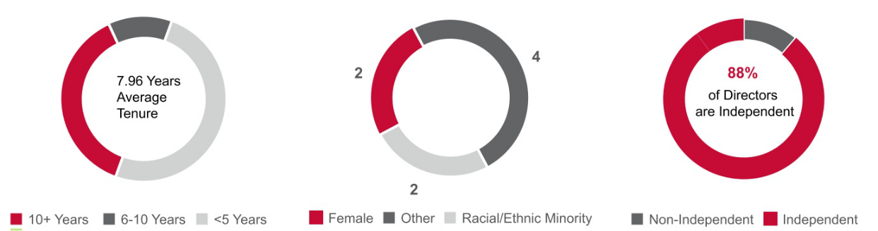

-5-

EXECUTIVE SUMMARY

Board Composition

Our directors bring a well-rounded variety of experience and skills and represent a mix of deep knowledge of the Company and fresh perspectives. The experience and skills that the Board considers in evaluating its membership, and which inform Board succession planning and our director nomination processes, are highlighted in the following table. The table also identifies which continuing directors have particularly strong experience and skills in the areas described below.

Director Skills and Experience*
Financial/Accounting | ü |  |  |  |  | ü |  | ü
Finance & financial accounting expertise, including experience as a financial officer, accounting officer, | ü |  |  |  |  | ü |  | ü
controller, accountant, or auditor
Executive Leadership | ü | ü |  | ü | ü | ü | ü | ü
Experience as a C-Suite executive of a public company | ü | ü
Manufacturing/Distribution | ü | ü |  | ü | ü | ü | ü | ü
Experience managing large scale manufacturing or distribution operations | ü | ü
Environmental Sustainability/Climate-Related Risks |  |  | ü | ü | ü | ü |  | ü
Experience in environmental sustainability/climate-related risks |  |  |  |  |  |  |  | ü
ERM | ü | ü |  | ü | ü | ü | ü | ü
Experience in enterprise risk management, including identifying, assessing & managing significant risks | ü | ü
Human Capital Management | ü | ü |  |  | ü | ü |  | ü
Experience establishing and leading compensation and benefit programs, career development programs & | ü | ü |  |  | ü | ü |  | ü
inclusion & belonging efforts
Marketing/Sales |  | ü |  | ü |  | ü | ü | ü
Experience growing market share and revenue through a variety of go-to-market channels |  | ü |  | ü |  | ü | ü | ü
Cybersecurity |  | ü |  |  |  | ü | ü | ü
Work experience or a certification in cybersecurity or experience in security architecture |  | ü |  |  |  | ü | ü | ü
Innovation/Technology |  | ü |  |  | ü | ü | ü | ü
Experience in engineering, design & technology innovation |  | ü
Strategic Planning/Oversight | ü | ü | ü | ü | ü | ü | ü | ü
Experience in strategic planning, developing business strategies & mergers & acquisitions in large
organizations operating in multiple geographies









- Does not include information about Janet K. Cooper and Gregory T. Swienton, who will be retiring immediately after the Annual Meeting. Further information about each individual director is set forth in the director biographies in this Proxy Statement.

-6-

EXECUTIVE SUMMARY

Governance Highlights

Our management team and the Board are focused on serving the long-term interests of Lennox’s stockholders. The Board’s primary responsibility is the oversight of the Company’s management team, and the Board has a number of measures in place to continually enhance Board composition, efficiency, and effectiveness, demonstrated through the following:

Independent Board Chair |  | Mandatory Board Retirement age: 75
Majority Voting (with carve-out in case of contested elections) |  | Key Committees 100% independent (Audit, Compensation, and Governance
 |  | (nominating) Committees)
No Directors Attended Less than 75% of Meetings |  | Anti-Hedging and Pledging Policies
Board is 88% independent (7 out of 8 continuing directors) |  | No Material Related-Party Transactions
Regularly Scheduled Executive Sessions of non-management directors |  | 3 Independent Board Members added in the last 5 yrs
Women hold Board leadership positions (Governance (nominating) Committee & |  | Succession Planning annually for key executives; robust CEO Succession Plan
Audit Committee chairs)
No Overboarding (directors not permitted to serve on more than four other public |  | Robust Stock Ownership Guidelines (5x retainer for Directors; 6x annual base
company boards) |  | salary for CEO; and 3x annual base salary for executive vice presidents)
Annual Self-Evaluation by the Board and its committees |  | One Class of Voting Stock
Individual evaluation for director nominees |  | No Poison Pill

Board Oversight

The Board and its committees have oversight of important topics, as shown below, and are highly engaged in working through issues and discussing plans in both formal and informal meetings.

Oversight

Full Board of Directors

• | Culture & Values |  | • Front-end Digital Customer Experience |  |  | • CEO Succession Planning & Compensation
• | Financial Performance |  | • Advanced Technology & Artificial Intelligence |  |  | • Employee Engagement Survey
• | Stockholder Value Creation |  | • Sustainable Product Development & Innovation (including |  |  | • Energy, Waste, Water & Refrigerant Management
• | M&A/Strategy |  |  | Product Safety) |  | • Community Involvement & Charitable Giving
• |  |  | • Technology Infrastructure & Cybersecurity |  |  | • Community Involvement & Charitable Giving
• | Key Strategic Initiatives |  |  |  |  | • Government Relations & Regulations
• |  |  | • Supply Chain & Logistics |  |  | • Government Relations & Regulations
• | Stockholder Rights |  |  |  |  | • ERM Oversight
 |  |  |  | ↓
Board-level Committees
Audit Committee |  |  | Board Governance Committee |  |  | Comp & HR Committee
• Climate Change Regulation & SEC Disclosure |  |  | • | Stockholder Rights |  | • CEO Succession Planning & Compensation
• Business Ethics, Compliance & Anti-Corruption |  |  | • | Board Composition |  | • Executive Compensation
• Accounting & Tax Transparency |  |  |  |  |  | • Employee Health & Safety
• ERM Processes & Policies |  |  |  |  |  | • Employee Engagement, Experience, Training & Development
 |  |  |  |  |  | (including Leadership Development)

• Pay Equity, Benefits & Pension

-7-

Proposals Requiring Your Vote

Proposal 1

Election of Directors

Our Bylaws provide that our Board may be composed of no less than three and no more than 15 members. The size of our Board is currently fixed at ten members, divided into three classes, with each class serving a three-year term. The size of the Board will be reduced by two members, effective upon Janet K. Cooper's and Gregory T. Swienton's retirements immediately following the Annual Meeting.

Upon the recommendation of the Board Governance Committee, the Board has nominated two Class III directors for re-election of a three-year term expiring at the 2028 Annual Meeting of Stockholders. The Board has nominated the directors using the process and criteria described in the “Corporate Governance—Board of Directors— Board Refreshment and Nomination Process” section of this Proxy Statement.

For each director and director nominee, we have included a biographical description below that includes the specific experience, attributes, and skills that led to the Board’s conclusion that such person should serve as a director of the Company at this time in light of our business and structure.

If you do not wish to vote your shares for any particular nominee, you may withhold your vote. If any director nominee becomes unavailable to serve, the persons named in the accompanying Proxy Card may vote for any alternate designated by the incumbent Board, or the number of directors constituting the Board may be reduced.

-8-

The Board has nominated the following directors for re-election as Class III directors for a three-year term expiring at the 2028

Annual Meeting of Stockholders:
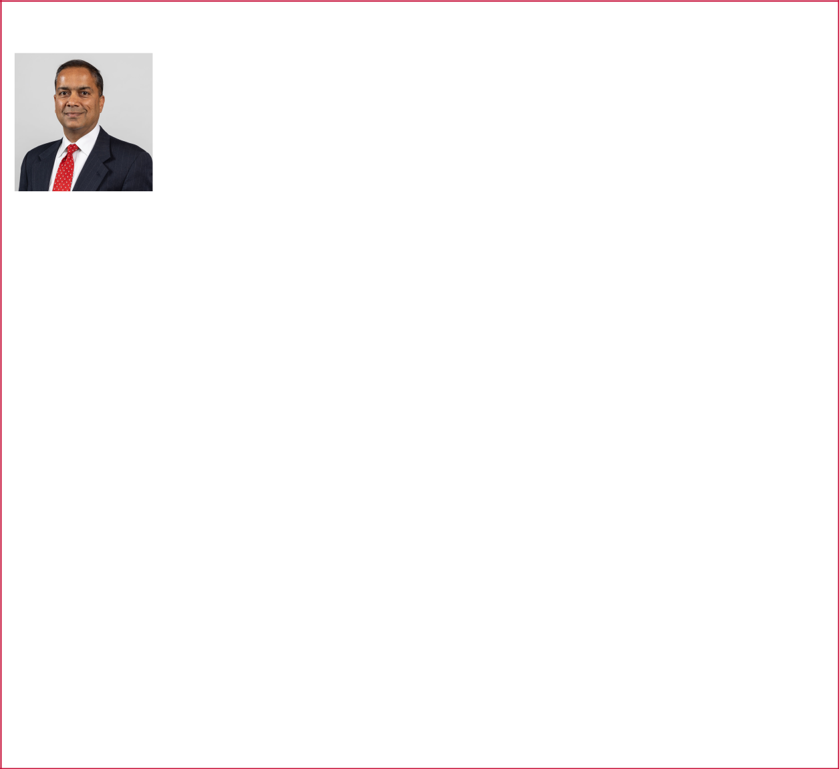

Alok Maskara

Class III

Director

Age 54

Director since 2022

Committees

Executive

Skills

Executive Leadership Manufacturing/Distribution ERM

Human Capital Management Marketing/Sales Cybersecurity
Innovation/Technology Strategic Planning/Oversight

Experience

- President and Chief Executive Officer (2022 – present)

- Chief Executive Officer and Director, Luxfer Holdings PLC, a publicly traded international industrial company focused on advanced materials (2017 – 2022). He spearheaded the company’s transformation, led value-enhancing acquisitions and partnerships, and drove growth in profitability
- President, Global Business Units, Pentair PLC, a leading provider of water treatment and sustainable applications, including its former Technical Solutions segment with over $2 billion in revenue (2008 – 2017)

- General Manager, Residential & Commercial Water, General Electric, a high-tech industrial company (2004 – 2008), which included significant experience in Lean Manufacturing
- Engagement Manager, McKinsey and Company, a global management consulting firm (2000 – 2004), advising businesses on industrial turnarounds and driving growth through customer insights and segmentation

Other Public Company Boards

- Franklin Electric Co., Inc., a publicly traded global leader in the production and marketing of systems and components for the movement of water and automotive fuels (2021 – present)

Education

- B.Tech in Chemical Engineering, Indian Institute of Technology

- M.S. in Chemical Engineering, University of New Mexico
- M.B.A., Northwestern University Kellogg School of Management

Key Qualifications

Mr. Maskara has extensive experience in the areas of management, finance, accounting, manufacturing, and corporate governance. As CEO, he has a deep understanding of Lennox’s core businesses and end market dynamics. He successfully guided the company through the “Recover and Invest” phase of our Self-Help Transformation Plan and set the foundation for growth and expansion in the next phases. With his guidance, the team executed the turnaround of the commercial segment, increased margins through strategic pricing initiatives, and refreshed the company’s culture with a focus on accountability.

-9-

Sivasankaran (“Soma”) Somasundaram

Class III

Independent Director

Age 59

Director since 2024

Committees

Audit

Board Governance

Skills

Executive Leadership Manufacturing/Distribution Sustainability
ERM
Human Capital Management
Innovation/Technology

Strategic Planning/Oversight

Experience
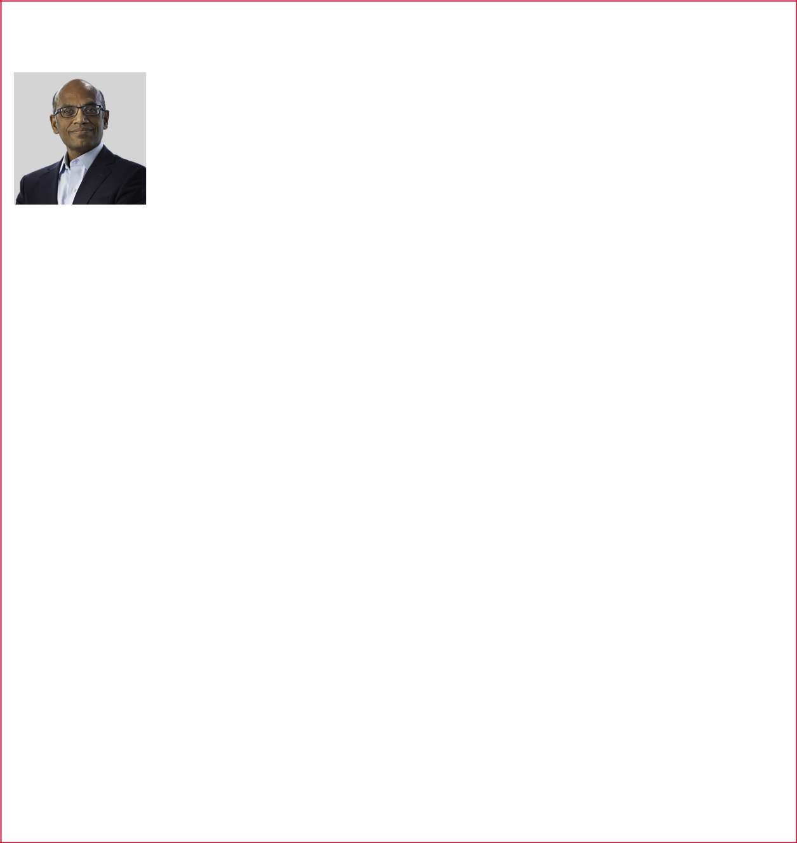

- Director, President & Chief Executive Officer, ChampionX (previously Apegy Corporation), a publicly traded global leader in chemistry solutions, artificial lift systems, and highly engineered equipment and technologies, and a spin-off of Dover Corporation (2018 – present)
- President and Chief Executive Officer, Energy Segment (2013 – 2018); Executive Vice President, Energy Segment (2012 – 2013); Executive Vice President, Dover Fluid Management (2010 – 2011); President, Fluid Solutions Platform (2008 – 2010); and other executive leadership roles (2004 - 2008), Dover Corporation, an American conglomerate manufacturer of industrial products

- Various global leadership roles at GL&V Inc., a global mining, industrial, pulp and paper technology solutions supplier (2002 – 2004)

- Various global leadership roles at Baker Hughes Inc., an energy products & technology company (1996 – 2002)

Other Professional Experience and Community Involvement

- 2024 ALLY Energy GRIT Lifetime Achievement Award recipient

- Member, National Petroleum Council, a federally chartered advisory committee (2023 – 2024)

- Director, Magellan Midstream Partners, L.P. a publicly traded energy pipeline operator (2022 – 2023)

- Named a “2022 Most Admired CEO” by the Houston Business Journal

- 2022 recipient, Energy Workforce & Technology Council DEI Champion Award

Education

- B.S., Mechanical Engineering, Anna University

- M.S., Industrial Engineering, University of Oklahoma

Key Qualifications

Mr. Somasundaram brings a depth of business, executive leadership, transformative growth strategies, operational, talent development, mergers & acquisitions, and strategic development experience to the Board, including his service as President and Chief Executive Officer of Apegy Corporation starting in 2018 and through its transformational merger in 2020 when the company changed its name to ChampionX Corporation and four years as President and Chief Executive Officer of Dover Energy, a segment of Dover Corporation, a public company. With his strong executive leadership and his technical experience and degrees in both Industrial and Mechanical Engineering, he is uniquely positioned to assist the Board in assessing and managing the types of risks and opportunities faced by the Company. Mr.

Somasundaram’s international experience also adds a valuable global perspective to the Board, having lived and worked in India, Germany, Singapore, and Australia.

THE BOARD RECOMMENDS A VOTE “FOR”

THE ELECTION OF EACH OF THE ABOVE NOMINEES.

-10-

The following Class I directors’ terms will continue until the 2026 Annual Meeting of Stockholders:
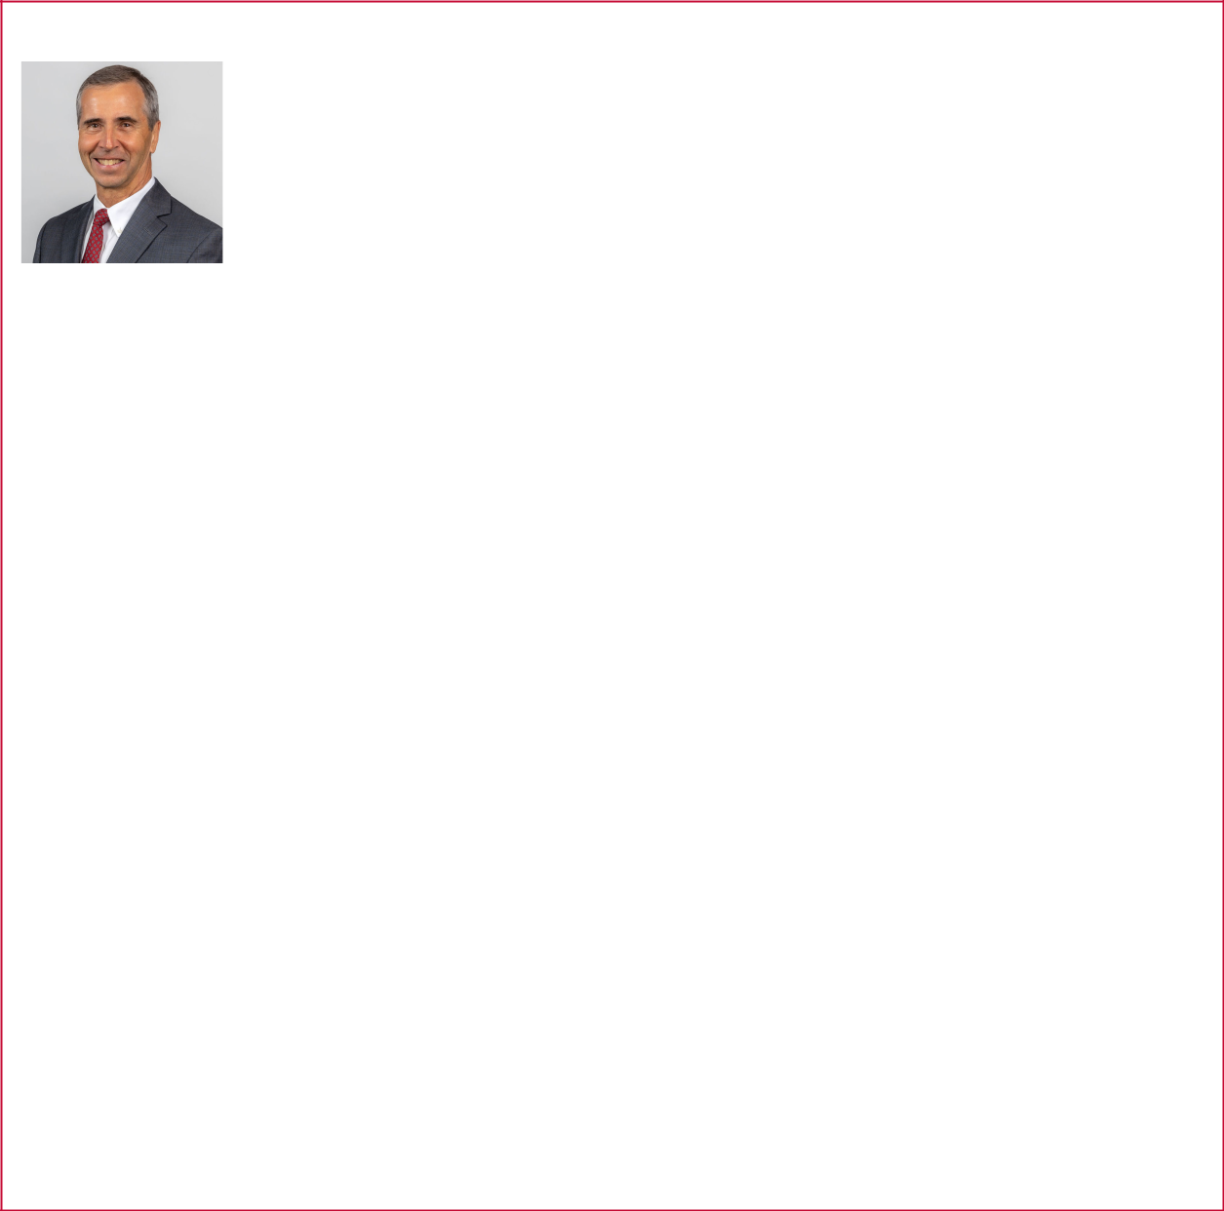

John W. Norris, III

Class I

Independent Director

Age 67

Director since 2001

Committees

Board Governance Compensation and Human Resources

Skills

Sustainability

Strategic Planning/Oversight

Experience

- Founding Chairman of two philanthropic collaboratives, the Environmental Funders Network and Climate Change Funders Forum, both focused on strategically aligning resources to address climate adaptation and mitigation strategies in Maine (2005 – present)

- Co-founder of Maine Network Partners, an organization supporting grassroots leaders and non-profit organizations in developing collaborative solutions to achieve greater impact (2007 – 2021)

- Program Officer - Rural Tourism Development, Northern Forest Center (2006 – 2007)

- Associate Director of Philanthropy, Maine Chapter of The Nature Conservancy (2001 – 2005)

- Co-Founder and President of Borealis, Inc., an outdoor products manufacturer (1988 – 2000)

- Peace Corps in Jamaica, small business development (1985 – 1987)
- Graduate School Intern, Lennox Industries Inc. (a subsidiary of the Company) (1983)

- Senior Credit Analyst, Fort Worth National Bank (1980 – 1982)

Other Professional Experience and Community Involvement

- Director (2019 – present) and Chair (2020 – present), Camp Chippewa for Boys
- Trustee (2008 – 2018) and Chair (2016 – 2018), Maine Chapter of the Nature Conservancy

- Director, Northern Forest Canoe Trail (2013 – 2016)
- Director, Maine Philanthropy Center (2005 – 2011)
- Director, Maine Wilderness Guides Organization (2005 – 2011)
- Director, Cape Elizabeth Education Foundation (2006 – 2009)
- Director, Center for Cultural Exchange (2004 – 2005)
- Completed Economist course on Climate Change and Business: Sustainability, Risk and the Push for Net Zero (2022)

Education

- B.B.A. in Finance and Economics, Texas Christian University

- M.B.A. in Organizational Behavior and Strategy, University of Michigan

Key Qualifications

Mr. Norris contributes substantial experience and knowledge on climate risk and environmental issues, benefitting the Company in its sustainability journey. Mr. Norris also provides organizational development insights from founding both non-profit and for-profit companies.

-11-

Karen H. Quintos

Class I

Independent Director

Age 61

Director since 2014

Committees

Board Governance (Chair)

Executive

Skills

Executive Leadership

Manufacturing/Distribution Sustainability ERM
Marketing/Sales
Strategic Planning/Oversight

Experience


- Retired; Executive Vice President and Chief Customer Officer, including responsibility for ESG and Diversity (2016 – 2020); Senior Vice President and Chief Marketing Officer (2010 – 2016); Vice President of Public Sector Marketing and North America Commercial (2008 – 2010); and other executive roles in services, support, and supply chain management (2000 – 2008), Dell Technologies Inc., a technology leader that provides essential infrastructure for organizations to build their digital future, transform IT, and protect their most important information
- Vice President, Operations & Technology, Citigroup North America Inc., a financial services corporation (1997 – 2000)

- Director of Packaging (1996 – 1997) and Director of Global Supply Chain Management (1993 – 1996), Merck & Co., a pharmaceutical company

Other Public Company Boards

- Cummins Inc., a global power technology leader that designs, engineers, manufactures, distributes, and services engines and related technologies

Other Professional Experience and Community Involvement

- Board of Trustees, Pennsylvania State University

- Chair of the Board of Visitors of Pennsylvania State University Smeal’s College of Business, where she was a 2014 recipient of the Smeal College of Business’ highest honor, the Distinguished Alumni Award

- Director, the National Center for Missing and Exploited Children
- Director, TGEN (Translational Genomics Research Institute)

Education

- B.S. in Supply Chain Management, Pennsylvania State University

- M.B.A. in Marketing and International Business, New York University

Key Qualifications

Ms. Quintos’ supervisory experience in the areas of marketing, branding,

communications, sustainability, operations, and supply chain management brings broad knowledge of these issues to the Board.

-12-

Shane D. Wall

Class I

Independent Director

Age 60

Director since 2020

Committees

Compensation and Human

Resources (Chair)
Executive

Skills

Executive Leadership Manufacturing/Distribution ERM

Marketing/Sales Cybersecurity Innovation/Technology
Strategic Planning/Oversight

Experience


- Retired; Special Advisor to Chief Executive Officer (2020 – 2023); Chief Technology Officer and Global Head (2015 – 2020), HP Labs of HP Inc., a global information technology company

- Chief Technology Officer and Senior Vice President of Printing and Personal Systems, Hewlett-Packard Company, a predecessor of HP Inc. (2012 – 2015)
- Several senior technology and general management positions, Intel Corporation, a technology company (1998 – 2012)

- Co-Founder and Chief Technology Officer of PrintPaks, a spin-out of Hewlett-Packard Company (1995 – 1998)

- Various engineering and management roles, Hewlett-Packard Company (1986 – 1995)

Other Professional Experience and Community Involvement

- Partner, Fusion Fund, an early stage venture capital firm focused on industrial, enterprise, and healthcare technologies
- Senior Advisor and Board Member, Arsenal Capital Partners, a specialized private equity firm focused on specialty industrials and healthcare

Education

- B.S. in Computer Engineering, Oregon State University

Key Qualifications

An experienced former Chief Technology Officer, Mr. Wall contributes extensive technology and cybersecurity experience, as well as meaningful experience in executive leadership and diverse business development within large global companies.

-13-

The following Class II directors’ terms will continue until the 2027 Annual Meeting of Stockholders:


Sherry L. Buck

Class II

Independent Director

Age 61

Director since 2019

Committees

Audit – Financial Expert &

Chair
Executive

Skills

Financial Accounting

Executive Leadership

Manufacturing/Distribution
ERM

Human Capital Management

Strategic Planning/Oversight

Experience

- Chief Financial Officer, W.L. Gore & Associates Inc., a multinational advanced materials company providing solutions for medical device, fabric laminates, aerospace, pharmaceuticals, mobile electronics, and other applications across diverse industries (2021 – present)
- Senior Vice President and Chief Financial Officer, Waters Corporation, a specialty measurement company serving the life, materials, and food sciences industries (2017 – 2020)
- Vice President, Chief Financial Officer, Libbey Inc., a global manufacturer and marketer of glass tableware products (2012 – 2016)
- Senior finance and operating leadership roles, Whirlpool Corporation, a leading global appliance manufacturer (1993 – 2012)

- Director, Overseas Accounting and Internal Audit Manager, TransWorld Airlines, a major airline (1988 – 1992)

- Senior Auditor, Price Waterhouse, a public accounting firm (1985 – 1988)

Education

- B.S. in Accounting, University of Missouri

Key Qualifications

Ms. Buck contributes extensive financial and leadership experience gained from her long tenure as a CFO. She adds industry expertise through her positions in large global manufacturing companies.

-14-

Todd J. Teske

Class II

Independent Chair

Age 60

Director since 2011

Committees

Audit – Financial Expert Executive (Chair)

Skills

Financial/Accounting

Executive Leadership Manufacturing/Distribution Sustainability
ERM
Human Capital Management

Marketing/Sales

Cybersecurity
Innovation/Technology

Strategic Planning/Oversight

Experience


- Independent Board Chair (2022 – present)

- Interim CEO (March 23, 2022 – May 9, 2022)
- Lead Independent Director (2015 – 2022)
- Chair, President, and Chief Executive Officer (2010 – 2020); President and Chief Operating Officer (2008 – 2009); Executive Vice President and Chief Operating Officer (2005 – 2008); and other senior-level positions including President of its power products business, head of corporate development and Controller (1999 – 2005), Briggs & Stratton Corporation, a manufacturer of gasoline engines for outdoor power equipment, portable generators, and lawn and garden powered equipment and related accessories

- Briggs & Stratton filed a voluntary petition for bankruptcy under Chapter 11 of the U.S. Bankruptcy Code in July 2020. In September 2020, Briggs & Stratton was acquired and exited bankruptcy

Other Professional Experience and Community Involvement

- Director, Badger Meter, Inc., a publicly traded leading innovator, manufacturer and marketer of flow measurement and control products (2009 – 2020)

- Licensed CPA (inactive)

Education

- B.S. in Accounting, University of Wisconsin Oshkosh

- Masters of Management, Northwestern University Kellogg School of Management

Key Qualifications

Mr. Teske brings extensive executive leadership, corporate governance, and industry experience as a former manufacturing-company CEO to his service as Chair of the Board. As well, as a former corporate controller, Mr. Teske contributes knowledge in the areas of finance and accounting.

-15-

Jon Vander Ark

Class II

Independent Director

Age 49

Director since 2024

Committees

Audit – Financial Expert

Compensation and Human Resources

Skills

Financial/Accounting

Executive Leadership Manufacturing/Distribution
Sustainability
ERM
Human Capital Management

Marketing/Sales Cybersecurity Innovation/Technology
Strategic Planning/Oversight

Experience


- President and Director (2019 – present) and Chief Executive Officer (2021 – present); Executive Vice President, Chief Operating Officer (2018 – 2019); Executive Vice President, Operations (2016 – 2017); and Executive Vice President, Chief Marketing Officer (2013 – 2016), Republic Services, Inc., an environmental services company

- McKinsey & Company, a global management consulting firm (2000 – 2012)

Other Professional Experience and Community Involvement

- Director, Board of Chances for Children, a non-profit supporting children in Haiti

Education

- B.A. in Philosophy and Political Science, Calvin University

- J.D., Harvard Law School

Key Qualifications

Mr. Vander Ark contributes to our Board extensive strategic growth experience, operational skills, and accomplishments implementing sustainability initiatives from his executive leadership at a large publicly traded company. Prior to joining Republic, Mr. Vander Ark’s role in consulting exposed him to a wide range of industries including automotive, logistics, and consumer durables. He developed deep expertise in marketing and sales serving leading global companies.

-16-

The following directors will retire immediately after the 2025 Annual Meeting:


Janet K. Cooper

Class III

Independent Director

Age 71

Director since 1999

Committees

Audit – Financial Expert Board Governance

Skills

Financial/Accounting Executive Leadership Sustainability
ERM
Cybersecurity
Innovation/Technology

Strategic Planning/Oversight

Experience

- Retired; Senior Vice President and Treasurer, Qwest Communications International Inc. (“Qwest”), a telecommunications carrier (2002 – 2008)

- Chief Financial Officer and Senior Vice President, McDATA Corporation, a global leader in open storage networking solutions (2001 – 2002)

- Senior Vice President, Finance, Qwest (2000 – 2001)
- Various senior level finance positions, including Vice President, Finance and Controller, and Vice President and Treasurer, US West Inc., a regional Bell operating company and predecessor of Qwest (1998 – 2000)

- Various capacities, including Vice President, Treasurer and Tax and Vice President, Treasurer, the Quaker Oats Company, an American food conglomerate (1978 – 1998)

Other Professional Experience and Community Involvement

- Director, The Toro Company, a manufacturer of equipment for turf and landscape maintenance, snow and ice management, underground utility construction, rental, and specialty construction (1994 – 2024)

- Trustee, Rose-Hulman Institute of Technology, an engineering and technology college (2015 – present)

- Director, CPI Aerostructures, Inc., a publicly traded aircraft component manufacturer (2019 – 2020)

- Director, Resonant Inc., a publicly traded software, intellectual property, and services platform for filter designs for radio frequency front ends (2014 – 2019)

- National Association of Corporate Directors (NACD) Leadership Fellowship

- Diligent Climate Leadership Certificate program
- Certificate in Cybersecurity Oversight, Carnegie Mellon University Software Engineering Institute.

Education

- B.S. in Math/Computer Science & Economics, University of Illinois Urbana-Champaign

- M.S. in Applied Math, University of Illinois Urbana-Champaign
- M.B.A., University of Chicago Booth School of Business

Key Qualifications

Ms. Cooper contributes a substantial financial background and extensive experience in capital markets, tax, accounting matters, and pension plan investments in her service as a director. Her leadership roles on boards and management teams of U.S. public companies allow her to provide valuable insight.

-17-

Gregory T. Swienton

Class II

Independent Director

Age 75

Director since 2010

Committees

Audit – Financial Expert

Compensation and Human Resources

Skills

Financial/Accounting

Executive Leadership Manufacturing/Distribution
Sustainability
ERM
Human Capital Management

Marketing/Sales Cybersecurity Innovation/Technology
Strategic Planning/Oversight

Experience
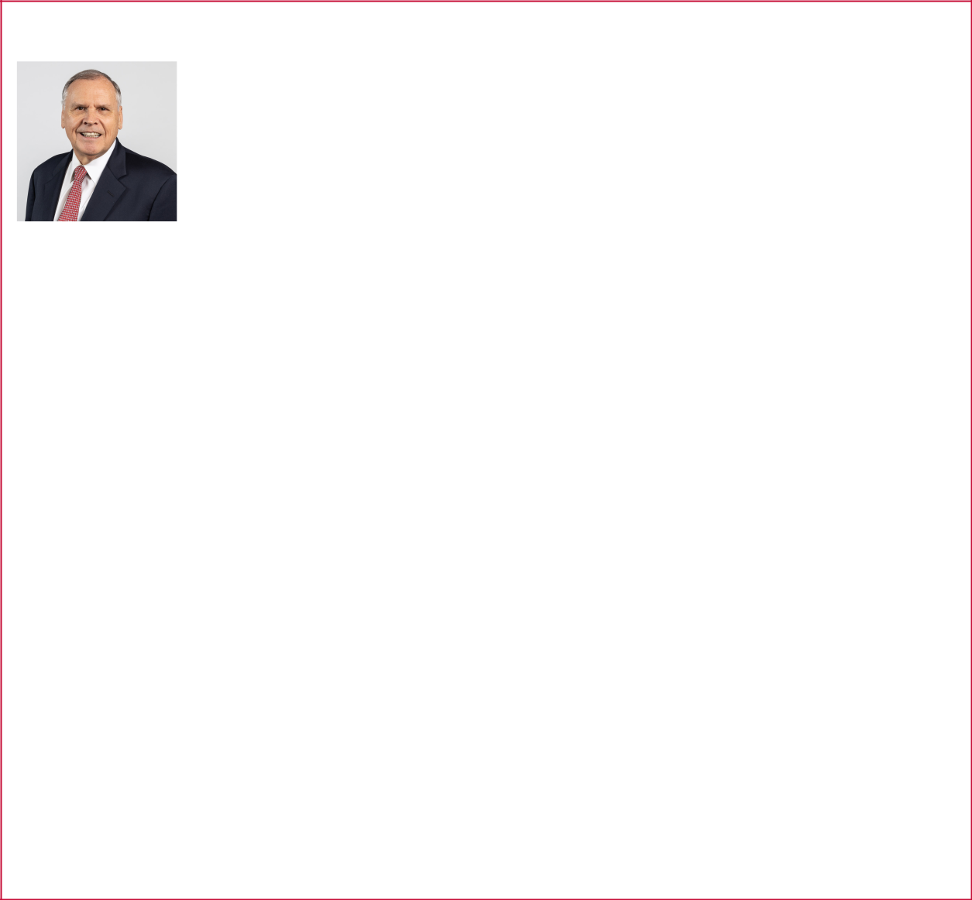

- Retired; Adviser (2013 – 2015); Executive Chairman (2013); Chairman (2002 – 2013); Chief Executive Officer (2000 – 2013); and President and Chief Operating Officer (1999 – 2000), Ryder System, Inc., a supplier of transportation, logistics and supply chain management solutions

- Senior Vice President for various business units, Burlington Northern Santa Fe Corporation (BNSF), a freight transportation company (1995 – 1999)
- Executive Vice President-Intermodal Business Unit, Burlington Northern Railroad Company, a predecessor of BNSF (1994 – 1995)

- Executive Director-Europe and Africa (1991 – 1994) and Managing Director—Western and Eastern Europe (1988 – 1990), DHL Worldwide Express, a global logistics and international shipping company (“DHL”)

- Regional Vice President, DHL Airways, Inc., a division of DHL (1982
– 1988)

- Various national account, sales, and marketing positions, AT&T and Illinois Bell Telephone Company, related telecommunications companies (1971 – 1982)

Other Professional Experience and Community Involvement

- Director, CRST/Hillcrest Holding, a privately held transportation and logistics company
- Director, L3 Harris Technologies, Inc., a publicly traded supplier of communications and information technology products (2000 – 2019)

- Chairman of the Board of Trustees, St. Thomas University, a private university in Miami, Florida (2001 – 2013)

- Past recipient of National Safety Council’s highest honor, the Green Cross for Safety medal, in recognition of career-long commitment to workplace safety

Education

- B.B.A., Loyola University of Chicago

- M.B.A., University of Chicago

Key Qualifications

Mr. Swienton contributes extensive international business experience, deep expertise in global distribution, experience in growth initiatives, and supply chain innovations from his executive leadership at transportation companies.

-18-

Proposal 2
Advisory Vote to Approve the
Compensation of Our Named Executive Officers

In accordance with Section 14A of the Securities Exchange Act of 1934 (the “Exchange Act”), we are asking our stockholders to vote to approve the compensation of our Company’s NEOs (the “Say-on-Pay vote”), as disclosed in this Proxy Statement. The Say-on-Pay vote is an advisory vote on the resolution below and is not binding. Although the vote is non-binding, the directors value stockholders’ opinions and will consider the voting results of this proposal when making future compensation decisions. Say-on-Pay advisory votes are currently conducted annually, and our next Say-on-Pay vote is expected to occur at our annual meeting of stockholders in 2026. Our next advisory vote on the frequency of Say-on-Pay votes is expected to take place at our annual meeting of stockholders in 2029.

As described more fully in the “Compensation Discussion and Analysis” section of this Proxy Statement, the Company designed its market-competitive NEO compensation program to reward successful execution of its business strategy and achievement of desired business results, with a focus on creating alignment with the interests of our stockholders. The program seeks to achieve these goals on both an annual and long-term basis through an appropriate combination of base pay, annual incentives, and long-term incentives.

For our NEOs, the majority of compensation in a typical year is both stock-based and contingent on performance. The annual incentive payout is based on Company financial performance metrics of core net income, free cash flow, and core revenue, and for NEOs who are business segment leaders, a combination of Company and business segment performance. Our long-term incentives generally include: (1) performance share units, which are designed to link compensation to the Company’s three-year financial performance as measured by return on invested capital and core net income growth; (2) stock appreciation rights, which are designed to incentivize NEOs to grow our business and deliver increased returns to our stockholders; and (3) restricted stock units, which are designed to support our retention efforts.

The Company also has several governance policies in place to align executive compensation with stockholder interests and mitigate risk. These policies include stock ownership guidelines; a prohibition on hedging and pledging of Company stock; clawback policies; and post-employment restrictive covenants. These policies are discussed in detail in the “Compensation Discussion and Analysis” section of this Proxy Statement.

In 2024, the Company posted record highs for revenue and earnings per share. Highlights of our 2024 performance include the following:

- Revenue up 7% and core revenue up 13% to approximately $5.3 billion;

- Operating profit margin up 350 basis points to 19.4%, while adjusted segment profit margin was up 150 basis points to 19.4%;

- Net income up 37% to $807 million and adjusted net income up 26% to $808 million;

- GAAP diluted earnings per share up 36% to $22.54, while adjusted diluted earnings per share was up 26% to $22.58;

- Operating cash flow up 28% to $946 million, while free cash flow was up 61% to $785 million;

- One-year total stockholder return of 37%, three-year total stockholder return of 95%, and five-year total stockholder return of 166%; and

- Quarterly dividends resulted in approximately $160 million cash paid to stockholders, and the Company used an additional $54 million to repurchase shares under our stock repurchase program.

Financial results, including those from prior periods, are described in more detail in our Form 10-K for the fiscal year ended December 31, 2024, which was filed with the SEC on February 11, 2025 (the “Form 10-K”). For non-GAAP results, see reconciliation in Appendix A. All total stockholder return calculations assume reinvestment of dividends.

-19-

We are asking stockholders to approve the following advisory resolution at the Annual Meeting:

RESOLVED, that the compensation of the Company’s named executive officers, as disclosed pursuant to the compensation disclosure rules of the Securities and Exchange Commission, including the Compensation Discussion and Analysis, compensation tables, and narrative discussion is hereby APPROVED.

THE BOARD OF DIRECTORS RECOMMENDS A VOTE “FOR” THE APPROVAL OF THE COMPENSATION OF THE NEOS AS DISCLOSED IN THIS PROXY STATEMENT.

-20-

Proposal 3
Ratification of the Appointment of Ernst & Young LLP
as Our Independent Registered Public
Accounting Firm for the 2025 Fiscal Year

As a matter of good corporate governance, the Audit Committee of the Board of Directors (the “Audit Committee”), with the assistance of management, issued a Request for Proposal (“RFP”) regarding the Company’s engagement of an independent registered public accounting firm to audit the Company’s consolidated financial statements for its fiscal year ending December 31, 2025. Thereafter, the Audit Committee conducted a comprehensive, competitive RFP process. The Audit Committee invited multiple firms to participate in this RFP process.

Following this process, effective March 10, 2025, the Audit Committee dismissed KPMG LLP (“KPMG”), which had previously served in such capacity since 2002, and appointed Ernst & Young LLP (“EY”) to continue as our independent registered public accounting firm for the 2025 fiscal year.

We are asking our stockholders to ratify the appointment of EY as our independent registered public accounting firm. If our stockholders do not ratify this appointment, the Audit Committee will consider the reasons for the rejection and whether it should select a different firm; however, it is not required to do so. Even if the appointment is ratified, the Audit Committee, in its discretion, may select a different independent registered public accounting firm at any time during the year if it determines that a change would be in the best interests of the Company and our stockholders.

A representative of EY will be present at the Annual Meeting and will be available to respond to appropriate questions. The representative will also have an opportunity to make a statement at the Annual Meeting if he or she desires to do so.

THE BOARD RECOMMENDS A VOTE “FOR” THE RATIFICATION OF ERNST & YOUNG LLP AS OUR INDEPENDENT REGISTERED PUBLIC ACCOUNTING FIRM FOR THE 2025 FISCAL YEAR.

Change in Certifying Accountant

On March 7, 2025, the Audit Committee approved the dismissal of KPMG. KPMG was notified of the dismissal on March 10, 2025.

KPMG’s reports on the Company’s consolidated financial statements as of and for the fiscal years ended December 31, 2024 and 2023 did not contain any adverse opinion or disclaimer of opinion; nor were they qualified or modified as to uncertainty, audit scope, or accounting principles.

During the fiscal years ended December 31, 2024 and 2023, and the subsequent interim period through March 10, 2025, there were: (i) no disagreements (within the meaning of Item 304(a)(1)(iv) of Regulation S-K and the related instructions) between the Company and KPMG on any matters of accounting principles or practices, financial statement disclosure, or auditing scope or procedure which, if not resolved to KPMG’s satisfaction, would have caused KPMG to make reference thereto in their reports; and (ii) no “reportable events” within the meaning of Item 304(a)(1)(v) of Regulation S-K.

In accordance with Item 304(a)(3) of Regulation S-K, the Company provided KPMG with a copy of the disclosure in the three preceding paragraphs prior to filing a Current Report on Form 8-K containing such disclosure with the Securities and Exchange Commission (the

“SEC”) on March 13, 2025, and requested that KPMG furnish the Company with a letter addressed to the SEC stating whether KPMG agreed with the statements made by the Company set forth above. A copy of KPMG’s letter, dated March 13, 2025, was attached as Exhibit 16.1 to the Current Report on Form 8-K filed on March 13, 2025.

On March 7, 2025, the Audit Committee approved the engagement of EY as the Company’s independent registered public accounting firm for the Company’s 2025 Audit. EY was engaged effective March 12, 2025.

-21-

During the fiscal years ended December 31, 2024 and 2023 and the subsequent interim period through March 12, 2025, neither the Company nor anyone on its behalf has consulted with EY regarding: (i) the application of accounting principles to a specific transaction, either completed or proposed, or the type of audit opinion that might be rendered on the Company's financial statements, and neither a written report nor oral advice was provided to the Company that EY concluded was an important factor considered by the Company in reaching a decision as to any accounting, auditing, or financial reporting issue; (ii) any matter that was the subject of a disagreement within the meaning of Item 304(a)(1)(iv) of Regulation S-K and the related instructions; or (iii) any reportable event within the meaning of Item 304(a)(1)(v) of Regulation S-K.

Audit and Non-Audit Fees

The following table sets forth the fees for audit and other services rendered by KPMG for each of the last two fiscal years (in thousands).

 |  | 2024 |  | 2023
Audit Fees ⁽¹⁾ | $ | 3,266 | $ | 3,752
Audit-Related Fees ⁽²⁾ |  | — |  | —
Tax Fees ⁽³⁾ |  | 24 |  | 17
Other Fees ⁽⁴⁾ |  | 10 |  | —
Total | $ | 3,300 | $ | 3,769

- Represents fees billed for the audit of our financial statements included in the Form 10-K and review of financial statements included in our Quarterly Reports on Form 10-Q, the audit of our internal control over financial reporting, and for services that are provided by KPMG in connection with statutory regulatory filings or engagements.

- Represents fees billed for assurance and consultative related services.

- Represents fees billed for tax compliance, including review of tax returns, tax advice, and tax planning.

- Represents fees billed for translation services for subsidiary financial statements.

Audit Committee Approval of Audit and Non-Audit Services

The Audit Committee is responsible for pre-approving all audit services provided by our independent registered public accountants. In addition, all non-audit services provided by our independent registered public accountant are pre-approved in accordance with our policy that prohibits our independent registered public accountants from providing services specifically prohibited by the SEC. For permissible non-audit services, the Audit Committee has delegated pre-approval authority to the Audit Committee Chair. In addition, the Audit Committee has approved annual maximum amounts for tax advisory and tax return services. No engagements are commenced until the Audit Committee Chair’s approval has been received. All approved services are reported to the full Audit Committee at each quarterly meeting. In accordance with the foregoing, all services provided by KPMG in 2023 and 2024 were pre-approved by the Audit Committee.

-22-

Audit Committee Report

The Audit Committee maintains effective working relationships with the Board, management, the Company’s internal auditors, and the Company’s independent registered public accounting firm (the “Independent Accountants”). As set forth in the Audit Committee Charter, it is not the duty of the Audit Committee to plan or conduct audits or to determine that our Company’s consolidated financial statements and disclosures are complete and accurate and in accordance with U.S. generally accepted accounting principles and applicable rules and regulations. The Independent Accountants are responsible for auditing the Company’s consolidated financial statements and expressing an opinion as to the conformity of these financial statements with U.S. generally accepted accounting principles and on the Company’s internal control over financial reporting.

The Audit Committee has (1) reviewed and discussed the Company’s audited consolidated financial statements for the year ended December 31, 2024, with the Company’s management and with KPMG, the Independent Accountants for the year ended December 31, 2024; (2) discussed with KPMG the matters required to be discussed by the applicable requirements of the Public Company Accounting Oversight Board and the SEC; and (3) received the written disclosures and the letter from KPMG required by applicable requirements of the Public Company Accounting Oversight Board regarding KPMG’s communications with the Audit Committee concerning independence, and the Audit Committee has discussed with KPMG its independence and considered the compatibility of non-audit services by KPMG to the Company with KPMG’s independence.

Members of the Audit Committee rely, without independent verification, on the information provided and on the representations made by management and the Independent Accountants. Accordingly, the Audit Committee’s oversight does not provide an independent basis to determine that management has maintained appropriate accounting and financial reporting principles or appropriate internal controls and procedures designed to assure compliance with accounting standards and applicable laws and regulations. Furthermore, the Audit Committee’s considerations and discussions referred to above do not assure that the audits of the Company’s consolidated financial statements have been carried out in accordance with generally accepted auditing standards, that the consolidated financial statements are presented in accordance with U.S. generally accepted accounting principles or that the Company’s Independent Accountants are in fact “independent.”

Based upon the reviews and discussions described above, and subject to the limitations on the role and responsibilities of the Audit Committee referred to in this report and in the Audit Committee Charter, the Audit Committee recommended to the Board that the audited consolidated financial statements be included in the Company’s Annual Report on Form 10-K for the fiscal year ended December 31, 2024.

Submitted by the Audit Committee of the Board:

Gregory T. Swienton (Chair)

Sherry L. Buck

Janet K. Cooper

Todd J. Teske

Jon Vander Ark

March 20, 2025

-23-

Corporate Governance

Director Independence

Our Corporate Governance Guidelines require that a majority of our directors be “independent,” and that the Compensation and Human Resources, Board Governance, and Audit Committees consist exclusively of independent directors as defined under the New York Stock Exchange ("NYSE") listing standards, the Exchange Act, and any other applicable laws or regulations regarding independence. No director qualifies as “independent” unless the Board affirmatively determines that the director has no material relationship with the Company.

Applying these standards, the Board has determined that all of our Board members are independent, except Alok Maskara, our CEO. All of the members of the Board’s Compensation and Human Resources, Board Governance, and Audit Committees are independent directors.

In making its determination as to the independence of our directors, the Board Governance Committee and the Board considered that (a) Mr. Teske served as Interim CEO of the Company for less than two months from March 23, 2022 to May 9, 2022 and (b) Mr. Vander Ark serves as the CEO of Republic Services, Inc., which provides waste management services to the Company in the ordinary course of business. The Board affirmatively determined that no director had a material relationship with the Company despite these facts.

Leadership Structure

Mr. Teske serves as independent Chair of the Board. As independent Chair, Mr. Teske, among other things, presided at all meetings of the Board, including executive sessions of the independent directors, served as liaison between the CEO and the independent directors, assisted in planning agendas for Board meetings, and advised on the presentation of information provided to the Board.

Board Refreshment and Nomination Process

The Board is responsible for nominating candidates for Board membership. The Board has delegated the director screening and recruitment process to the Board Governance Committee. In this capacity, the Board Governance Committee develops and periodically reviews the qualification criteria for Board membership, identifies new director candidates, and makes recommendations to the Board regarding the appropriate size of the Board and appointment of members to the Board’s committees. The Board Governance Committee typically retains a third-party search firm to assist in identifying and evaluating potential new director candidates. We strive to maintain a well-rounded Board with a diversity of experience, functional expertise, and industry knowledge. Required qualifications for Board membership vary according to the particular areas of expertise, experience, and skills being sought to complement the existing Board composition at the time of any vacancy.

As part of our robust Board refreshment and succession planning process, we welcomed two new directors with impressive leadership experience in 2024: Soma Somasundaram, CEO of ChampionX, who brings technical engineering and strategic development experience, and Jon Vander Ark, CEO of Republic Services, Inc., who brings knowledge of sustainability practices and financial expertise. The identification and evaluation process described above was followed with respect to both Mr. Somasundaram and Mr. Vander Ark. We already are seeing both make valuable contributions in the boardroom and look forward to benefiting from their contributions going forward.

Following the Annual Meeting, Janet K. Cooper, who has served on the Board since Lennox became an independent publicly traded company in 1999, will retire. Additionally, Gregory T. Swienton, who has served on the Board since 2010, has reached the mandatory retirement age under the Company's Corporate Governance Guidelines and will also retire following the Annual Meeting.

In 2024 and 2025, we also realigned committee assignments and elected new Chairs to our Compensation and Human Resources, Audit, and Board Governance committees, additions that we believe add new insights and perspective to our committees. In each instance, the new committee Chair spent time serving as a committee member to ensure a smooth transition.

Key Attributes

The Board Governance Committee considers the following factors in evaluating candidates, in addition to other factors it deems relevant:

-24-

 | • | leadership
Personal Characteristics | • | integrity
Personal Characteristics | • | interpersonal skills and effectiveness
 | • | accountability
 | • | high performance standards
 | • high levels of leadership experience in business
 | • substantial knowledge of issues faced by publicly traded companies
Business Attributes | • experience in positions demonstrating expertise, including on other boards of directors
Business Attributes | • | financial acumen
 | • industry and Company knowledge
 | • | diversity of viewpoints
 | • experience in international markets and strategic planning
Independence | • compliance with the standards contained in the NYSE listing standards, the Exchange Act,
Independence |  | and any other applicable laws or regulations regarding independence
 | • willingness to commit the time required to fully discharge his or her responsibilities
Professional | • commitment to attend meetings
Professional | • | ability and willingness to represent the stockholders’ long- and short-term interests
Responsibilities | • | awareness of our responsibilities to our customers, employees, suppliers, regulatory
 |  | bodies, and the communities in which we operate
 | • willingness to advance his or her opinions
Governance | • ability to understand, and distinguish between, the roles of governance and management
Responsibility
Availability and | • | availability based on the number of commitments to other entities existing or contemplated
Commitment |  | by the candidate






Our Corporate Governance Guidelines specifically state that when nominating new directors, the Board will seek the best qualified candidates to achieve a high performing Board, including a diversity of professional experience, race, ethnicity, gender, age, and cultural background. For additional information, please see the Company’s Corporate Governance Guidelines. In addition, the Board considers a variety of viewpoints in determining the qualifications desired for any new Board member. Finally, we believe that diversity with respect to tenure is important to benefit from both fresh perspectives and deep experience and knowledge of our Company and our business. Therefore, we aim to maintain an appropriate balance of tenure among our directors.

We regularly assess whether our Board maintains the right balance of skills, experience, and acumen required for exceptional leadership. This year, our Board continues to bring a diverse set of backgrounds, skills, and experiences to Lennox that are essential to collaborating with management and driving our strategy forward.

When a vacancy occurs on the Board, a majority of the directors then in office may fill the vacancy or the size of the Board may be reduced. The Board Governance Committee considers nominees for election to the Board recommended by stockholders in the same manner as other candidates.

Stockholder Nominations for Director

A stockholder wishing to nominate a candidate for election to the Board at a meeting of the stockholders (“Nominating Stockholder”) is required to give written notice to our Corporate Secretary of his or her intention to make a nomination in accordance with the terms of our Bylaws. The Nominating Stockholder must be a holder of record of stock of the Company entitled to vote at the annual meeting of stockholders and must appear at the annual meeting of stockholders to nominate such person. The Nominating Stockholder must include a written consent from its proposed director nominee. The proposed director nominee must also represent and agree that he or she (1) has not and will not give any assurance or commitment not disclosed to the Company on how he or she would vote on any issue or question, (2) has not and will not become party to any agreement not disclosed to the Company regarding direct or indirect compensation (other than from the Company) for his or her service as a director, and (3) if elected, will comply with all applicable policies and guidelines of the Company. We must receive the notice of nomination at least 60 days

-25-

but no more than 90 days prior to the annual meeting of stockholders. However, if we give less than 70 days’ notice of the date of the annual meeting of stockholders, the notice of nomination must be received within 10 days following the date on which notice of the date of the annual meeting of stockholders was mailed or such public disclosure was made to our stockholders.

Pursuant to our Bylaws, the notice for the proposed director nominee must contain certain information about the nominee, the Nominating Stockholder, and any person “acting in concert” with the Nominating Stockholder, including descriptions of any arrangements or understanding related to the nomination, the information that would be required if such person was making a stockholder proposal (as described under “Other Information – Stockholder Proposals for the 2026 Annual Meeting of Stockholders”), and other information sufficient to allow the Board Governance Committee to determine if the candidate meets our qualification criteria for Board membership. The Board Governance Committee may require the proposed director nominee to furnish additional information in order to determine that person’s eligibility to serve as a director. A nomination that does not comply with the above procedure will be disregarded. Nominating Stockholders whose nominations comply with the foregoing procedure and who meet the criteria described above under the heading “Board Refreshment and Nomination Process” and in our Corporate Governance Guidelines, will be evaluated by the Board Governance Committee in the same manner as the Board Governance Committee’s nominees.

In addition to satisfying the requirements under our Bylaws, to comply with the universal proxy rules, stockholders who intend to solicit proxies in support of director nominees other than the Company’s nominees must provide notice that sets forth the information required by Rule 14a-19 under the Exchange Act, which notice must be postmarked or transmitted electronically to us at our principal executive offices no later than 60 calendar days prior to the first anniversary date of this year’s Annual Meeting. Accordingly, for the 2026 Annual Meeting of Stockholders, we must receive such notice no later than March 23, 2026. If the date of the 2026 Annual Meeting of Stockholders is changed by more than 30 calendar days from the anniversary of the Annual Meeting, then notice must be provided by the later of 60 calendar days prior to the date of the 2026 Annual Meeting of Stockholders or the 10th calendar day following the day on which public announcement of the date of the 2026 Annual Meeting of Stockholders is first made.

Communications with Directors

Stockholders and all other interested parties may send written communications to the Board by email to investor@lennox.com, or by regular mail to 2140 Lake Park Blvd., Richardson, Texas 75080, Attention: Board of Directors, c/o Corporate Secretary.

Communications received by the Corporate Secretary will be delivered to one or more members of the Board or management, as determined by the Corporate Secretary. Any allegations of accounting, internal controls, or auditing-related complaints or concerns will be directed to the Chair of the Audit Committee.

Board & Committee Meetings

The Board met fourteen times in 2024. All directors attended more than 75% of the total number of all meetings of the Board and committees of the Board on which they served. Our Corporate Governance Guidelines include a policy that Board members are expected to attend the Annual Meeting. All of the individuals serving as directors at the time of our 2024 Annual Meeting of Stockholders attended our 2024 Annual Meeting of Stockholders, and we expect all current directors to attend the 2025 Annual Meeting.

Executive Session Meetings

The non-management directors of our Board, all of whom are independent, meet regularly in executive session without the presence of management. In 2024, the independent Chair of the Board chaired the executive session meetings of our independent directors.

Committee Meetings

- The standing committees of the Board are as follows: Audit, Board Governance, Compensation and Human Resources, and Executive.

- The Board has adopted charters for each of these committees, copies of which are available on our website at www.lennox.com by following the links “Investors — Corporate Governance — Documents & Charters.”

- Each of the Audit, Board Governance, and Compensation and Human Resources committees is led by a different independent director and all committees members are independent directors.

-26-

- The Executive Committee is led by the independent Chair of the Board and its members are the CEO and each committee Chair.

- Each standing committee has the authority to retain independent advisors to assist in the fulfillment of its responsibilities, to approve the fees paid to those advisors, and to terminate their engagements.

- Previously, the Board had a standing Public Policy Committee, which was dissolved in December 2024. Prior to its dissolution, it was responsible for overseeing the Company’s (a) actions in furtherance of corporate environmental and social responsibilities and other sustainability issues of significance to investors and other key Company stakeholders and (b) health and safety issues. Those issues are now overseen by the full Board or by another committee. The Board determined that each member that served on the Public Policy Committee in 2024 was independent as defined by the NYSE. The Public Policy Committee met four times in 2024.

AUDIT COMMITTEE


Committee Chair:

Sherry L. Buck

Other Committee Members:

Janet K. Cooper

Soma Somasundaram

Gregory T. Swienton

Todd J. Teske

Jon Vander Ark

Meetings Held in 2024:

9

t

BOARD GOVERNANCE COMMITTEE


Committee Chair:

Karen H. Quintos

Other Committee Members:

Janet K. Cooper

John W. Norris, III

Soma Somasundaram

Meetings Held in 2024:

10

Responsibilities:

The Audit Committee assists the Board in fulfilling its oversight responsibilities relating to the integrity of our financial statements and related systems of internal controls, our compliance with legal and regulatory requirements, the independent registered public accounting firm’s qualifications, independence and performance and the performance of our internal audit function. The Audit Committee also has the direct responsibility for the appointment, compensation, retention, and oversight of our Independent Accountants.

About the Members:

- All members are independent & financially literate in accordance with NYSE requirements

- Ms. Buck, Ms. Cooper, Mr. Teske, Mr. Swienton, and Mr. Vander Ark are audit committee financial experts as defined by the SEC
- None of the members serve on the audit committees of more than three public companies

Responsibilities:

The Board Governance Committee assists the Board by identifying individuals qualified to become Board members, developing qualification criteria for Board membership, making recommendations to the Board regarding the appropriate size of the Board and appointment of members to the Board’s committees, developing and recommending to the Board any changes to the Corporate Governance Guidelines and Code of Business Conduct applicable to our Company, and overseeing the evaluation of our Board and each of the Board’s committees. The Board Governance Committee also conducts an individual peer review for any directors who are scheduled to be re-nominated.

About the Members:

- All members are independent

-27-

COMPENSATION & HUMAN RESOURCES COMMITTEE


Committee Chair:

Shane D. Wall

Other Committee Members:

John W. Norris, III

Gregory T. Swienton

Jon Vander Ark

Meetings Held in 2024:

5

Independent Compensation Consultant:

Meridian Compensation Partners, LLC

Responsibilities:

The Compensation and Human Resources Committee determines the compensation philosophy and oversees the compensation programs for the Company’s executive officers and the non-employee members of the Board. The Committee’s responsibilities include oversight of the short- and long-term incentive plans and senior management succession plans. The Committee also reviews the funding requirements and investment policies for the defined benefit and defined contribution retirement plans, and the performance of investment funds, investment advisors, and investment managers under those plans. The Committee may delegate its responsibilities to a subcommittee comprised of Committee members.

Although the Committee seeks input from the CEO on various elements of executive compensation, the Committee determines and approves the final compensation elements and amounts to be provided to the Company’s NEOs. The independent members of the Board (rather than the Committee) have direct responsibility for approving CEO and Board compensation; however, the Committee reviews and recommends proposed changes to CEO and Board compensation to the independent members of the Board for approval. See “Executive Compensation — Compensation Discussion and Analysis” for information concerning the Committee’s philosophy and objectives in overseeing executive compensation.

About the Members:

- All members are independent as defined for compensation committee members by NYSE

- All members are “non-employee directors” under Section 16b-3 of the Exchange Act

EXECUTIVE COMMITTEE


Committee Chair:

Todd J. Teske

Other Committee Members:

Alok Maskara

Sherry L. Buck

Karen H. Quintos

Shane D. Wall

Meetings Held in 2024:

0

Responsibilities:

The Executive Committee aids the Board in handling any matters that arise between Board meetings and, in the opinion of the Chair of the Board, should not be postponed until the next scheduled meeting of the Board.

Risk Management

While the Board oversees the Company’s risk management, our management is responsible for the development, implementation, and maintenance of our risk management processes. Management provides periodic reports to the Board and Board committees on its assessment of strategic, operational, legal and compliance, information security, and financial reporting risks to the Company. The Board and Board committees, as appropriate, review and consider the management reports provided on the Company’s enterprise risk and risk management strategy.

In 2024, our Enterprise Risk Management program, identifying and addressing risk, was presented to the full Board twice. The Audit Committee oversees the guidelines and policies that govern the Company’s processes to assess and manage significant enterprise risk exposure.

-28-

Other Corporate Governance Policies and Practices

Code of Business Conduct

The Company has adopted a Code of Ethics (which we call our Code of Business Conduct) that applies to all its directors and employees, including its senior financial and principal executive officers. The Code of Business Conduct covers a variety of matters, such as acting with integrity and compliance with laws, including anti-corruption laws. Amendments to and waivers, if any, of the Code of Business Conduct as it pertains to the principal executive officer, principal financial officer, and principal accounting officer, if any, will be disclosed on our website. The Code of Business Conduct is available on the Company’s website at www.lennox.com by following the links “Investors — Corporate Governance — Documents & Charters.”

Corporate Governance Guidelines

The Company has adopted Corporate Governance Guidelines that are available on the Company’s website at www.lennox.com by following the links “Investors — Corporate Governance — Corporate Governance Guidelines.”

Insider Trading Policy

The Company has adopted an insider trading policy governing the purchase, sale, and other dispositions of the Company’s securities that applies to all Lennox personnel, including directors, officers, employees, and other covered persons. The insider trading policy also applies to transactions by the Company in its own securities. We believe our insider trading policy is reasonably designed to promote

compliance with insider trading laws, rules and regulations, and listing standards applicable to Lennox. A copy of the Company’s insider trading policy was filed as Exhibit 19.1 to the Form 10-K.

Whistleblower Procedures

The Audit Committee has established procedures for the handling of complaints regarding accounting, internal accounting controls, or auditing matters, including procedures for confidential and anonymous submission by our employees of concerns regarding such matters. The Company’s Code of Business Conduct prohibits retaliation against employees who report violations or suspected violations of the Code of Business Conduct.

-29-

Director Compensation

Our non-employee director compensation program uses a combination of cash and equity awards to provide market-competitive compensation to members of our Board.

Each year, the Compensation and Human Resources Committee (the “Committee”) reviews benchmark data from our Compensation Peer Group and other general industry surveys to assess the competitiveness of our director compensation program. If the Committee believes changes are warranted to the Board compensation program, the Committee recommends the proposed changes to the independent members of the Board for approval.

2024 Annual Compensation

In 2024, we provided the following compensation to our non-employee directors; cash retainers shown in the table below are paid in quarterly installments to members of our Board.

Board Retainer for Each Director

$105,000 payable quarterly in cash with the option to receive a portion in Company common stock.

Board Leadership Retainers |  |  | Equity Award for Each Director
• | Chair of the Board | $ 150,000 | $150,000 annual stock grant
• | Audit Chair | $ 25,000
• | Compensation and Human Resources Chair | $ 20,000
• | Board Governance Chair | $ 20,000
• | Public Policy Chair | $ 20,000

Equity Awards

Non-employee directors receive 100% of their equity award in the form of common stock under the 2019 Equity and Incentive Compensation Plan. In 2024, each non-employee director continuing in service following the Annual Meeting received approximately $150,000 in common stock on the date of the Annual Meeting.

Perquisites and Other Compensation

We allow our non-employee directors to participate in our employee rebate program, which provides rebates on eligible residential heating and air conditioning equipment, accessories, and supplies. We also reimburse all non-employee directors for their reasonable expenses incurred in connection with attendance at Board or Board committee meetings.

Stock Ownership Guidelines

Pursuant to our director stock ownership guidelines, each non-employee director is required to own shares of our common stock having a value of at least five times their annual retainer within five years after their first election to the Board. Directors must retain their shares until they have met their ownership requirement. Unvested restricted stock units (“RSUs”) and shares of common stock owned count towards this requirement.

As of December 31, 2024, all non-employee directors elected prior to 2024 were in compliance with these stock ownership guidelines. While Soma Somasundaram and Jon Vander Ark do not yet meet the 5X ownership requirement, they were elected to the Board in 2024 and have until 2029 to meet the ownership requirement.

-30-

2024 Director Compensation Table

The following table provides information regarding compensation earned in 2024 by each non-employee director who served as a non-employee director during 2024.

 | Fees Earned or Paid in Cash ($) | Stock
Name | (1) | Awards ($)(2) | Total ($)
Sherry L. Buck | 105,000 | 149,804 | 254,804
Janet K. Cooper | 125,000 | 149,804 | 274,804
John W. Norris, III | 105,000 | 149,804 | 254,804
Karen H. Quintos | 125,000 | 149,804 | 274,804
Kim K.W. Rucker | 31,250 | 333,147 | 364,397
Soma Somasundaram | 105,000 | 149,804 | 254,804
Gregory T. Swienton | 130,000 | 149,804 | 279,804
Todd J. Teske | 255,000 | 149,804 | 404,804
Jon Vander Ark | 78,750 | — | 78,750
Shane D. Wall | 125,000 | 149,804 | 274,804

- In 2024, all of the non-employee directors elected to receive their retainer in cash.

- For Ms. Rucker, the amount represents the incremental fair value associated with the vesting of outstanding RSUs upon her separation from the Board on February 29, 2024. For the other non-employee directors, the amounts shown represent the grant date fair value for common stock granted under the 2019 Equity and Incentive Compensation Plan, in accordance with Financial Accounting Standards Board Accounting Standards Codification (“FASB ASC”) Topic 718, as follows:

 |  | Common Stock | Grant Date Fair Value | Grant Date Fair
 | Grant Date | Granted in 2024 (#) | Per Share ($)(a) | Value ($)
Each Non-Employee Director | May 16, 2024 | 305 | 491.16 | 149,804

(a) $491.16 is the closing NYSE trading price of our common stock on the date of grant.

The following table provides information regarding the aggregate number of outstanding RSUs held by each non-employee director as of December 31, 2024. RSUs generally vest on the third anniversary of the date of grant.

 | Aggregate RSUs Outstanding as
Name | of December 31, 2024 (# of shares)
Sherry L. Buck | 567
Janet K. Cooper | 567
John W. Norris, III | 567
Karen H. Quintos | 567
Kim K.W. Rucker | —
Soma Somasundaram | —
Gregory T. Swienton | 567
Todd J. Teske | 567
Jon Vander Ark | —
Shane D. Wall | 567

-31-

Executive Officers

Our current executive officers, their present positions, and their ages are as follows as of April 9, 2025:

Alok Maskara 54 Chief Executive Officer

- Chief Executive Officer (2022 - present)

- Chief Executive Officer, Luxfer Holdings PLC (2017 - 2022)

- Director, Franklin Electric Co., Inc. (2021 - present)

Michael P. Quenzer 47 Executive Vice President, Chief Financial Officer

- Executive Vice President and Chief Financial Officer (2024 - present)

- Vice President, Financial Planning & Analysis and Investor Relations (2023)

- Chief Financial Officer, Commercial segment (2016 - 2022)

Gary S. Bedard 60 Executive Vice President & President, Home Comfort Solutions

- Executive Vice President & President, Home Comfort Solutions (2023 - present)

- Executive Vice President & President, Worldwide Refrigeration business (2017 - 2022)

Prakash Bedapudi 58 Executive Vice President, Chief Technology Officer

- Executive Vice President, Chief Technology Officer (2008 - present)

Monica M. Brown 52 Executive Vice President, Chief Legal Officer and Secretary

- Executive Vice President, Chief Legal Officer and Secretary (January 2025 - present)

- Vice President, Deputy General Counsel, and Assistant Secretary (2023 - 2024)

- Assistant General Counsel, Securities and Assistant Secretary (2021 - 2023)

- Assistant General Counsel, Worldwide Refrigeration (2016 - 2021)

Chris A. Kosel 58 Vice President, Chief Accounting Officer and Controller

- Vice President, Chief Accounting Officer and Controller (2017 - present)

Joseph S. Nassab 58 Executive Vice President & President, Building Climate Solutions

- Executive Vice President & President, Building Climate Solutions (2022 - present)

- Vice President and General Manager, Allied Air (2010 - 2022)

Daniel M. Sessa 60 Executive Vice President, Chief Human Resources Officer

- Executive Vice President, Chief Human Resources Officer (2007 - present)

-32-

Executive Compensation

Compensation Discussion and Analysis

2024 CD&A At-A-Glance

This Compensation Discussion and Analysis (“CD&A”) reviews the philosophy, objectives, and elements of our executive compensation program, and describes the 2024 compensation of our named executive officers (“NEOs”). It also describes the process followed by the Committee for making pay decisions, as well as its rationale for specific pay decisions for 2024 executive compensation.

At our 2024 Annual Meeting of Stockholders, the advisory vote to approve the compensation of the Company’s NEOs received the approval of approximately 97% of the stockholders voting for or against this proposal. The Committee considered this vote to represent strong overall support for our NEO compensation program, and it did not make any changes to our executive compensation policies or practices that were significantly driven by the results of the vote.

Our business continued to strengthen in 2024 with the Company delivering year-over-year revenue growth of 7% and up 13% for core operations. Record Company performance in 2024 resulted in STI and LTI payouts above target with a strong pay-for-performance relationship resulting in total shareholder return (“TSR”) of 37%. Operating profit margin was up 350 basis points and adjusted segment profit margin was up 150 basis points; net income increased 37% to $807 million and adjusted net income increased 26% to $808 million; and operating cash flow increased 28% to $946 million. For non-GAAP results, see reconciliation in Appendix A.

More information about our 2024 business achievements and the resulting compensation actions taken by the Committee are summarized below.

2024 NEOs

NEO | Title
Alok Maskara | President and Chief Executive Officer
Michael P. Quenzer | Executive Vice President, Chief Financial Officer
Gary S. Bedard | Executive Vice President and President, Home Comfort Solutions
Daniel M. Sessa | Executive Vice President, Chief Human Resources Officer
John D. Torres | Former Executive Vice President, Chief Legal Officer and Corporate Secretary

Leadership Transitions

On October 21, 2024, John D. Torres, Executive Vice President, Chief Legal Officer and Corporate Secretary, notified the Company of his decision to retire as Chief Legal Officer and Corporate Secretary effective December 31, 2024. Thereafter, Mr. Torres continued to serve as Executive Vice President, with no changes to his compensation package, to assist in the Chief Legal Officer and Corporate Secretary leadership transition until his retirement from the Company effective February 28, 2025.

Effective January 1, 2025, Monica Brown, who previously served as Vice President and Deputy General Counsel, succeeded Mr. Torres as Executive Vice President, Chief Legal Officer and Corporate Secretary of the Company. Ms. Brown served in her prior role since January 2023. Prior to that, she successfully led a broad range of legal functions at Lennox for over 12 years. Before joining Lennox, she spent almost 13 years practicing complex commercial litigation at a prestigious law firm. Ms. Brown holds a bachelor’s degree from Howard University and a J.D. from the University of Texas School of Law.

Gary Bedard, Executive Vice President and President of Home Comfort Solutions, notified the Company of his decision to retire after 26 years of dedicated service at Lennox; Mr. Bedard’s retirement will be effective April 30, 2025. On March 31, 2025, the Company announced Sarah Martin as Executive Vice President and President of Home Comfort Solutions, effective April 28, 2025. Ms. Martin previously served in senior leadership operating roles with Honeywell International Inc.

-33-

Executive Summary

The Company’s executive compensation program is designed to attract, retain, and motivate leadership talent, align with short- and long-term business goals, maintain market competitiveness, and increase stockholder value by maintaining a strong alignment between pay and performance.

Highlights of our 2024 financial performance and the linkage between executive compensation and financial performance are set forth below.

Financial Highlights

In 2024, the Company posted record highs for revenue, net income, and operating cash flow. Highlights of our 2024 performance include the following (dollars in millions):

Revenue Operating Profit Margin Adjusted Net Income⁽¹⁾ Operating Cash Flow
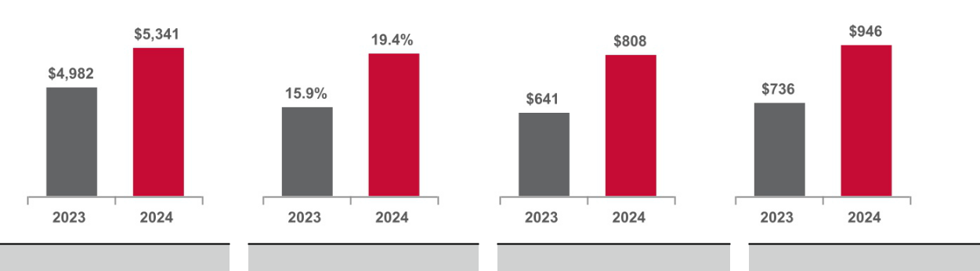

7% Increase + 350 Basis Points 26% Increase 28% Increase

- See adjusted net income GAAP reconciliation in Appendix A

  - GAAP diluted earnings per share up 36% to $22.54, while adjusted diluted earnings per share was up 26% to $22.58;

  - Operating profit margin was up 350 basis points and adjusted segment profit margin was up 150 basis points to 19.4%;

  - One-year TSR of 37%, three-year TSR of 95%, and five-year TSR of 166%; and

  - Quarterly dividends resulted in approximately $160 million paid to stockholders, and the Company used an additional $54 million to repurchase shares under our stock repurchase program.

Financial results, including those from prior periods, are described in more detail in our Form 10-K. For non-GAAP results, see reconciliation in Appendix A. All total stockholder return calculations assume reinvestment of dividends.

Compensation Highlights

The Committee believes that the design of the Company’s executive compensation program provides a direct link between Company performance and the compensation to our NEOs. Our executive compensation program has three primary elements: base salary, short-term incentives (as part of our Short-Term Incentive (“STI”) Program), and long-term equity incentives (as part of our Long-Term Incentive (“LTI”) Program). Each of these compensation elements serves a specific purpose in our compensation strategy. Base salary is an essential component to any market-competitive executive compensation program. Short-term incentives reward the achievement of annual goals, while long-term incentives drive our NEOs to focus on continuous stockholder value creation.

- Base salaries: NEOs’ base salaries are adjusted annually, effective April 1. The average increase in 2024 was 3.5% with a range of 0% to 7.0%.

- STI Program: STI amounts are determined by Company performance against the earnings, cash flow, and revenue goals, as approved by the Committee. Once the Company’s performance against goals is determined, 25% of that amount may be modified from 0% to 225% based on each NEO’s individual performance, with total payout capped at 225%. When determining whether to modify an NEO’s calculated STI amount, the Committee considered each NEO’s performance against specific financial, operational, and strategic objectives, as well as each NEO’s contribution to our sustainability commitment for the benefit of our

-34-

stakeholders. The Company’s sustainability goals include reducing the environmental impact of our products and operations, reducing the number of safety incidents in our operations, and enhancing the inclusiveness of our workforce. For more information on the Company’s sustainability performance, see www.lennox.com/sustainability.

For 2024, Company performance against the STI earnings, cash flow, and revenue goals substantially exceeded target, resulting in an STI payout of approximately 217% of target. Mr. Bedard’s STI payout of 211% was a result of Home Comfort Solutions exceeding segment performance goals and blended with consolidated Company performance. The STI payout for all NEOs was calculated based on Company performance against pre-established goals. Amounts were not modified based on individual performance and did not include any discretionary adjustments.

- LTI Program: NEOs receive 50% of their annual LTI grant in the form of performance-based restricted stock units, which vest after three years. In 2024, the NEOs earned 200% of their target performance share units (“PSUs”) granted in December 2021 based on net income and ROIC performance over the 2022-2024 three-year period. The three-year TSR over this time frame was 95%.

Positive Governance Practices

The Committee assesses trends and developments in executive compensation practices and implements those that best fit with the Company’s business strategy and our stockholders’ long-term interests. Below are some of the practices we have incorporated into our executive compensation program:

What We Do

- Median compensation philosophy

- Pay-for-performance linkage

- Long-term balance in compensation structure

- Use of independent compensation consultant

- Annual risk assessment

- Rigorous stock ownership guidelines

- Clawback policies and provisions

- Non-Competition / Non-Solicitation restrictions

- Annual review of share utilization

- Regular market assessment of our peer group

What We Don’t Do

- No excise tax gross-ups

- No hedging of Company stock

- No pledging of Company stock

- No dividends on equity awards in annual grant

- No repricing of stock appreciation rights or options

- No cash buyouts of underwater stock appreciation rights or options

- No significant annual perquisites

- Change-in-Control double-trigger for severance and equity vesting

- Minimum vesting requirement of at least one year for 95% or more of equity incentive plan awards

What Guides Our Program

Pay-for-Performance

We maintain a pay-for-performance philosophy designed to reward successful execution of our business strategy and achievement of desired business results, with a focus on aligning compensation with stockholders’ interests. When our financial results exceed performance goals, monetary rewards to our NEOs generally pay out at higher levels. When our financial results fall below performance goals, monetary awards to our NEOs generally pay out at lower levels or not at all.

Recent payouts under our STI and LTI Programs demonstrate the alignment between Company performance and payments made to our NEOs. In 2024, the Company’s strong earnings, cash flow, and revenue performance resulted in above target level payouts under our annual STI program for all NEOs.

-35-

Under our LTI Program, weighted average return on invested capital of 48.4% for the 2022-2024 performance period exceeded the maximum payout goal for that metric, while the Company core net income compound annual growth rate of 20.1% for that same period exceeded the maximum payout goal for that metric. As a result, our NEOs received a PSU payout of 200% for the 2022-2024 performance period under our LTI Program, consistent with our pay-for-performance approach and results-oriented compensation.

The two charts below illustrate that the three-year Lennox CEO target total direct compensation (“TDC”) was below median of the peer group and Lennox substantially outperformed the peer group on three-year TSR and certain other relevant financial measures.
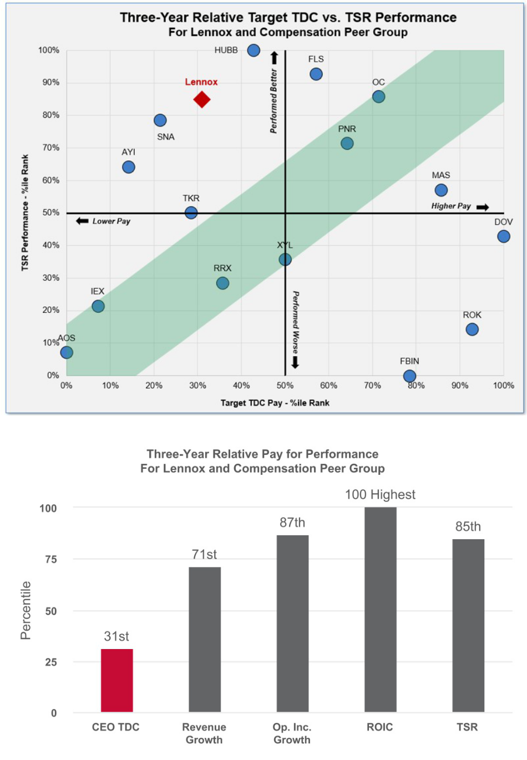

 | Lennox CEO Pay |  | Lennox Performance

-36-

Key Strategic Objectives

The strategic objectives of our executive compensation program are to:

- attract, retain, and motivate top executive talent;

- align compensation with the achievement of short-term and long-term business goals;

- maintain a market-competitive executive compensation program; and

- drive increased stockholder value by maintaining a strong alignment between pay and performance.

The following table lists each element of executive compensation and how the Committee believes it correlates to our compensation philosophy and key objectives:

 |  | Retain & | Achieve | Achieve
 | Attract | Motivate | Short- | Long- | Maintain
 | Top | Top | Term | Term | Market | Pay for
Executive Compensation Elements | Talent | Talent | Goals | Goals | Competitiveness | Performance
Base Salary | ü | ü |  |  | ü
Short-Term Incentive Program | ü | ü | ü |  | ü | ü
Long-Term Incentive Program:

Performance Share Units

- Restricted Stock Units

- Stock Appreciation Rights Perquisites

Benefit Programs

Pay Positioning and Compensation Mix

ü | ü |  | ü | ü | ü
ü | ü |  |  | ü
ü | ü | ü | ü | ü | ü
ü |  |  |  | ü
ü |  |  |  | ü

For 2024, the Committee targeted all elements of compensation for the Company’s NEOs at the 50th percentile of the market and granted a majority of the NEOs’ total target compensation in the form of incentive compensation. The following chart shows the 2024 average total target direct compensation mix for the CEO and NEOs.

CEO & NEOs – Target Compensation Mix
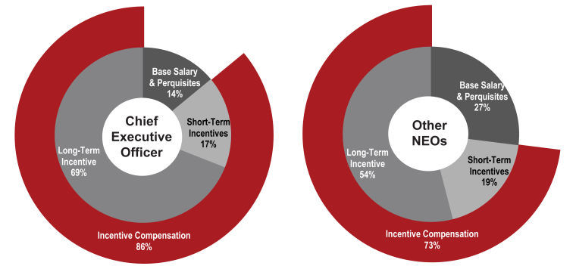

-37-

The Decision-Making Process

Role of the Compensation and Human Resources Committee

The Committee establishes and administers our executive compensation program, practices, and policies. The Committee receives input from management and its independent compensation consultant and considers competitive practices, our business objectives, stockholder interests, regulatory requirements, and other relevant factors to develop our executive compensation program in an effort to most effectively drive the achievement of the Company’s business objectives.

Role of Senior Management

The Committee obtains input from management and the Committee’s independent consultant when making NEO compensation decisions. The CEO makes recommendations to the Committee with respect to all elements of compensation for each NEO, excluding himself. The CEO’s recommendations on NEO pay are developed in consultation with the Chief Human Resources Officer and the Committee’s independent compensation consultant and are considered with market data. The Committee determines and approves the final compensation elements and amounts to be provided to the NEOs.

The Committee reviews and recommends proposed changes to CEO compensation to the independent members of the Board for approval. All independent members of the Board (rather than just the Committee) have responsibility for approving CEO compensation.

Role of the Independent Compensation Consultant

The Committee has the authority to engage and retain an independent compensation consultant to provide independent counsel and advice. At least annually, the Committee conducts an evaluation of the effectiveness of the independent compensation consultant and periodically conducts a request for proposal process to ensure the independent compensation consultant is meeting the Committee’s needs. For the first half of 2024, the Committee retained the services of Pearl Meyer. In July 2024, after a thorough review process, the Committee transitioned the Committee’s consulting services to Meridian Compensation Partners (“Meridian”).

At the Committee’s request, Pearl Meyer and Meridian performed the following services in 2024:

- provided and analyzed data for all elements of CEO compensation;

- reviewed and opined on our executive compensation philosophy;

- reviewed and opined on our Compensation Peer Group;

- provided and analyzed data for various elements of executive compensation;

- reviewed and opined on our executive and Board compensation programs, including NEO and Board target compensation;

- presented executive compensation trends and regulatory updates to the Committee; and

- provided input and perspective on various technical matters pertaining to executive compensation.

The Committee conducted an independence assessment of Meridian in accordance with SEC rules. Based on this review, we are not aware of any conflict of interest raised by the work performed by the consultant that would prevent Meridian from serving as independent consultants to the Committee. Meridian reported directly to the Committee and did not provide any additional services to the Company or its management.

Market Competitive Compensation

To maintain a market-competitive program, the Committee uses benchmarking data when establishing executive compensation. Benchmarking against a representative peer group assists the Committee in assessing the competitiveness of our executive compensation program.

-38-

For the purposes of setting 2024 compensation, our Company’s compensation peer group, as reviewed and approved by the Committee, included the following 15 companies (the “Compensation Peer Group”):

• A. O. Smith Corporation (AOS) |  | • | Hubbell Inc. (HUBB) | • Regal Rexnord Corporation (RRX)
• Acuity Brands, Inc. (AYI) |  | • | IDEX Corporation (IEX) | • Rockwell Automation, Inc. (ROK)
• | Dover Corporation (DOV) | • | Masco Corporation (MAS) | • | Snap-On Incorporated (SNA)
• | Flowserve Corporation (FLS) | • | Owens Corning (OC) | • The Timken Company (TKR)
• Fortune Brands Innovations, Inc. |  | • | Pentair, Inc. (PNR) | • | Xylem Inc. (XYL)
 | (FBIN)

The Committee selected the Compensation Peer Group using the following criteria:

- industry – building products, electrical components/equipment, and industrial machinery;

- revenues of approximately 0.5 to 2.0 times our revenues;

- business and product mix similar to ours; and

- international presence and operations.

In 2024, the Committee analyzed the Compensation Peer Group on the criteria above and made no adjustments. Lennox revenues are at the 53rd percentile of the peer group and market capitalization is at the 77th percentile, as of December 31, 2024.
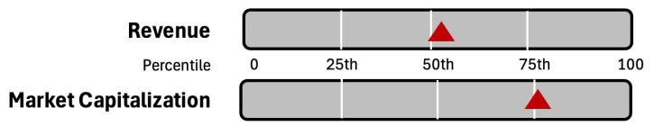

In addition to comparing our NEO compensation to the compensation of our Compensation Peer Group, the Committee also references published compensation data and other studies of compensation trends and market practices (these data and practices, including our Compensation Peer Group, are collectively referred to as the “Market”).

Beyond traditional Market analysis, the Committee also utilizes various other compensation analyses to assist with its decision-making process. Below are examples of information the Committee reviews and considers, as appropriate, when making compensation decisions:

- “all in” compensation summaries and pay histories for the CEO and other executive officers;

- CEO realized pay analysis;

- CEO pay versus performance analysis;

- dilution and share utilization analysis, projections, and benchmarking;

- equity compensation expense analysis;

- short-term and long-term incentive design, metrics, and award type; and

- short-term and long-term incentive plan performance results.

-39-

Components and Analysis of 2024 Executive Compensation

Base Salary

In establishing each NEO’s annual base salary, the Committee considered Market data, each individual’s experience and responsibilities, our annual merit budget for all employees, achievement of performance objectives, internal equity, and recommendations provided by the CEO for his direct reports.

The following table provides detail regarding base salaries for each NEO:

 | Base Salary as of | Increase Effective | Base Salary as of Base Salary Earned in
Name | January 1, 2024 | April 1, 2024 | April 1, 2024⁽¹⁾ | 2024
Alok Maskara | $1,075,000 | 7.0 % | $1,150,000 | $1,131,250
Michael P. Quenzer⁽²⁾ | 550,000 | — | 550,000 | 550,000
Gary S. Bedard | 560,000 | 3.6 % | 580,000 | 575,000
Daniel M. Sessa | 570,000 | 3.5 % | 590,000 | 585,000
John D. Torres | 550,000 | 3.6 % | 570,000 | 565,000

- Base salary remained the same at December 31, 2024 for all NEOs.

- Mr. Quenzer was promoted to the CFO role effective January 1, 2024, at which time he received a 57% base salary increase. He did not receive a further base salary increase in April 2024.

In setting NEO base salaries, the Committee uses the 50th percentile of the market as a guideline and may adjust the base salaries based on a number of factors, which may include merit increases, the executive’s unique job responsibilities, management experience, individual contributions, number of years in his or her position, and market position of current salary.

Short-Term Incentive Program

Our STI Program, as established under the Lennox International Inc. 2019 Equity and Incentive Compensation Plan, is an annual cash-based program for our NEOs designed to reward the successful performance of our Company, our business segments, and each individual NEO. In February 2024, the Committee approved financial metrics and performance goals required to be achieved for any payouts to be made under our STI Program. Under the STI Program, once the calculated STI amount is determined based on performance against the pre-approved goals, 25% of that amount may be modified up or down from 0% to 225% based on each NEO’s individual performance. However, the individual performance modifier may not increase the STI payout above 225% of the NEO’s STI target. The chart below illustrates how STI payouts are calculated for our NEOs:


Base Salary $ |  | STI Target % |  | Achieved Financial |  | = | STI Calculated
Base Salary $ | r | STI Target % | r | Performance Factor |  | =
 |  |  |  |  |  |  | Amount $
 |  |  |  | (0% - 225%)
NEO STI Target $ Amount
 |  |  |  |  |  |  | 25% of STI
 |  |  |  | 75% of STI |  | « | Calculated Amount |  | = | STI Payout $
 |  |  |  |  |  | « | subject to Individual |  | = | STI Payout $
 |  |  |  | Calculated Amount |  |  |  |  | = | STI Payout $
 |  |  |  |  |  |  | Performance Modifier
 |  |  |  |  |  |  | (0% - 225%)

Financial Performance. The following table summarizes the 2024 STI Program performance goals and payout opportunities, along with Company and business segment performance for each metric as approved by the Committee.

-40-

2024 Short-Term Incentive Program Summary – Financial Performance ($ in thousands)

Company NEOs⁽¹⁾ : Alok Maskara, Michael P. Quenzer, Daniel M. Sessa, John D. Torres
 |  | Payout Opportunity as a % of Target
 |  | 50% | 100% | 225%
Metric | Weight | Threshold | Target | Maximum | Performance
Company Core Net Income⁽²⁾ | 50% | $545,600 | $682,000 | $795,700 | $808,396
Company Free Cash Flow⁽³⁾ | 30% | 367,500 | 525,000 | 700,000 | 784,190
Company Core Revenue⁽⁴⁾ | 20% | 4,500,000 | 5,000,000 | 5,500,000 | 5,344,437
Segment NEO : Gary S. Bedard⁽¹⁾
 |  | Payout Opportunity as a % of Target
 |  | 50% | 100% | 225%
Metric | Weight | Threshold | Target | Maximum | Performance
HCS Segment Profit⁽⁵⁾ | 50% | $549,100 | $668,400 | $760,700 | $758,906
HCS Segment Controllable Cash Flow⁽⁶⁾ | 30% | 463,400 | 662,000 | 832,100 | 770,817
HCS Segment Revenue⁽⁷⁾ | 20% | 3,055,500 | 3,395,000 | 3,734,500 | 3,656,305

- Messrs. Maskara, Quenzer, Sessa, and Torres were measured 100% on overall Company financial performance, which resulted in a calculated award of 217% of target. As the President of our Home Comfort Solutions segment, Mr. Bedard’s award was measured 50% on Home Comfort Solutions financial performance and 50% on overall Company financial performance. Home Comfort Solutions financial performance resulted in a factor of 205% of target, which when blended with the Company’s factor of 217% of target, resulted in a calculated award of 211% of target for Mr. Bedard.

- Company core net income, a non-GAAP financial measure, is income from continuing operations, adjusted for loss on sale of previous dispositions.

- Company free cash flow, a non-GAAP financial measure, is net cash provided by operating activities less purchases of property, plant, and equipment plus proceeds from disposal of property, plant, and equipment, and adjusted for certain other items.

- Company core revenue, a non-GAAP financial measure, is net revenues for the Company, less net revenues from non-core businesses, and adjusted for certain other items.

- HCS segment profit, a non-GAAP financial measure, is earnings from continuing operations for the applicable segment, before interest expense, other expenses, and income taxes, adjusted for loss on sale of previous dispositions and certain other items, and adjusted to include Allied Air commercial results.

- HCS segment controllable cash flow, a non-GAAP financial measure, is HCS segment profit, defined above, less purchases of property, plant, and equipment plus proceeds from disposal of property, plant, and equipment, plus or minus changes in accounts receivable, inventory, accounts payable, and certain other items.

- HCS segment revenue, a non-GAAP financial measure, adjusted for certain other items, and adjusted to include Allied Air commercial results.

Goal Setting. The Board is focused on setting targets that align with investor expectations. For 2024:

- Company core net income goal at target was set up 6.4% from 2023 actual results.

- Company free cash flow goal at target was set up 7.5% from 2023 actual results.

- Company core revenue goal at target was set up 5.6% from 2023 actual results.

Performance goals at maximum payout are appropriately stretched to help ensure stockholder alignment. Record Company performance in 2024 resulted in STI payout of 217% of target (for NEOs whose opportunity was based 100% on Company-wide performance goals) and total shareholder return of 37%.

Individual Performance. Once the calculated STI amount is determined based on performance against the pre-approved earnings, cash flow, and revenue goals, 25% of that amount may be modified up or down from 0% to 225% based on each NEO’s individual performance. When determining whether to modify an NEO’s calculated STI amount, the Committee considered each NEO’s performance against specific financial, operational, and strategic objectives, as well as each NEO’s contribution to our sustainability goals. The Company’s sustainability goals include reducing

-41-

the environmental impact of our products and operations, reducing the number of safety incidents in our operations, and enhancing the inclusiveness of our workforce. The CEO reviewed with the Committee the individual performance of each NEO (other than himself). Based on exceptional performance during the year and the resulting payout above target, the Committee did not modify the STI payouts for any of the NEOs.

Targets and Payouts. Under the STI Program, target payout opportunities are determined as a percentage of base salary earned during the year. The target payout opportunities are based on market data using the 50th percentile as a guideline. Each NEO’s target percentage fits within this guideline and was unchanged for 2024.

Based on analysis of the market data and internal equity considerations, the Committee (or with respect to the CEO, the independent Board members) set the following STI targets for 2024. Based on financial and individual performance, the Committee (or with respect to the CEO, the independent Board members) approved the following 2024 payouts for each NEO:

2024 Short-Term Incentive Targets and Payouts

 | 2024 STI Target |  |  | 2024 STI Payout
Name | % of Base Salary | $ |  | % of Target | $
Alok Maskara | 120 % | $1,357,500 | 217 % |  | $2,948,762
Michael P. Quenzer | 75 % | 412,500 | 217 % |  | 896,033
Gary S. Bedard | 75 % | 431,250 | 211 % |  | 909,334
Daniel M. Sessa | 75 % | 438,750 | 217 % |  | 953,053
John D. Torres | 75 % | 423,750 | 217 % |  | 920,470

The short-term incentive payments made to the NEOs for 2024, which were approved by the Committee on February 28, 2025, and paid on March 14, 2025, are included in the 2024 Summary Compensation Table under “Non-Equity Incentive Plan Compensation.”

Long-Term Incentive Program

The LTI Program is designed to incentivize those employees who have principal responsibility for our long-term profitability. We believe participation in our LTI Program aligns the interests of our NEOs with the interests of our stockholders.

We use a mix of PSUs, RSUs, and stock appreciation rights (“SARs”) in our LTI Program. PSUs and SARs reward performance, as

measured by achievement of specified financial objectives for PSUs and stock price growth for SARs. RSUs help us retain key members of management through time-based vesting. The Committee allocated the mix of elements in our LTI Program in a manner designed to drive Company performance, retain key talent, and provide competitive compensation.

The annual Lennox long-term incentive award allocations for our NEOs are as follows:
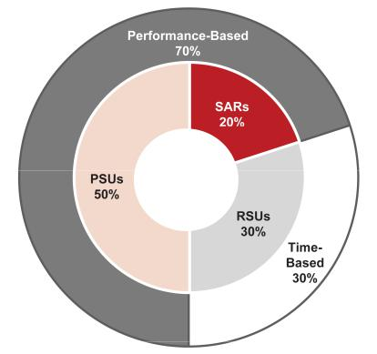

-42-

The Committee determines the grant date for all long-term incentive awards, which is three trading days following the fourth quarter earnings release. The Committee sets the exercise price of our SARs at 100% of fair market value, which is defined as the average of the high and low NYSE trading prices of our common stock on the date of grant.

The target award values under our LTI Program are based on Market data for similar positions using the 50th percentile as a guideline. The number of shares available for grant under the 2019 Equity and Incentive Compensation Plan is also considered. The Committee established the target award values at or near the 50th percentile of the Market for all NEOs. When determining the award for each NEO, the Committee and independent Board members considered the NEO’s time in position, individual performance and potential, impact on the financial performance of the Company, and internal equity.

Once the Committee determined the target long-term incentive award values for each NEO for the grants, 50% of the value was provided as PSUs, 30% as RSUs, and 20% as SARs.

The following table summarizes the target award values and number of awards granted for each NEO:

 | Target Award Value for February 2024 Awards |  |  |  |  | Number of Awards Granted in February 2024
Name | PSUs | RSUs | SARs | Total |  | PSUs⁽¹⁾ | RSUs⁽¹⁾ | SARs⁽²⁾ | Total
Alok Maskara | $2,850,000 | $1,710,000 | $1,140,000 | $5,700,000 |  | 6,482 | 3,889 | 8,360 | 18,731
Michael P. Quenzer | 500,000 | 300,000 | 200,000 | 1,000,000 |  | 1,137 | 682 | 1,467 | 3,286
Gary S. Bedard | 650,000 | 390,000 | 260,000 | 1,300,000 |  | 1,478 | 887 | 1,907 | 4,272
Daniel M. Sessa | 600,000 | 360,000 | 240,000 | 1,200,000 |  | 1,365 | 819 | 1,760 | 3,944
John D. Torres | 600,000 | 360,000 | 240,000 | 1,200,000 |  | 1,365 | 819 | 1,760 | 3,944

- The number of PSUs and RSUs was determined by dividing the corresponding target award value by the closing price of our common stock on the NYSE averaged over the 15 calendar days ending on February 1, 2024 ($439.649).

- The number of SARs granted was determined by dividing the corresponding target award value by the Black-Scholes value of our common stock based on the 15 calendar day average closing price of our common stock as of February 1, 2024 ($136.370).

PSUs. To maintain our strong focus on long-term Company performance, 50% of the February 2024 long-term incentive award was granted in the form of PSUs. PSUs generally vest at the end of a three-year performance period. If at least the threshold performance level has been achieved at the end of the performance period, the PSUs are distributed in the form of Company common stock based on the performance achieved. If threshold performance is not achieved, the entire award is forfeited. Dividends are not earned or paid on PSU awards during the three-year performance period. The Committee determines the three-year measurement criteria annually, selecting financial metrics and setting performance goals designed to enhance stockholder value. The Committee certifies the financial performance levels following the end of the performance period and the Company distributes any earned shares.

The key attributes of the PSUs granted in February 2024 are summarized in the following table. The Committee established the Return on Invested Capital (“ROIC”) performance goals based on its assessment of desired return relative to the cost of capital as well as historical and projected ROIC outcomes. Similarly, the Committee set Company core net income growth performance goals based on historical results, projected outcomes of that measure, and expected market conditions. While specific forward-looking performance goals are not included in the table below in light of competitive sensitivities, the following chart broadly describes the performance required to achieve a target payout.

-43-

February 2024 PSU Grant

(for the January 1, 2024 – December 31, 2026 Performance Period)

Metric | Weight | Rationale for Selection | Measurement Period | Threshold | Target | Maximum
ROIC | 50% | Measures efficient use of capital: | 3-year weighted average (20% | No payout occurs unless ROIC exceeds the
 |  | higher ROIC correlates to greater | lowest year, 40% other two | Company’s estimated cost of capital. Target payout
 |  | cash flow | years) | occurs at approximately three times the Company’s
 |  |  |  | estimated cost of capital
Company Core Net Income⁽¹⁾ | 50% | Measures profitability: higher | 3-year compound annual | Target payout requires high single digit Company
 |  | Company core net income | growth rate | core net income compound annual growth rate
 |  | correlates with higher earnings per
 |  | share
Payout as a % of Target Award |  |  |  | 50% | 100% | 200%

- Company core net income, a non-GAAP financial measure, is income from continuing operations, adjusted for restructuring charges, certain legal charges and contingency adjustments, unrealized gains and losses on unsettled futures contracts, impairments on assets held for sale, gain on sale of businesses, non-core business results, and certain other items.

The PSUs granted in 2024 are included in the 2024 Grants of Plan Based Awards table in the “Estimated Future Payouts Under Equity Incentive Plan Awards” columns.

December 2021 PSU Grant. The key attributes of the PSUs granted in December 2021, which vested on December 31, 2024, are summarized in the following table along with the financial performance goals and payout opportunities versus performance. In 2024, NEOs earned a payout of 200% of target for the PSUs granted in December 2021. The payout value is reflected in the 2024 Option Exercises and Stock Vested Table in the “Stock Awards - Value Realized on Vesting” column.

December 2021 PSU Grant

(for the January 1, 2022 – December 31, 2024 Performance Period)

Metric | Weight | Measurement Period | Threshold | Target | Maximum | Performance
ROIC(1) | 50% | 3-year weighted average (20% lowest year, | 20% | 30% | 40% | 48.4 %
 |  | 40% other two years)
Company Core Net Income(2) | 50% | 3-year compound annual growth rate | 6% | 12% | 20% | 20.1 %
Payout as a % of Target Award |  |  | 50% | 100% | 200% | 200.0 %

- Net operating profit after tax, a component of ROIC and a non-GAAP financial measure used for incentive compensation purposes, is income from continuing operations, adjusted for restructuring charges, impairments on assets held for sale, gain on sale of businesses, non-core business results, certain legal charges and contingency adjustments, unrealized gains and losses on unsettled futures contracts, pension settlement charges, and certain other items.

- Company core net income, a non-GAAP financial measure, is income from continuing operations, adjusted for restructuring charges, certain legal charges and contingency adjustments, unrealized gains and losses on unsettled futures contracts, impairments on assets held for sale, gain on sale of businesses, non-core business results, and certain other items.

RSUs. To support our leadership retention objectives, 30% of the February 2024 LTI award was granted in the form of RSUs. RSUs generally vest and are distributed in shares of Company common stock three years following the date of grant if the recipient remains an employee of the Company and all other conditions of the award are met. Dividends are not earned or paid on RSUs during the three-year vesting period. The number of shares granted to our NEOs in 2024 is included in the 2024 Grants of Plan-Based Awards Table in the “All Other Stock Awards: Number of Shares of Stock or Units” column.

SARs. To incentivize NEOs to grow our business and deliver increased returns to our stockholders, 20% of the February 2024 LTI award was granted in the form of SARs. SARs vest in one-third increments on each anniversary of the date of grant. Upon the exercise of vested SARs, the increase between the fair market value of our common stock on the date of grant and the fair market value on the date of the SAR exercise is paid in Company common stock. The grant date fair value and the SAR exercise price are determined on the date of grant. SARs granted in February 2024 expire seven years from the date of grant. The number of SARs granted to our NEOs in 2024 is included in the 2024 Grants of Plan-Based Awards Table in the “All Other Option Awards: Number of Securities Underlying Options” column.

-44-

Other Compensation Practices, Policies and Programs

Stock Ownership Guidelines

The Company has stock ownership guidelines for the CEO and other NEOs. We believe stock ownership by executives aligns the interests of executives with the interests of our stockholders and motivates executives to build long-term stockholder value.

The following chart sets forth, as of December 31, 2024, for each NEO, the stock ownership requirements as a multiple of base salary, the total number of shares and unvested RSUs counted toward the stock ownership requirements, and the value of the shares and unvested RSUs as a multiple of base salary. NEOs must retain their net shares until they have met their ownership requirements. All NEOs who were serving as executive officers as of December 31, 2024, met the stock ownership guidelines as of such date, except for Mr. Quenzer who first became subject to these guidelines in 2024. NEOs are given five years from the date of appointment as an NEO to meet the guidelines.

 | Ownership |  | Stock Ownership as
 | Requirement as a Total Number of Shares |  | Multiple of Base
Name | Multiple of Base Salary | and Unvested RSUs | Salary(1)
Alok Maskara | 6X | 12,861 | 6.0X
Michael P. Quenzer | 3X | 2,460 | 2.4X
Gary S. Bedard | 3X | 19,600 | 18.1X
Daniel M. Sessa | 3X | 31,634 | 28.8X
John D. Torres | 3X | 4,269 | 4.0X

(1) Based on the average daily closing price for 2024 of $536.86.

The Committee oversees and administers the stock ownership guidelines. If an NEO fails to comply with the guidelines, the Committee will determine any appropriate corrective measures to be taken.

Clawback Policy

Under this policy, in the event of a restatement of our Company’s financial results, the Company will recover certain excess incentive compensation paid to executive officers and resulting from attainment of a financial reporting measure during the three completed fiscal years prior to the date the restatement is required. A copy of the policy is available on our website at www.investor.lennox.com.

Prohibition on Hedging / Pledging Policy

The Company’s Insider Trading Policy prohibits directors, NEOs, all other employees, and each of their designees from trading in any interest, security, or position relating to the future price of Company securities, such as a put, call, swap, short sale, hedge, or any other type of derivative security. It also prohibits directors, NEOs, and all other employees from holding Company securities in a margin account or pledging Company securities as collateral for a loan.

Benefit Programs

To attract top executive talent and as a market-competitive practice, we provide certain benefit programs to our NEOs that are in addition to those provided to our other employees. The following table summarizes the additional benefit programs in place during 2024 and the purpose of each program.

Additional Benefit Programs Offered to NEOs in 2024

Plan | Type | Purpose
Supplemental Restoration | Non-Qualified Defined | Provide market-competitive retirement benefit by allowing contributions that could not otherwise
Retirement Plan | Contribution | occur because of limitations on compensation under federal tax rules

-45-

Plan | Type | Purpose
Life Insurance Plan | Company-Sponsored Life | Provide market-competitive life insurance benefits. $3 million in coverage for our CEO. NEO plan
 | Insurance | includes base salary plus most recent bonus paid with a minimum of $1 million
Supplemental Retirement Plan | Non-Qualified Defined | Closed legacy plan
 | Benefit

In 2018, the Committee closed the defined benefit Supplemental Retirement Plan to new participants and approved a defined contribution restoration plan for individuals who become eligible executive officers on or after January 1, 2019. The Committee made these changes to better align the Company’s non-qualified retirement benefit with current market practices. The CEO does not participate in the closed Supplemental Retirement Plan.

Annual Perquisites

We believe providing reasonable perquisites is a market-competitive practice to attract and retain top executive talent. Rather than offering individual perquisites, however, we provide a monthly cash stipend to each of our NEOs to allow more flexibility and choice. Our NEOs have full discretion on how the cash stipend is spent and it is not tracked by the Company after the money is paid. In addition, we offer the installation of Company products and equipment at each NEO’s home to promote our brand to business and personal guests. The value of the Company products, equipment, and related installation is included as taxable income to each NEO.

Employment Agreements

We have employment agreements with each NEO as reviewed and approved by the Committee. We believe employment agreements are helpful in attracting and retaining top executive talent and for financial and business planning purposes. Our employment agreements and the potential payments and benefits to which each NEO would be entitled in the event of termination of employment are discussed in the “Potential Payments Upon Termination or Change in Control” section.

Change in Control Severance Plan

We believe change-in-control (“CIC”) benefits are necessary to (1) retain key executives during periods of uncertainty; (2) enable executives to objectively evaluate, negotiate, and execute a CIC transaction; (3) encourage executives to remain focused on running the business rather than seeking other employment in the event of a possible CIC; (4) preserve stockholder value by providing continuity of management during a transition period; and (5) provide benefit to the Company in the form of restrictive covenants, such as non-compete and non-solicitation provisions.

In December 2022, the Company and its NEOs terminated each NEO’s existing CIC agreement and the Company adopted a CIC Severance Plan (as summarized below), which included the following changes to better align with market practices:

- Replaced single-trigger equity vesting with double-trigger equity vesting;

- Eliminated excise tax gross-ups;

- Reduced cash severance for NEOs (other than the CEO) from three times base pay and target bonus to two times base pay and target bonus;

- Eliminated 15% of base salary payment in lieu of outplacement services, and replaced it with actual outplacement services;

- Eliminated 45% of base salary payment in lieu of perquisites;

- Eliminated incremental age and years of service benefit under Supplemental Retirement Plan; and

- Reduced NEO (other than the CEO) health care coverage from 36 months to 24 months.

Our CIC Severance Plan and the potential payments and benefits to which each NEO would be entitled in the event of a CIC are discussed in the “Potential Payments Upon Termination or Change-in-Control” section in the Summary Compensation Table.

-46-

Equity Grant Practices

The Committee or, with respect to the CEO’s equity award, the Board, approves the monetary value of the equity compensation to be awarded to executive officers annually at their regularly-scheduled December meetings. The equity grant occurs on the third trading day after the Company issues its fourth quarter earnings release in January. The values approved in December are converted into shares, using the average daily closing price over fifteen calendar days prior to grant, with the fifteenth day being the first trading day after the Company’s fourth quarter earnings release. The SAR exercise price is equal to the average of the high and low NYSE trading prices of the common shares on the date of grant.

The Committee does not take material nonpublic information into account when determining the timing and terms of LTI equity awards. Instead, the timing of grants is in accordance with the yearly compensation cycle, with awards granted at the start of the new fiscal year to incentivize the executives to deliver on the Company’s strategic objectives for the new fiscal year. The Company has not timed the disclosure of material nonpublic information to affect the value of executive compensation.

The Company did not grant any SARs to NEOs of the Company in the last completed fiscal year during the period from four business days before to one business day after the filing of any of the Company’s Quarterly Reports on Form 10-Q, Annual Report on Form 10-K, or the filing or furnishing of any Current Report on Form 8-K that discloses material nonpublic information.

Tax and Accounting Implications

Deductibility of Executive Compensation

Section 162(m) generally disallows a federal income tax deduction to publicly traded companies like Lennox for compensation in excess of $1 million per year paid to certain current and former executive officers. The Committee will continue to consider the income tax consequences to our Company when analyzing our executive compensation program. If granting awards or providing other executive compensation is consistent with Market data, our compensation philosophy or our strategic business goals, the Committee may provide executive compensation that is not fully deductible.

Non-Qualified Deferred Compensation

In addition to the closed non-qualified Supplemental Retirement Plan, the Company also maintains a frozen non-qualified Profit Sharing Restoration Plan.

Accounting for Stock-Based Awards

When developing NEO compensation, the Committee considers the accounting consequences (in accordance with the requirements of FASB ASC Topic 718) of the program design and award levels and structures the Company’s executive compensation program accordingly.

Compensation Risk

Annual Compensation Risk Assessment

The Board reviews the Company’s compensation policies and practices to determine if risks arising from those policies and practices are reasonably likely to have a material adverse effect on the Company. All of the Company’s material incentive compensation plans are reviewed at least annually. Based on these reviews, the Board has not identified any risks arising from the compensation policies and practices that are reasonably likely to have a material adverse effect on the Company.

Compensation Committee Report

The Compensation and Human Resources Committee has reviewed and discussed the foregoing CD&A with management. Based on this review and discussion, the Committee recommended to the Board that the CD&A be included in this Proxy Statement and incorporated by reference in our Form 10-K.

Submitted by the Compensation and Human Resources Committee of the Board:

Shane D. Wall (Chair)

John W. Norris, III

Soma Somasundaram

Gregory T. Swienton

March 20, 2025

-47-

2024 Summary Compensation Table

The following table provides information regarding the total compensation of each of the Company’s NEOs for the years ended December 31, 2024, 2023, and 2022, as applicable.

 |  |  |  |  |  |  | Change in Pension
 |  |  |  |  |  |  | Value and
 |  |  |  |  |  |  | Nonqualified
 |  |  |  |  |  |  | Deferred
 |  |  |  | Stock | Option | Non-Equity | Compensation | All Other
Name and |  | Salary |  | Awards | Awards | Incentive Plan | Earnings | All Other | Total
Name and | Year | Salary | Bonus ($) |  |  |  |  | Compensation ($) | Total
Principal Position | Year | ($) | Bonus ($) | ($)(1) | ($)(2) | Compensation ($) | _{($)}(3) | (4) | ($)
Alok Maskara | 2024 | 1,131,250 | — | 4,429,662 | 1,125,423 | 2,948,762 | — | 272,814 | 9,907,911
President and Chief Executive Officer | 2023 | 1,064,750 | — | — | — | 2,729,934 | — | 1,188,979 | 4,983,663
President and Chief Executive Officer | 2022 | 667,792 | 1,000,000 | 6,708,818 | 971,133 | 472,476 | — | 277,560 | 10,097,779
Michael P. Quenzer | 2024 | 550,000 | — | 776,931 | 197,488 | 896,033 | — | 83,876 | 2,504,328
Executive Vice President, Chief
Financial Officer
Gary S. Bedard | 2024 | 575,000 | — | 1,010,138 | 256,720 | 909,334 | 592,821 | 55,700 | 3,399,713
Executive Vice President and | 2023 | 548,750 | — | — | — | 680,724 | 470,174 | 54,847 | 1,754,495
President, Home Comfort Solutions | 2022 | 511,250 | — | 920,008 | 233,054 | 525,003 | 348,349 | 48,511 | 2,586,175
Daniel M. Sessa | 2024 | 585,000 | — | 932,830 | 236,931 | 953,053 | 867,150 | 50,768 | 3,625,732
Executive Vice President, Chief Human | 2023 | 566,250 | — | — | — | 907,387 | 253,146 | 49,800 | 1,776,583
Resources Officer | 2022 | 551,250 | — | 881,746 | 223,373 | 304,703 | — | 48,324 | 2,009,396
John D. Torres | 2024 | 565,000 | — | 932,830 | 236,931 | 920,470 | 404,199 | 66,982 | 3,126,412
Former Executive Vice President, Chief | 2023 | 547,500 | — | — | — | 877,341 | 273,516 | 49,800 | 1,748,157
Legal Officer and Corporate Secretary | 2022 | 536,250 | — | 843,238 | 213,627 | 237,130 | — | 48,418 | 1,878,663

- The amounts shown represent the grant date fair value of the aggregate amount of all stock awards for each year, in accordance with FASB ASC Topic 718, in connection with RSUs and PSUs granted under the 2019 Equity and Incentive Compensation Plan. Assumptions used in calculating these amounts are described in Note 15 of the Consolidated Financial Statements for the fiscal year ended December 31, 2024, included in our Form 10-K. Amounts for 2024 PSUs reflect the probable outcome for the awards on the grant date, valued at the date of grant in accordance with FASB ASC Topic 718. If the PSUs were valued at maximum performance levels, the total PSU value at grant would be as follows:

 | PSU Value at Maximum Performance Levels ($)
Name | 2022 | 2023 | 2024
Alok Maskara | 8,591,414 | n/a | 5,537,184
Michael P. Quenzer | — | — | 971,271
Gary S. Bedard | 1,149,826 | n/a | 1,262,567
Daniel M. Sessa | 1,102,243 | n/a | 1,166,038
John D. Torres | 1,054,170 | n/a | 1,166,038

- The amounts shown represent the grant date fair value of the aggregate amount of all SAR awards for each year, in accordance with FASB ASC Topic 718, in connection with SARs granted under the 2019 Equity and Incentive Compensation Plan. Assumptions used in calculating these amounts are included in Note 15 of the Consolidated Financial Statements for the fiscal year ended December 31, 2024, included in our Form 10-K.

- The amounts shown represent the aggregate change in the actuarial present value of accumulated pension benefits that accrued during the applicable year under our closed defined benefit Supplemental Retirement Plan and frozen Consolidated Pension Plan, each as discussed under “Retirement Plans,” as a result of changes in the valuation discount rate, changes in compensation, and an additional one year of service, as applicable. Mr. Maskara and Mr. Quenzer do not participate in the Supplemental Retirement Plan or Consolidated Pension Plan. No above-market interest on nonqualified deferred compensation was earned.

-48-

- The amounts shown include perquisites and other compensation. The following table identifies the amounts attributable to each category of perquisites and other compensation in 2024 for each NEO.

 |  |  |  | Perquisites |  |  |  |  |  | Other Compensation
 |  |  |  | Company |  |  |  |  |  | Term Life
 |  |  |  | Equipment and Matching Charitable |  |  |  |  |  | Insurance |  | Retirement
Name | Cash Stipend |  |  | Installation | Contributions |  | Other |  |  | Premium |  | Contributions |  | Total
Alok Maskara | $ | 30,000 | $ | — $ | 10,002 | $ | — $ |  |  | 1,141 | $ | 231,671 | $ | 272,814
Michael P. Quenzer |  | 30,000 |  | — | 300 |  | — |  |  | 385 |  | 53,191 |  | 83,876
Gary S. Bedard |  | 30,000 |  | — | 5,000 |  | — |  |  | — |  | 20,700 |  | 55,700
Daniel M. Sessa |  | 30,000 |  | — | — |  | — |  |  | 68 |  | 20,700 |  | 50,768
John D. Torres |  | 30,000 |  | 14,582 | — |  | 1,619 |  |  | 81 |  | 20,700 |  | 66,982

The values attributable to each item listed above are calculated as follows:

- Cash Stipend — Cash paid to each NEO in lieu of individual perquisites.

- Company Equipment and Installation — Company equipment is based on the purchase price of the equipment, adjusted in accordance with our employee rebate program. Installation of this equipment is based on the cost for installation paid by the Company in 2024.

- Matching Charitable Contributions — Represents matching charitable contributions paid by the company in 2024. The LII Lennox Charitable Foundation matches charitable contributions for full-time employees on a one-for-one basis up to an annual cap ($5,000 in 2024). Additionally, in certain circumstances, such as large-scale natural disasters, Lennox may run special campaigns for disaster-relief efforts resulting in additional charitable matches.

- Other — For Mr. Torres, represents Company-provided gifts.

- Term Life Insurance Premiums — The amounts shown are based on the incremental cost paid in 2024 on behalf of each NEO for Basic Life and Basic Accidental Death and Dismemberment over and above the premiums we would otherwise pay under our life insurance program for other employees.

- Retirement Contributions — Mr. Maskara received $210,971 and Mr. Quenzer received $32,491 in company contributions made under our nonqualified defined contribution Supplemental Restoration Plan. This nonqualified plan provides market-competitive retirement benefits by providing contributions that could not otherwise occur due to compensation limits under the Code for qualified 401(k) plans. All NEOs received $20,700 in Company contributions made under our qualified 401(k) Plan.

-49-

2024 Grants of Plan-Based Awards

The following table provides information regarding short-term incentive awards and long-term incentive awards (PSUs, RSUs, and SARs) granted under the 2019 Equity and Incentive Compensation Plan to our NEOs in 2024.

 |  |  |  |  |  |  |  |  |  | All Other
 |  |  |  |  |  |  | Estimated Future |  |  | Stock | All Other
 |  |  |  |  |  |  |  |  |  | Awards: | Option Awards: |  | Closing | Grant Date
 |  |  | Estimated Possible Payouts |  |  |  | Payouts Under Equity Incentive |  |  | Awards: | Option Awards: |  | Closing | Grant Date
 |  |  |  |  |  |  |  |  |  | Number of | Number of | Exercise or | Market | Fair Value of
 |  |  | Under Non-Equity |  |  |  |  | Plan
 |  |  |  |  |  |  |  | Plan |  | Shares of | Securities Base Price of |  | Price on | Stock and
 |  |  | Incentive Plan Awards⁽¹⁾ |  |  |  | Awards⁽²⁾
 |  | Board |  |  |  |  |  |  |  | Stock or | Underlying | Option | Date of | Option
 |  | Approval |  | Target | Max. |  |  | Target | Max. | Units | Options | Awards | Grant | Awards
Name | Grant Date | Date | Threshold ($) | ($) | ($) |  | Threshold (#) | (#) | (#) | _{(#)}(3) | (#)⁽⁴⁾ | ($/Sh)⁽⁵⁾ | ($/Sh) | ($)⁽⁶⁾
Alok | — | — | 678,750 | 1,357,500 | 3,054,375
Maskara
 | 2/5/2024 | 12/8/2023 |  |  |  | 3,241 |  | 6,482 | 12,964 |  |  |  |  | 2,768,592
 | 2/5/2024 | 12/8/2023 |  |  |  |  |  |  |  | 3,889 |  |  |  | 1,661,070
 | 2/5/2024 | 12/8/2023 |  |  |  |  |  |  |  |  | 8,360 | 418.69 | 422.70 | 1,125,423
Michael P. | — | — | 206,250 | 412,500 | 928,125
Quenzer
 | 2/5/2024 | 12/7/2023 |  |  |  | 569 |  | 1,137 | 2,274 |  |  |  |  | 485,635
 | 2/5/2024 | 12/7/2023 |  |  |  |  |  |  |  | 682 |  |  |  | 291,296
 | 2/5/2024 | 12/7/2023 |  |  |  |  |  |  |  |  | 1,467 | 418.69 | 422.70 | 197,488
Gary S. | — | — | 215,625 | 431,250 | 970,313
Bedard
 | 2/5/2024 | 12/7/2023 |  |  |  | 739 |  | 1,478 | 2,956 |  |  |  |  | 631,283
 | 2/5/2024 | 12/7/2023 |  |  |  |  |  |  |  | 887 |  |  |  | 378,855
 | 2/5/2024 | 12/7/2023 |  |  |  |  |  |  |  |  | 1,907 | 418.69 | 422.70 | 256,720
Daniel M. | — | — | 219,375 | 438,750 | 987,188
Sessa
 | 2/5/2024 | 12/7/2023 |  |  |  | 683 |  | 1,365 | 2,730 |  |  |  |  | 583,019
 | 2/5/2024 | 12/7/2023 |  |  |  |  |  |  |  | 819 |  |  |  | 349,811
 | 2/5/2024 | 12/7/2023 |  |  |  |  |  |  |  |  | 1,760 | 418.69 | 422.70 | 236,931
John D. | — | — | 211,875 | 423,750 | 953,438
Torres
 | 2/5/2024 | 12/7/2023 |  |  |  | 683 |  | 1,365 | 2,730 |  |  |  |  | 583,019
 | 2/5/2024 | 12/7/2023 |  |  |  |  |  |  |  | 819 |  |  |  | 349,811
 | 2/5/2024 | 12/7/2023 |  |  |  |  |  |  |  |  | 1,760 | 418.69 | 422.70 | 236,931

- The amounts shown represent award opportunities under our STI Program for 2024. The awards were paid March 14, 2025, in the amounts included in the 2024 Summary Compensation Table.

- The amounts shown represent the PSUs granted, which to the extent earned, will vest and be distributed in shares of our common stock at the end of the three-year performance period ending December 31, 2026.

- The amounts shown represent the RSUs granted, which generally vest and will be distributed in shares of our common stock on the third anniversary of the date of grant.

- The amounts shown represent the SARs granted, which generally vest in one-third increments on each of the first three anniversaries of the date of grant and expire seven years from the date of grant.

- The amounts shown reflect the exercise price of SARs granted, based on the average of the high and low NYSE trading prices of our common stock on the date of grant.

-50-

- The amounts shown represent the grant date fair values of PSUs, RSUs and SARs, calculated in accordance with FASB ASC Topic 718. The grant date fair value for SARs was determined using the Black-Scholes valuation model. The grant date fair value for the PSU and RSU awards equals the dividend-discounted value of our common stock on the date of grant. The assumptions used to calculate the grant date fair values of such awards are set forth below.

 |  |  | Assumptions
 |  |  |  |  |  | FMV Based on | Grant Date
 |  |  |  |  | Risk Free | Average High/ | Grant Date
 |  |  |  |  | Risk Free | Low NYSE Trading | Fair Value
 |  | Volatility | Expected Life | Dividend Yield | Interest Rate | Prices on Date of | Per Share
Grant Date | Award | (%) | (Years) | (%) | (%) | Grant ($) | ($)
2/5/2024 | PSU | — | — | 1.23 | — | 418.69 | 427.12
2/5/2024 | RSU | — | — | 1.23 | — | 418.69 | 427.12
2/5/2024 | SAR | 34.89 | 4.18 | 1.23 | 4.05 | 418.69 | 134.62

-51-

Outstanding Equity Awards at 2024 Fiscal Year-End

The following table provides information regarding all outstanding equity awards held by our NEOs as of December 31, 2024.


 |  |  | Options/SAR Awards⁽¹⁾
 |  |  | Number of
 |  | Number of | Securities
 |  | Securities | Underlying
 |  | Underlying | Unexercised
 | Grant Date | Unexercised | Options/ | Option/ SAR
 | for Options/ | Options/ SARs | SARs (#) | Exercise Price | Option/ SAR
Name | SARs | (#) Exercisable⁽¹⁾ | Unexercisable⁽¹⁾ | ($/Sh)⁽²⁾ | Expiration Date
Alok Maskara | 12/9/2022 | 10,031 | 5,016 | 259.56 | 12/9/2029
 | 2/5/2024 | — | 8,360 | 418.69 | 2/5/2031

Stock Awards

 |  | Equity Incentive | Equity Incentive
 |  | Plan | Plan
 |  | Awards: | Awards:
 |  | Number of | Market or Payout
Number of | Market Value of | Unearned Shares, Value of Unearned
Shares or Units | Shares or Units of | Units or Other | Shares, Units or
of Stock That | Stock That Have | Rights That Have | Other Rights That
Have Not Vested | Not Vested | Not Vested | Have Not Vested
_{(#)}(3) | _{($)}(4) | _{(#)}(5) | _{($)}(4)
9,750 | 5,940,675 | 32,500 | 19,802,250

Michael P. Quenzer | 12/11/2020 | 635 |  | — | 278.00 | 12/11/2027 | 928 | 565,430 | 3,094 | 1,885,174
 | 12/10/2021 | 556 |  | — | 328.65 | 12/10/2028
 | 12/9/2022 | 421 |  | 211 | 259.56 | 12/9/2029
 | 2/5/2024 | — |  | 1,467 | 418.69 | 2/5/2031
Gary S. Bedard | 12/13/2019 | 4,335 |  | — | 257.08 | 12/13/2026 | 2,294 | 1,397,734 | 7,644 | 4,657,489
 | 12/11/2020 | 2,858 |  | — | 278.00 | 12/11/2027
 | 12/10/2021 | 2,642 |  | — | 328.65 | 12/10/2028
 | 12/9/2022 | 2,407 | 1,204 |  | 259.56 | 12/9/2029
 | 2/5/2024 | — | 1,907 |  | 418.69 | 2/5/2031
Daniel M. Sessa | 12/13/2019 | 5,058 |  | — | 257.08 | 12/13/2026 | 2,167 | 1,320,353 | 7,224 | 4,401,583
 | 12/11/2020 | 3,334 |  | — | 278.00 | 12/11/2027
 | 12/10/2021 | 3,059 |  | — | 328.65 | 12/10/2028
 | 12/9/2022 | 2,307 |  | 1,154 | 259.56 | 12/9/2029
 | 2/5/2024 | — |  | 1,760 | 418.69 | 2/5/2031
John D. Torres | 12/10/2021 | 1,020 |  | — | 328.65 | 12/10/2028 | 2,108 | 1,284,404 | 7,028 | 4,282,160
 | 12/9/2022 | 1,103 | 1,104 |  | 259.56 | 12/9/2029
 | 2/5/2024 | — | 1,760 |  | 418.69 | 2/5/2031

- Outstanding unvested SARs vest in one-third increments on each of the first three anniversaries of the date of grant, with the first anniversary date occurring one year after the date of grant.

- Pursuant to the 2019 Equity and Incentive Compensation Plan, the exercise price for all outstanding SARs is based on the grant date fair market value, which is the average of the high and low NYSE trading prices of our common stock on the date of grant.

- The amounts shown represent all outstanding RSUs held by the NEOs. Refer to column (a) of the table below for the vesting dates of such awards.

- The amounts shown are based on the NYSE closing price of our common stock on December 31, 2024 ($609.30).

-52-

- The amounts shown represent outstanding PSUs held by the NEOs. Refer to column (b) of the table below for the vesting dates of such awards and the performance assumptions used to calculate the number of unvested PSUs.

 | (a) |  |  |  |  | (b)
 | Shares or Units of Stock That Have Not |  |  |  | Equity Incentive Plan Awards: Unearned Shares, Units or
 | Vested |  |  |  | Other Rights That Have Not Vested
 |  |  |  |  |  |  | Performance
Name | Number of Awards |  | Vesting Date |  | Number of Awards | Vesting Date | Assumption
Alok Maskara | 5,861 |  | 12/9/2025 | 19,536 |  | 12/31/2025 | Max
 | 3,889 |  | 2/5/2027 | 12,964 |  | 12/31/2026 | Max
Total | 9,750 |  |  |  | 32,500
Michael P. Quenzer | 246 |  | 12/9/2025 | 820 |  | 12/31/2025 | Max
 | 682 |  | 2/5/2027 | 2,274 |  | 12/31/2026 | Max
Total
Total | 928 |  |  | 3,094
Gary S. Bedard | 1,407 |  | 12/9/2025 | 4,688 |  | 12/31/2025 | Max
 | 887 |  | 2/5/2027 | 2,956 |  | 12/31/2026 | Max
Total | 2,294 |  |  |  | 7,644
Daniel M. Sessa | 1,348 |  | 12/9/2025 | 4,494 |  | 12/31/2025 | Max
 | 819 |  | 2/5/2027 | 2,730 |  | 12/31/2026 | Max
Total
Total | 2,167 |  |  | 7,224
John D. Torres | 1,289 |  | 12/9/2025 | 4,298 |  | 12/31/2025 | Max
 | 819 |  | 2/5/2027 | 2,730 |  | 12/31/2026 | Max
Total | 2,108 |  |  |  | 7,028

-53-

2024 Option/SAR Exercises and Stock Vested

The following table provides information regarding the exercise of SARs by our NEOs and the vesting of RSUs and PSUs held by our NEOs for 2024.

 | Options/SAR Awards |  |  |  | Stock Awards
 | Number of SARs | Value Realized on |  |  | Number of Shares | Value Realized on
 | Exercised | Exercise |  |  | Acquired on Vesting | Vesting
Name | (#) | ($) |  |  | (#) | _{($)}(1)
Alok Maskara | — | — |  | RSU | 2,335 | 1,129,440
 |  |  |  | PSU | 18,676 | 10,640,464
Michael P. Quenzer | 1,841 | 707,481 |  | RSU | 192 | 122,817
 |  |  |  | PSU | 638 | 363,494
Gary S. Bedard | 3,132 | 1,126,690 |  | RSU | 910 | 582,100
 |  |  |  | PSU | 3,034 | 1,728,591
Daniel M. Sessa | 11,977 | 4,357,263 |  | RSU | 1,054 | 674,212
 |  |  |  | PSU | 3,514 | 2,002,066
John D. Torres | 6,476 | 1,944,446 |  | RSU | 1,054 | 674,212
 |  |  |  | PSU | 3,514 | 2,002,066

(1) The dollar amounts shown for RSUs and PSUs are based on the average of the high and low NYSE trading prices of our common stock on the day of distribution.

Retirement Plans

Qualified Retirement Plans

Frozen Consolidated Pension and Profit Sharing Retirement Plans

Effective January 1, 2009, the Company’s Consolidated Pension Plan and Profit Sharing Retirement Plan were frozen. As of that date, benefits under the frozen Consolidated Pension Plan stopped increasing with additional service and compensation, and additional contributions to the Profit Sharing Plan were discontinued.

The monthly target benefit under the frozen Consolidated Pension Plan is based on 1.0% of final average annual pay, plus 0.6% of final average annual pay above Social Security covered compensation, multiplied by the number of years of credited service (not to exceed 30 years). The target benefit is reduced by the value of the participant’s defined contribution profit sharing account under the frozen Profit Sharing Plan, with the difference, if any, provided by the frozen Consolidated Pension Plan. Participants vested in their frozen Consolidated Pension Plan accrued benefits after five years of service and may commence unreduced benefits at age 65 (normal retirement age) or actuarially reduced benefits at younger ages, if age and service requirements are met (generally the attainment of age 62 and 10 years of service or if age plus years of service total 80). Benefits are generally paid in the form of an annuity. We do not grant extra years of service under the frozen Consolidated Pension Plan. Participants in the frozen Profit Sharing Plan are fully vested after six years of service and the Company directs the investment funds. Distributions may occur at separation from service and are eligible for roll-over into another qualified retirement plan.

401(k) Salaried Retirement Plan

Salaried employees are eligible to participate in this plan, and contributions can be made on a pre-tax or Roth post-tax basis, subject to limitations for qualified plans under the Code. Participants can contribute up to 75% of their eligible earnings and receive a Company match of 50% on up to 6% of their eligible pay. In addition, all participants (after completing one year of service) receive a fully vested base contribution equal to 3% of eligible pay. The match vests after the participant completes two years of service.

-54-

Nonqualified Retirement Plans

Defined Contribution Supplemental Restoration Retirement Plan

New executive officers on or after January 1, 2019, are eligible for the Supplemental Restoration Retirement Plan, a nonqualified defined contribution plan that provides market-competitive retirement benefits by providing contributions that could not otherwise occur due to compensation limits under the Code. Participants receive 6% of eligible compensation, as defined under the qualified 401(k) Plan that exceeds compensation limits under the Code for the applicable year. Eligible employer contributions are immediately vested and pay out following termination. Contributions are invested, at the Participant’s election, in indices or broad-based funds similar to those in the Company’s qualified 401(k) plan.

Defined Benefit Supplemental Retirement Plan

In 2018, the Committee closed the defined benefit Supplemental Retirement Plan to new participants and approved the defined contribution Supplemental Restoration Retirement Plan for individuals who become eligible executive officers on or after January 1, 2019. The Committee made these changes to better align the Company’s nonqualified retirement benefit with current Market practices.

The purpose of our closed Supplemental Retirement Plan is to provide market-competitive executive level retirement benefit opportunities. It permits income above Code limitations to be considered in determining final average annual pay, doubles the rate of benefit accrual available under the frozen Consolidated Pension Plan (2.0% of final average annual pay, plus 1.2% of final average annual pay above Social Security covered compensation), limits credited service to 15 years, generally permits early retirement on more favorable terms than the frozen Consolidated Pension Plan (for example, unreduced benefits at age 62 with 10 years of service or unreduced benefits at age 60 if age plus years of service total 80), and pays benefits in the form of a lump-sum. Any benefits provided under the Supplemental Retirement Plan are reduced by the benefits payable under our Company’s frozen Consolidated Pension Plan (as if such plan had not been frozen), frozen Profit Sharing Plan, and frozen Profit Sharing Restoration Plan. Participants become vested in their Supplemental Retirement Plan benefit after five years of service.

Frozen Profit-Sharing Restoration Plan

The Company froze the Profit Sharing Restoration Plan and discontinued contributions effective January 1, 2009. Distributions may occur at separation from service and may be paid as a lump-sum or in equal annual installments over either a five- or ten-year period. We direct the investment funds for the frozen Profit Sharing Restoration Plan, which mirror the investments and returns under the frozen Profit Sharing Retirement Plan. The weighted average annual rate of return for the calendar year ended December 31, 2024, was 6.6%.

-55-

2024 Pension Benefits

The following table provides information regarding the number of years of service credited to each NEO, the present value of accumulated benefits payable to each NEO under our frozen Consolidated Pension Plan and our Supplemental Retirement Plan as of December 31, 2024, and payments made to each NEO in 2024 under such plans.

 |  |  | Present Value of
 |  | Number of Years | Accumulated | Payments During
Name | Plan Name | Credited Service | Benefit | Last Fiscal Year
Name | Plan Name | (#) | ($)⁽¹⁾ | ($)
Alok Maskara⁽²⁾ | Consolidated Pension Plan (Frozen) | N/A | N/A | —
 | Supplemental Retirement Plan (Closed) | N/A | N/A | —
Michael P. Quenzer⁽²⁾ | Consolidated Pension Plan (Frozen) | N/A | N/A | —
 | Supplemental Retirement Plan (Closed) | N/A | N/A | —
Gary S. Bedard | Consolidated Pension Plan (Frozen) | 10.5 | — | —
 | Supplemental Retirement Plan (Closed) | 7.3 | 1,583,491 | —
Daniel M. Sessa | Consolidated Pension Plan (Frozen) | 1.7 | 35,644 | —
 | Supplemental Retirement Plan (Closed) | 15.0 | 5,732,318 | —
John D. Torres⁽²⁾ | Consolidated Pension Plan (Frozen) | N/A | N/A | —
 | Supplemental Retirement Plan (Closed) | 15.0 | 5,429,385 | —

- The actuarial present value of the lump-sum accumulated benefit payable at December 31, 2024, is equal to the annualized present value factor, multiplied by the monthly benefit. The amounts shown are calculated in accordance with FASB ASC Topic 715, using a 5.15% interest (discount) rate for the Supplemental Retirement Plan and 5.79% for the Consolidated Pension Plan as of December 31, 2024, and the Pri-2012 healthy retiree mortality rates, with a white collar adjustment, with generational projections of mortality improvement using scale MP-2021. The calculations assume payments are deferred until age 65 for all participants under our frozen Consolidated Pension Plan and until the earliest unreduced retirement age for each participant under our Supplemental Retirement Plan. Additional assumptions are included in Note 10 of the Consolidated Financial Statements for the fiscal year ended December 31, 2024, included in our Form 10-K.

- Messrs. Maskara and Quenzer are not eligible to participate in the frozen Consolidated Pension Plan or the closed Supplemental Retirement Plan. Mr. Torres was not eligible to participate in the Consolidated Pension Plan prior to the plan being frozen.

-56-

2024 Nonqualified Deferred Compensation

The following table provides information regarding contributions, earnings, withdrawals, and distributions under our frozen Profit Sharing Restoration Plan and our Defined Contribution Supplemental Restoration Plan in 2024 for each NEO, as well as each NEO’s aggregate balance in such plan at December 31, 2024.

 |  | Executive | Company
 |  | Contributions in | Contributions in | Aggregate | Aggregate | Aggregate
Name | Plan Name | Last Year | Last Year | Earnings in Last | Withdrawals/ | Balance at Last
Name | Plan Name | ($) | ($)⁽¹⁾ | Year ($)⁽²⁾ | Distributions ($) | Year-End ($)
Alok Maskara⁽³⁾ | Profit Sharing Restoration Plan (Frozen) | N/A | N/A | N/A | N/A | N/A
 | Supplemental Restoration Retirement Plan | — | 210,971 | 41,714 | — | 358,123
Michael P. Quenzer⁽³⁾ | Profit Sharing Restoration Plan (Frozen) | N/A | N/A | N/A | N/A | N/A
 | Supplemental Restoration Retirement Plan | — | 32,491 | 857 | — | 33,348
Gary S. Bedard⁽³⁾⁽⁴⁾ | Profit Sharing Restoration Plan (Frozen) | N/A | N/A | N/A | N/A | N/A
 | Supplemental Restoration Retirement Plan | N/A | N/A | N/A | N/A | N/A
Daniel M. Sessa⁽⁴⁾ | Profit Sharing Restoration Plan (Frozen) | — | — | 1,722 | — | 27,983
 | Supplemental Restoration Retirement Plan | N/A | N/A | N/A | N/A | N/A
John D. Torres⁽³⁾⁽⁴⁾ | Profit Sharing Restoration Plan (Frozen) | N/A | N/A | N/A | N/A | N/A
 | Supplemental Restoration Retirement Plan | N/A | N/A | N/A | N/A | N/A

- Amounts listed in this column were reported as compensation for the last fiscal year in the “All Other Compensation” column of the 2024 Summary Compensation Table.

- No amounts listed in the Aggregate Earnings column were reported in the 2024 Summary Compensation Table.

- Messrs. Maskara, Quenzer, Bedard, and Torres were not eligible to participate in the Profit Sharing Restoration Plan prior to the plan being frozen in 2009.

- Messrs. Bedard, Sessa, and Torres are not eligible to participate in the Defined Contribution Supplemental Restoration Retirement Plan since they became executive officers before January 1, 2019.

-57-

Potential Payments Upon Termination or Change in Control Employment Agreements and Change in Control Severance Plan

The Company generally provides employment agreements to our NEOs. These agreements serve as the basis for the payments and benefits to which each NEO would be entitled in the event of termination of employment not connected to a CIC transaction with our Company. In the event of termination in connection with a CIC, payments to NEOs are subject to our change-in-control severance plan (the “CIC Severance Plan”).

Employment Agreements

The employment agreements with our NEOs establish the basis of compensation and responsibilities for each NEO and contain post-employment covenants, including non-competition of employment (for employments entered into after 2007) and non-solicitation of employees and customers for a period of 24 months following termination of employment. On January 1 of each year, the agreements automatically renew for an additional year, unless either party notifies the other in writing at least 30 days prior to such date of its decision not to renew the agreement. Except as otherwise provided below, the terms and conditions of our employment agreement with each NEO are substantially similar.

Change in Control Severance Plan

In 2022, the Company terminated all existing change-in-control agreements (“CIC Employment Agreements”) for its NEOs and adopted the CIC Severance Plan. As described below, severance benefits and equity vesting are both tied to “double trigger.” The CIC Severance Plan does not provide for any excise tax gross-ups.

Payments Made Upon Voluntary Termination or Upon For Cause Termination

If an NEO voluntarily terminates his employment with our Company or we terminate an NEO for cause, he will be entitled to receive base salary through the last day of employment and a lump-sum payment equal to unused, accrued vacation days. Unvested SARs, RSUs, and PSUs terminate on the NEO’s last day of employment. Vested SARs will be exercisable for 90 days after the last day of employment if the NEO voluntarily terminates his employment.

Payments Made Upon Retirement

If an NEO retires, he is entitled to receive his base salary through the last day of employment, a payment under our short-term incentive program based on company performance (prorated through the NEO’s last day of employment) and a lump-sum payment equal to unused, accrued vacation days. In addition, with respect to long-term incentive awards:

- unvested SARs terminate on the NEO’s last day of employment and vested SARs remain exercisable for the remainder of the term of the award;

- for RSUs, the NEO receives a prorated portion of shares based on the date of retirement at the end of the applicable vesting period; and

- for PSUs, the NEO receives, to the extent earned based on achievement of specific performance measures, a prorated portion of shares based on the date of retirement at the end of the applicable performance period.

NEOs are eligible for retirement treatment for their long-term incentive awards if (i) they are at least age 65; (ii) they are at least age 62 and have 10 years of service; or (iii) if age plus years of service total 80. At December 31, 2024, Messrs. Bedard and Torres were eligible for retirement treatment for their long-term incentive awards.

Payments Made Upon Involuntary or Not for Cause Termination

If we terminate an NEO prior to the expiration of his employment agreement (including non-renewal of the NEO’s agreement) for any reason other than for cause, the NEO is generally entitled to receive “normal severance compensation” or, in the NEO’s sole discretion, “enhanced severance benefits.” Under both severance packages:

- all vested SARs continue to be exercisable for 90 days following the NEO’s last day of employment; and

- unvested equity awards (SARs, RSUs, and PSUs) terminate on the NEO’s last day of employment.

Normal Severance Compensation. If the NEO elects to receive “normal severance compensation,” he will receive monthly payments equal to the greater of (1) his monthly base salary for the remainder of the employment

-58-

agreement’s term, or (2) three months of his monthly base salary in addition to any other compensation or benefits applicable to an employee at the NEO’s level, including a lump-sum payment equal to unused, accrued vacation days.

Enhanced Severance Benefits. If the NEO agrees to execute a written general release of any and all possible claims against us existing at the time of termination, we will provide the employee with “enhanced severance benefits.” Payments provided under this severance arrangement, which are dependent on years of service with our Company, generally include the following:

Component | Less than Three Years of Service | Three or More Years of Service
Base Salary | One year of base salary | Two years of base salary
Short-Term Incentive | Lump-sum payment equal to all payments under our STI | Lump-sum payment equal to all payments under our
 | programs received by the NEO in the previous 12 months | STI programs received by the NEO in the previous
 |  | 24 months
Payment in Lieu of Outplacement Services | Lump-sum payment equal to 10% of base salary | Same
Payment in Lieu of Perquisites | Lump-sum payment equal to 10% of base salary | Same
Post-Employment Health Care Coverage | Payment of COBRA premiums for up to 18 months while the | Same
 | NEO is unemployed and not eligible for other group health
 | coverage and payment of the equivalent of such premium for
 | up to an additional six months, should the NEO remain
 | unemployed
Death Benefit | If the NEO dies during the enhanced severance period, a | Same
 | lump-sum death benefit equal to six months of the NEO’s
 | base salary will be paid to the NEO’s beneficiary
Accrued Vacation | A lump-sum payment equal to unused, accrued vacation | Same
 | days

Payments Made Upon Death or Disability

Generally, if an NEO dies during the term of his employment agreement, the NEO’s beneficiary is entitled to receive “normal severance compensation,” as described above. If an NEO becomes permanently disabled during the agreement term, he will generally be entitled to, at the NEO’s option, either “normal severance compensation” or “enhanced severance benefits,” as described above. In the case of either death or disability, with respect to long-term incentive awards:

- all SARs vest immediately and remain exercisable for the duration of the term;

- for RSUs, the NEO, or his beneficiary, receives a prorated payment based upon the portion of the vesting period the NEO actually served as an employee payable at the time employment ceases; and

- for PSUs, the NEO, or his beneficiary, receives, to the extent earned based on achievement of performance measures, a prorated portion of shares based upon the portion of the performance period the NEO actually served as an employee, payable at the time employment ceases.

Payments Made to our CEO if he Terminates his Employment for “Good Reason,” Upon Involuntary — Not for Cause Termination, or Upon Death or Disability

Except as described below, Mr. Maskara receives similar severance benefits as the other NEOs. Mr. Maskara’s employment agreement provides for certain severance benefits in the event he terminates his employment for “good reason.” “Good reason” includes:

- any change in Mr. Maskara’s position, authority, duties, or responsibilities inconsistent with the position of CEO (excluding de minimis changes and an isolated, insubstantial, and inadvertent action not taken in bad faith and promptly remedied by the Company after notice);

- any failure by the Company to comply with any of the provisions of Mr. Maskara’s employment agreement (excluding an isolated, insubstantial, and inadvertent action not taken in bad faith and promptly remedied by the Company after notice);

-59-

- the relocation of the principal place of Mr. Maskara’s employment by more than thirty-five (35) miles from our current headquarters in Richardson, Texas; or

- any failure by our Board to nominate him for election by the stockholders as a director.

Pursuant to his employment agreement, in the event (1) Mr. Maskara terminates his employment for “good reason,” (2) we terminate his employment prior to the expiration of his employment agreement (including non-renewal of his agreement) for any reason other than for cause, or (3) Mr. Maskara becomes permanently disabled during the term of his employment agreement, he is entitled to receive “enhanced severance benefits” as described above under “Payments Made Upon Involuntary or Not For Cause Termination,” provided Mr. Maskara (or his personal representative, as applicable) agrees to execute a written general release of any and all possible claims against the Company existing at the time of termination.

Payments Made Upon a Change in Control

Definition of Change in Control

A CIC generally includes the occurrence of any of the following events, subject to certain exceptions:

- an acquisition by a third party of 35% or more of our voting stock;

- a change in a majority of Board members without majority Board approval;

- stockholder approval of the liquidation or dissolution of our Company;

- consummation of a merger, consolidation, or reorganization; or

- consummation of the sale of substantially all corporate assets.

Definition of Good Reason

“Good reason,” under the CIC Severance Plan, includes:

- any change in the NEO’s authorities, duties, or responsibilities (excluding de minimis changes);

- any reduction in the NEO’s base salary, target STI bonus, or annual LTI awards;

- a required relocation of more than 50 miles of the Company’s headquarters;

- any failure by any successor to adopt and comply with the CIC Severance Plan; or

- any failure to re-elect to the Board any NEO serving as a member of the Board.

Change in Control Benefits

If an NEO’s employment is terminated by the Company without cause or by the NEO for “good reason” either (1) within two years following a CIC, or (2) within six months prior to a CIC, we will provide the NEO with the following CIC benefits:

Component | CIC Benefit
Base Salary Severance | Lump-sum payment equal to three times the CEO’s annual base salary, and two times annual base salary for
 | other NEOs.
Prorated Bonus | Lump-sum payment equal to the NEO’s target bonus, prorated based on the last day of employment.
Bonus Severance | Lump-sum payment equal to three times the CEO’s target bonus, and two times target bonus for other
 | NEOs.
Payment in Lieu of Outplacement Services | Payment for actual cost of outplacement services.
Post-Employment Health Care Coverage | Payment of COBRA premiums for up to 36 months for the CEO and 24 months for other NEOs while the
 | NEO is unemployed and not eligible for other group health coverage.
Accrued Vacation | A lump-sum payment equal to unused, accrued vacation days.

-60-

Upon termination in connection with CIC, all outstanding SARs, RSUs and PSUs held by the NEO immediately vest and become exercisable, with applicable performance measures for outstanding PSUs deemed to have been satisfied at the greater of target or actual performance level. NEOs who are terminated within one year following a CIC have 90 days to exercise outstanding SARs.

To receive these CIC benefits, NEOs agree to certain post-employment covenants, including non-competition of employment and non-solicitation of employees and customers.

Tables Illustrating Potential Payments Upon Termination or Change in Control

The following tables provide information regarding the benefits to which each NEO would be entitled in the event of termination of such individual’s employment with our Company under specified circumstances, including a CIC. Except as otherwise noted, the amounts shown
- are estimates only, and (2) assume that (a) termination was effective as of December 31, 2024, (b) the NEO did not take any vacation days in 2024, (c) in the case of disability, the NEO elects to receive “enhanced severance benefits,” (d) in the case of CIC, the NEO terminates for “good reason” or is involuntarily terminated without cause, and (e) that financial performance is tracking at target for PSU awards. The amounts shown for Long-Term Equity Accelerated Vesting reflect pro-rata vesting of unvested RSUs and PSUs in the event of retirement, death, and disability and immediate vesting of unvested SARs in the event of death and disability, as described above. These amounts are based on the NYSE closing price of our common stock on December 31, 2024, which was $609.30. The tables do not include pension or deferred compensation benefits described above under 2024 Pension Benefits and 2024 Nonqualified Deferred Compensation.

Alok Maskara

Involuntary-Not For Cause

Termination

 | Voluntary |  | Normal | Enhanced |  |  | For Cause | Change in
Component | Termination | Retirement⁽¹⁾ | Severance | Severance⁽²⁾ | Death | Disability | Termination | Control
Base Salary | $— | n/a | $287,500 | $1,150,000 | $287,500 | $1,150,000 | $— | $3,450,000
Prorated Bonus | n/a | n/a | n/a | n/a | n/a | n/a | n/a | 1,380,000
Bonus | — | n/a | — | 2,729,934 | — | 2,729,934 | — | 4,140,000
Outplacement Services (or | — | n/a | — | 115,000 | — | 115,000 | — | 5,975
payment in lieu)
Payment in Lieu of Perquisites | — | n/a | — | 115,000 | — | 115,000 | — | —
Post-Employment Health Care Coverage | — | n/a | — | 59,807 | — | — | — | 92,632
Long-Term Equity Accelerated | — | n/a | — | — | 17,096,041 | 17,096,041 | — | 19,189,595
Vesting
Unused, Accrued Vacation | 110,577 | n/a | 110,577 | 110,577 | 110,577 | 110,577 | 110,577 | 110,577
TOTAL | $110,577 | n/a | $398,077 | $4,280,318 | $17,494,118 | $21,316,552 | $110,577 | $28,368,779

- Mr. Maskara did not meet retirement eligibility requirements on December 31, 2024.

- The amounts shown reflect the same severance benefits that would be provided to Mr. Maskara if he terminated employment with our Company for “good reason” under his employment agreement as discussed above.

-61-

Michael P. Quenzer

Involuntary-Not For Cause

Termination

Component | Voluntary | Retirement⁽¹⁾ | Normal | Enhanced | Death | Disability | For Cause | Change in
Component | Termination | Retirement⁽¹⁾ | Severance | Severance | Death | Disability | Termination | Control
Base Salary | $— | n/a | $137,500 | $1,100,000 | $137,500 | $1,100,000 | $— | $1,100,000
Prorated Bonus | n/a | n/a | n/a | n/a | n/a | n/a | n/a | 412,500
Bonus | — | n/a | — | 369,778 | — | 369,778 | — | 825,000
Outplacement Services (or payment in lieu) | — | n/a | — | 55,000 | — | 55,000 | — | 5,975
Payment in Lieu of Perquisites | — | n/a | — | 55,000 | — | 55,000 | — | —
Post-Employment Health Care Coverage | — | n/a | — | 56,106 | — | — | — | 56,106
Long-Term Equity Accelerated Vesting | — | n/a | — | — | 1,376,435 | 1,376,435 | — | 1,861,437
Unused, Accrued Vacation | 52,885 | n/a | 52,885 | 52,885 | 52,885 | 52,885 | 52,885 | 52,885
TOTAL | $52,885 | n/a | $190,385 | $1,688,769 | $1,566,820 | $3,009,098 | $52,885 | $4,313,903

(1) Mr. Quenzer did not meet retirement eligibility requirements on December 31, 2024.

Gary S. Bedard

Involuntary-Not For Cause

Termination

 | Voluntary |  | Normal | Enhanced |  |  | For Cause | Change in
Component | Termination | Retirement | Severance | Severance | Death | Disability | Termination | Control
Base Salary | $— | $— | $145,000 | $1,160,000 | $145,000 | $1,160,000 | $— | $1,160,000
Prorated Bonus | n/a | n/a | n/a | n/a | n/a | n/a | n/a | 435,000
Bonus | — | — | — | 1,205,727 | — | 1,205,727 | — | 870,000
Outplacement Services (or | — | — | — | 58,000 | — | 58,000 | — | 5,975
payment in lieu)
Payment in Lieu of Perquisites | — | — | — | 58,000 | — | 58,000 | — | —
Post-Employment Health Care Coverage | — | — | — | 54,191 | — | — | — | 54,191
Long-Term Equity Accelerated Vesting | — | 3,257,927 | — | — | 4,042,507 | 4,042,507 | — | 4,511,059
Unused, Accrued Vacation | 55,769 | 55,769 | 55,769 | 55,769 | 55,769 | 55,769 | 55,769 | 55,769
TOTAL | $55,769 | $3,313,696 | $200,769 | $2,591,687 | $4,243,276 | $6,580,003 | $55,769 | $7,091,994

-62-

Daniel M. Sessa

Involuntary-Not For Cause

Termination

Component | Voluntary | Retirement⁽¹⁾ | Normal | Enhanced | Death | Disability | For Cause | Change in
Component | Termination | Retirement⁽¹⁾ | Severance | Severance | Death | Disability | Termination | Control
Base Salary | $— | n/a | $147,500 | $1,180,000 | $147,500 | $1,180,000 | $— | $1,180,000
Prorated Bonus | n/a | n/a | n/a | n/a | n/a | n/a | n/a | 442,500
Bonus | — | n/a | — | 1,212,090 | — | 1,212,090 | — | 885,000
Outplacement Services (or | — | n/a | — | 59,000 | — | 59,000 | — | 5,975
payment in lieu)
Payment in Lieu of Perquisites | — | n/a | — | 59,000 | — | 59,000 | — | —
Post-Employment Health Care | — | n/a | — | 36,565 | — | — | — | 36,565
Coverage
Long-Term Equity Accelerated Vesting | — | n/a | — | — | 3,835,536 | 3,835,536 | — | 4,260,219
Unused, Accrued Vacation | 56,731 | n/a | 56,731 | 56,731 | 56,731 | 56,731 | 56,731 | 56,731
TOTAL | $56,731 | n/a | $204,231 | $2,603,386 | $4,039,767 | $6,402,357 | $56,731 | $6,866,990

(1) Mr. Sessa did not meet retirement eligibility requirements on December 31, 2024.

John D. Torres

Involuntary-Not For Cause

Termination

 | Voluntary |  | Normal | Enhanced |  |  | For Cause | Change in
Component | Termination | Retirement⁽¹⁾ | Severance | Severance | Death | Disability | Termination | Control
Base Salary | $— | $— | $142,500 | $1,140,000 | $142,500 | $1,140,000 | $— | $1,140,000
Prorated Bonus | n/a | n/a | n/a | n/a | n/a | n/a | n/a | 427,500
Bonus | — | — | — | 1,114,471 | — | 1,114,471 | — | 855,000
Outplacement Services (or | — | — | — | 57,000 | — | 57,000 | — | 5,975
payment in lieu)
Payment in Lieu of Perquisites | — | — | — | 57,000 | — | 57,000 | — | —
Post-Employment Health Care Coverage | — | — | — | 37,539 | — | — | — | 37,539
Long-Term Equity Accelerated Vesting | — | 2,991,663 | — | — | 3,713,250 | 3,713,250 | — | 4,147,071
Unused, Accrued Vacation | 54,808 | 54,808 | 54,808 | 54,808 | 54,808 | 54,808 | 54,808 | 54,808
TOTAL | $54,808 | $3,046,471 | $197,308 | $2,460,818 | $3,910,558 | $6,136,529 | $54,808 | $6,667,893

- Mr. Torres retired on February 28, 2025. Upon his termination, he received amounts calculated consistent with those disclosed in the “Retirement” column. He will also receive his vested benefits under the retirement plans in which he participated, included as described above under 2024 Pension Benefits and 2024 Nonqualified Deferred Compensation.

-63-

CEO Pay Ratio

For 2024, the ratio of the annual total compensation of the CEO to the median of the annual total compensation of all employees of the Company other than the CEO was approximately 162 to 1. This pay ratio is a reasonable estimate calculated in a manner consistent with Item 402(u) of Regulation S-K using the data and assumptions summarized below.

Date Used to Identify Median | 10/31/2024
Employee | 10/31/2024
 | Our employee population consisted of approximately 14,089 individuals on October 31, 2024. In
 | determining the median employee, we excluded all employees from certain non-U.S. countries under
Employee Pool Used to Identify | the de minimis exemption under applicable SEC regulations. The list of excluded countries, together
Employee Pool Used to Identify | with the number of employees excluded in each country, was as follows: China (29) and Canada
Median Employee
Median Employee | (240). In total, we excluded 269 employees under the de minimis exemption, representing
 | approximately 1.9% of our total employee population as of October 31, 2024. Therefore, there were
 | 13,820 employees used for purposes of identifying our median employee.
Compensation Used to Identify | Total gross wages as derived from the Company’s payroll records.
Median Employee
 | $61,166, which includes the value of the median employee’s health and welfare benefits and
Median Employee Annual Total | retirement benefits. We calculated the median employee’s compensation in the same manner as we
Compensation for 2024 | calculated total compensation of the CEO in the 2024 Summary Compensation Table and then added
 | the value of health and welfare benefits.
CEO Annual Total Compensation | $9,923,347, which is $15,436 more than the amount disclosed in the 2024 Summary Compensation
CEO Annual Total Compensation | Table. The increase reflects the value of health and welfare benefits, which are excluded from the
for 2024
for 2024 | 2024 Summary Compensation Table under SEC rules.
Pay Ratio | 162:1
 | -64-

Pay Versus Performance Disclosure

Pay Versus Performance Table

As required by Section 953(a) of the Dodd-Frank Wall Street Reform and Consumer Protection Act, and Item 402(v) of Regulation S-K, we are providing the following information about the relationship between executive “compensation actually paid” or “CAP” and certain financial performance of the Company. You should refer to the “Compensation Discussion and Analysis” in this proxy statement for a more detailed description of how executive compensation relates to Company performance and how the Compensation and Human Resources Committee makes its decisions.

 |  |  |  |  |  |  |  |  | Value of Initial Fixed $100
 | Summary |  |  |  |  |  | Average SCT |  | Investment Based On:
 | Compensation | Compensation | SCT |  |  |  | Total for | Average CAP |  | Peer
 | Table (SCT) | Actually Paid | Total for | CAP to | SCT |  | Non-PEO | to Non-PEO |  | Group |  | Company
 | Total for PEO | (“CAP”) to PEO 1 | PEO 2 | PEO 2 | Total for CAP to PEO |  | Named | Named | Total | Total |  | Core Net
 | 1 (Todd M. | (Todd M. | (Todd J. | (Todd J. | PEO 3 (Alok | 3 (Alok | Executive | Executive | Shareholder | Shareholder | Net Income | Income
 | Bluedorn) | Bluedorn) | Teske) | Teske) | Maskara) | Maskara) | Officers | Officers | Return | Return | (in $millions) | (in $millions)
Year | (b)⁽¹⁾ | (c)⁽¹⁾ | (b)⁽¹⁾ | (c)⁽¹⁾ | (b)⁽¹⁾ | _{(c)}(1)(2) | (d) | _{(e)}(1)(2) | (f)⁽³⁾ | (g)⁽³⁾ | (h) | (i)⁽⁴⁾
(a) | ($) | ($) | ($) | ($) | ($) | ($) | ($) | ($) | ($) | ($) | ($) | ($)
2024 | — | — | — | — | 9,907,911 | 26,216,189 | 3,164,046 | 5,947,816 | 265.96 | 186.57 | 806.9 | 808.4
2023 | — | — | — | — | 4,983,663 | 17,440,536 | 2,113,404 | 4,640,007 | 193.75 | 166.38 | 590.1 | 641.8
2022 | 307,131 | (14,370,215) | 593,636 | 493,206 | 10,097,779 | 11,097,872 | 2,397,526 | 1,399,029 | 102.22 | 129.46 | 497.1 | 505.3
2021 | 5,027,345 | 14,483,856 | — | — | — | — | 3,314,344 | 4,935,005 | 136.21 | 157.26 | 464.0 | 464.5
2020 | 14,475,348 | 12,279,138 | — | — | — | — | 3,535,972 | 3,015,242 | 113.79 | 117.41 | 356.3 | 399.3

- Todd M. Bluedorn (“PEO 1”) served as our principal executive officer (“PEO”) from January 1, 2022 to March 23, 2022, and for the full year for 2021 and 2020. Todd J. Teske (“PEO 2”) served as our PEO from March 23, 2022, through May 8, 2022. Alok Maskara (“PEO 3”) has served as our PEO from May 9, 2022, to present. For 2024, our non-PEO NEOs were Michael P. Quenzer, Gary S. Bedard, Daniel M. Sessa, and John D. Torres. For 2023, our non-PEO NEOs were Joseph W. Reitmeier, Joseph F. Nassab, Daniel M. Sessa, John D. Torres, and Douglas L. Young. For 2022, our non-PEO NEOs were Joseph W. Reitmeier, Gary S. Bedard, Douglas L. Young, and Joseph F. Nassab. For 2021 and 2020, our non-PEO NEOs were Joseph W. Reitmeier, Douglas L. Young, Daniel M. Sessa, and John D. Torres.

- For 2024, the values included in these columns for the compensation actually paid to our PEO and the average compensation actually paid to our non-PEO NEOs reflect the following adjustments to the values included in column (b) and column (d), respectively:

 | Alok Maskara | Average for Non-
 | (PEO 3) | PEO NEOs
Summary Compensation Table Total Compensation | 9,907,911 | 3,164,046

- aggregate change in actuarial present value of pension benefits + service cost of pension benefits
+ prior service cost of pension benefit

- SCT “Stock Awards” column value

- SCT “Option Awards” column value

- year-end fair value of equity awards granted in the covered year that are outstanding and unvested as of the covered year-end

[+/-] change in fair value (from prior year-end to covered year-end) of equity awards granted in prior years that are outstanding and unvested as of the covered year-end
+ vesting date fair value of equity awards granted and vested in the covered year

—466,043

—73,977

——

4,429,662 913,182

1,125,423 232,018

10,455,299 2,155,317

5,519,984 1,010,228

— —

-65-

[+/-] change in fair value (from prior year-end to vesting date) of equity awards granted in prior years that vested in the covered year
- fair value as of prior-year end of equity awards granted in prior years that failed to vest in the covered year + dollar value of dividends/earnings paid on equity awards in the covered year
Compensation Actually Paid

Alok Maskara | Average for Non-
(PEO 3) | PEO NEOs
5,888,080 | 1,155,491
— | —
— | —
26,216,189 | 5,947,816

The fair values reflected for equity awards are calculated in a manner consistent with the methodology used to account for share-based payments in our financial statements, as described in Note 15 of the Consolidated Financial Statements for the fiscal year ended December 31, 2024, included in our Form 10-K.

- For purposes of this pay versus performance disclosure, our peer group consists of the following entities for 2024, which are the same entitles included in the peer group for 2023: A. O. Smith Corporation, Acuity Brands, Inc., Dover Corporation, Flowserve Corporation, Fortune Brands Innovations, Inc., Hubbell Inc., IDEX Corporation, Masco Corporation, Owens Corning, Pentair, Inc., Regal Rexnord Corporation, Rockwell Automation, Inc., Snap-On Incorporated, The Timken Company, and Xylem Inc. (the “Peer Group”).

- Company core net income, a non-GAAP financial measure, is income from continuing operations, adjusted for restructuring charges, certain legal charges and contingency adjustments, unrealized gains and losses on unsettled futures contracts, impairments on assets held for sale, gain on sale of businesses, non-core business results, and certain other items.

Pay Versus Performance Relationship Descriptions

The following graphical comparisons provide descriptions of the relationships between certain figures included in the Pay Versus Performance table for each of 2024, 2023, 2022, 2021, and 2020, including: (a) a comparison between our cumulative total shareholder return and the total shareholder return of the Peer Group; and (b) comparisons between (i) the compensation actually paid to the three PEOs, and the average compensation actually paid to our non-PEO NEOs and (ii) each of the performance measures set forth in columns (f), (h) and (i) of the Pay Versus Performance table.
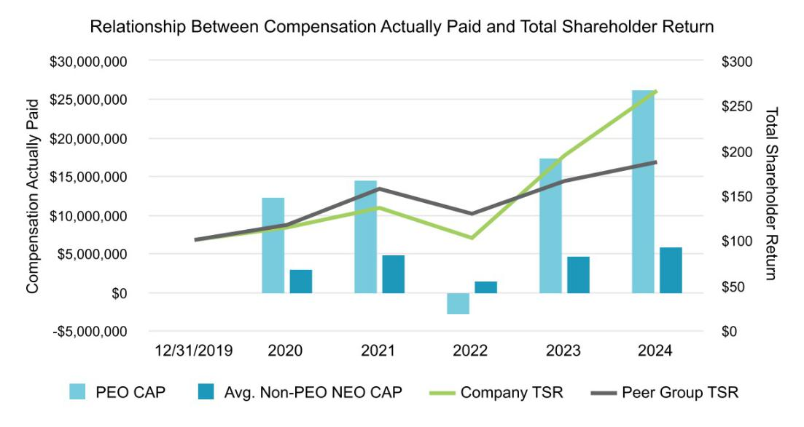

-66-

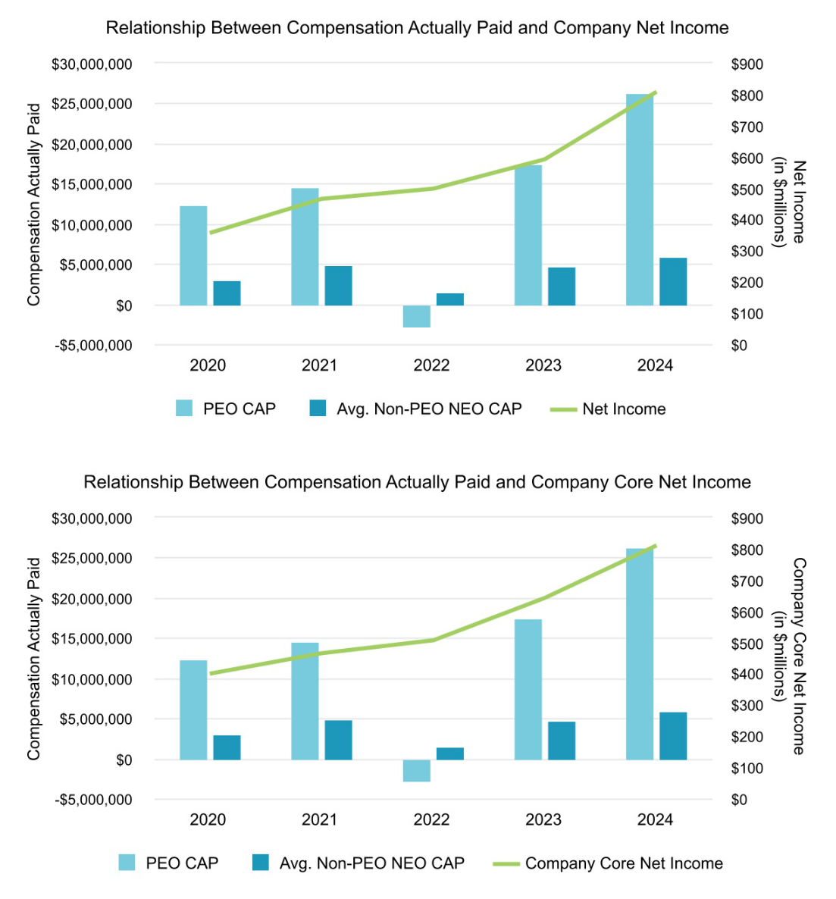

Tabular List

The following table lists the four financial performance measures that we believe represent the most important financial performance measures the Company used to link compensation actually paid to our NEOs for fiscal 2024 to our performance:
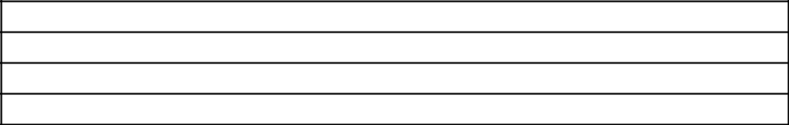

Company Core Net Income

Earnings Per Share

ROIC

Company Free Cash Flow

-67-

Equity Compensation Plan Information

We currently administer two equity compensation plans: the 2019 Equity and Incentive Compensation Plan and the 2022 Employee Stock Purchase Plan. The following table provides information as of December 31, 2024, regarding shares of our common stock that may be issued under these equity compensation plans.

 |  |  |  |  |  | Number of
 |  |  |  |  |  | Securities
 | Number of |  |  |  |  | Remaining Available
 | Securities to be |  |  |  |  | for Future Issuance
 | Issued Upon |  |  | Weighted Average |  | Under Equity
 | Exercise of |  |  | Exercise Price of |  | Compensation
 | Outstanding |  |  | Outstanding |  | Plans (excluding
 | Options, Warrants |  |  | Options, Warrants |  | securities reflected
Plan Category | and Rights(1) |  |  | and Rights⁽²⁾ |  | in column (a)⁽³⁾
 | (a) |  |  | (b) |  | (c)
Equity compensation plans approved by security holders
• 2019 Equity and Incentive Compensation Plan⁽⁴⁾ | 330,552 |  | $ | 306.46 | (5) | 1,637,606
• 2022 Employee Stock Purchase Plan | — |  |  | — |  | 971,132
Equity compensation plans not approved by security holders | — |  |  | — |  | —
Total | 330,552 |  | $ | 306.46 |  | 2,608,738

- Includes the following:

  - 203,304 SARs outstanding under the 2019 Equity and Incentive Compensation Plan, which, upon exercise, will be net-settled in shares of our common stock;

  - 70,504 shares of our common stock to be issued upon the vesting of RSUs outstanding under the 2019 Equity and Incentive Compensation Plan; and

  - 56,744 shares of our common stock to be issued, assuming we meet the target performance goals for the applicable three-year performance period, of PSUs outstanding under the 2019 Equity and Incentive Compensation Plan.

The following table illustrates the number of shares of our common stock that may be issued pursuant to outstanding PSUs and the number of shares that may be available for future issuance under our equity compensation plans if our performance falls below or exceeds our target performance goals:

 |  | Performance Level
 | Below
 | Threshold | Threshold | Target | Maximum
Shares to be Issued Pursuant to Outstanding | — | 28,372 | 56,744 | 113,488
PSUs
Number of Securities Remaining Available for | 2,665,482 | 2,637,110 | 2,608,738 | 2,551,994
Future Issuance Under Equity Compensation Plans

- Excludes PSU and RSU awards because those awards do not have an exercise price.

- With respect to outstanding PSUs, the number shown assumes we meet target performance goals for the applicable three-year performance period, and includes 1,637,606 shares of common stock available for issuance in the form of options, stock appreciation rights, restricted stock, RSUs, other stock-based awards and cash awards under the 2019 Equity and Incentive Compensation Plan, and 971,132 shares of common stock available for issuance under the 2022 Employee Stock Purchase Plan.

- Also includes SARs outstanding under the 2010 Incentive Plan; the 2010 Incentive Plan was replaced by the 2019 Equity and Incentive Compensation Plan and no new awards will be made under the 2010 Incentive Plan.

- In total, the weighted-average term for all outstanding SARs is 4.26 years.

-68-

Certain Relationships and Related Party Transactions

The written Related Party Transactions Policy adopted by our Board requires the Audit Committee to approve any potential related party transaction, which is defined in the policy to mirror the definition of Item 404 of Regulation S-K. Any related party transaction must be on terms that are fair to our Company and comparable to those that could be obtained in arm’s length dealings with an unrelated third party. In the event a related party transaction involves one or more members of the Audit Committee, such member will recuse themself from the review, consideration, or approval of the transaction. There were no transactions with related persons in 2024 that require disclosure pursuant to Item 404(a) of Regulation S-K.

Compensation Committee Interlocks and Insider Participation

No member of the Compensation and Human Resources Committee was an officer or employee of our Company or any of our subsidiaries during 2024 or at any other time, and no member had any relationship with the Company requiring disclosure under “Certain Relationships and Related Party Transactions” above. In addition, none of our executive officers served on the board of directors or on the compensation committee of any other entity, for which any executive officers of such other entity served either on our Board or on our Compensation and Human Resources Committee.

Delinquent Section 16(a) Reports

Section 16(a) of the Exchange Act requires the Company’s directors, executive officers, and persons who own more than 10% of a registered class of the Company’s equity securities, to file reports of ownership and changes in ownership of the Company’s common stock with the SEC and the NYSE, and furnish the Company with copies of the forms filed. To the Company’s knowledge, based solely on a review of the copies of such reports furnished to it and written representations of our officers and directors, during the year ended December 31, 2024, all Section 16(a) reports applicable to its officers and directors were filed on a timely basis except for (a) late reports filed by Mr. Norris for seven automatic dividend reinvestment transactions in 2021 and 2022, each less than ten shares, for a trust for which he disclaims beneficial ownership and (b) late reports filed by Mr. Norris for his appointment as co-trustee of a trust holding Lennox shares, his election as president of the general partner of a limited partnership holding Lennox shares, and the distribution of a trust holding Lennox shares, each following his father’s death.

-69-

Beneficial Ownership of Common Stock

The following table provides information regarding the beneficial ownership of our common stock as of March 15, 2025 by (1) each person known to own beneficially more than 5% of our common stock, (2) each of our directors, (3) each of our named executive officers, and (4) all current directors and executive officers as a group.

For purposes of this table, “beneficial ownership” (as defined in Rule 13d-3 of the Exchange Act) takes into account shares as to which the individual has or shares voting or investment power as well as shares that may be acquired within 60 days (such as by exercising vested SARs, receiving earned performance shares or the vesting of RSUs) and is different from beneficial ownership for purposes of Section 16 of the Exchange Act. As a result, the numbers below may differ from the numbers reported in forms filed pursuant to Section 16 (e.g., Form 4).

To our knowledge and unless otherwise indicated, each stockholder listed below has sole voting and investment power over the shares listed as beneficially owned by such stockholder. Percentage of ownership is based on 35,468,304 shares of common stock outstanding as of March 15, 2025. Number of shares held by beneficial owners of more than 5% of our common stock and percentage ownership are as of the date of the applicable SEC filing made by those owners (unless otherwise noted).

 |  | Common Stock
 | Common | that may be | Total Shares | Percent of Class
 | Stock | Acquired Within | Beneficially | Percent of Class
Name of Beneficial Owner | Held (#) | 60 Days (#)⁽¹⁾ | Held (#) | (%)
5% Stockholders
BlackRock, Inc.(2) | 2,863,070 | — | 2,863,070 | 8.07 %
The Vanguard Group(3) | 3,883,531 | — | 3,883,531 | 10.95 %
Directors and Named Executive Officers
Gary S. Bedard | 19,002 | 12,877 | 31,879 | *
Sherry L. Buck | 1,126 | — | 1,126 | *
Janet K. Cooper(4) | 17,925 | — | 17,925 | *
Alok Maskara | 14,437 | 12,817 | 27,254 | *
John W. Norris, III(5) | 3,261,829 | — | 3,261,829 | 9.20 %
Michael P. Quenzer | 1,946 | 2,101 | 4,047 | *
Karen H. Quintos | 7,520 | — | 7,520 | *
Daniel M. Sessa | 31,610 | 14,344 | 45,954 | *
Soma Somasundaram | 305 | — | 305 | *
Gregory T. Swienton | 13,389 | — | 13,389 | *
Todd J. Teske | 7,344 | — | 7,344 | *
John D. Torres | 4,156 | 586 | 4,742 | *
Jon Vander Ark(6) | 4 | — | 4 | *
Shane D. Wall(7) | 1,468 | — | 1,468 | *
All current directors and executive officers as a group (17 persons) | 3,399,606 | 56,821 | 3,456,427 | 9.73 %

- Less than 1% of outstanding common stock

- Consists of vested SARs.

- As reported by BlackRock, Inc., 50 Hudson Yards, New York, NY 10001, on an amendment to Schedule 13G filed with the SEC on February 5, 2025. BlackRock, Inc. reported sole voting power with respect to 2,652,118 shares and sole dispositive power with respect to 2,863,070 shares.

- As reported by The Vanguard Group, 100 Vanguard Boulevard, Malvern, PA 19355 on an amendment to Schedule 13G filed with the SEC on January 8, 2025. The Vanguard Group reported shared voting power with respect to 38,334 shares, sole dispositive power with respect to 3,767,938 shares and shared dispositive power with respect to 115,593 shares.

- Includes 9,820 shares held by the Janet K. Cooper 2012 Trust.

-70-

- Includes (a) 28,372 shares held by the L.C. Norris Revocable Trust, 28,372 shares held by the W.H. Norris Revocable Trust, and 28,372 shares held by the B.W. Norris Revocable Trust, for each of which Mr. Norris is a co-trustee; (b) 1,685 shares held by the Norris-Newman Minors Trust, for which Mr. Norris is the trustee; (c) 107,250 shares held by the John W. Norris, III Trust A, for which Mr. Norris is the co-trustee; (d) 5,636 shares held by his spouse, Catherine Houlihan; (e) 47,853 shares held by the Norris Living Trust, for which Mr. Norris is the co-trustee; (f) 18,480 shares held by the Norris Marital Trust - Exempt, for which Mr. Norris is the co-trustee; (g) 146,835 shares held by the Norris Marital Trust - Non-Exempt, for which Mr. Norris is the co-trustee; (h) 2,545,105 shares directly owned by the Norris Family Limited Partnership, for which Mr. Norris is the President of its general partner, JW Norris, Inc., (i) 93,700 shares held by the Cabin Foundation, for which Mr. Norris is the President and (j) 530 shares held by the Norris Child’s Trust fbo John W. Norris III.

- Shares held by Jonathan D. Vander Ark and Amy B. Vander Ark Joint Revocable Trust.

- Includes 966 shares held by the Wall Family Trust.

-71-

Other Information

Attending and Voting at the Annual Meeting of Stockholders


The virtual-only meeting format enhances stockholder access to the Annual Meeting by enabling stockholder attendance and participation from anywhere in the world, without cost. We believe that the virtual-only meeting format gives stockholders the opportunity to exercise the same rights as if they had attended an in-person meeting and encourages communication with our Board and management.

To attend the Annual Meeting, you must register in advance at www.proxydocs.com/LII using the control number located on your Proxy Card, Notice of Internet Availability of Proxy Materials, or voting instruction form. Upon completing your registration, you will receive further instructions by email, including a unique link that will allow you access to the Annual Meeting and to vote and submit questions to be answered at the Annual Meeting. If you are a beneficial owner of shares registered in the name of a broker, bank, or other nominee, as part of the registration process, you will also need to provide the registered name on your account and the name of your broker, bank, or other nominee.

The Annual Meeting will start promptly at 10:30 a.m, CDT. Stockholders may begin to log in to the Annual Meeting 15 minutes prior to the start time. If you encounter any difficulties accessing the virtual Annual Meeting platform, including any difficulties voting, you may call the technical support number that will be included in your instructional email.

Questions at the Virtual Annual Meeting

Our Annual Meeting allows stockholders to submit questions before and during the Annual Meeting. After the votes are tabulated for each of the proposals, there will be a designated question and answer period where we will respond to questions submitted by stockholders. We will answer as many questions as time permits, and any questions that we are unable to address during the Annual Meeting will be answered following the Annual Meeting.

If we receive substantially similar questions, to avoid repetition, we will group those questions together and provide a single response. Questions regarding personal matters or matters not relevant to the Annual Meeting will not be answered. We will also post questions submitted by stockholders and our answers on our website for a period of 60 days following the Annual Meeting.

Record Versus Beneficial Ownership of Shares

If your shares are registered directly in your name with our transfer agent, Computershare Trust Company, N.A., you are the “stockholder of record” with respect to those shares. If you are a stockholder of record, we sent our proxy materials directly to you. If your shares are held in a stock brokerage account or by a bank, you are considered the “beneficial owner” of shares held in street name. In that case, our proxy materials will be forwarded to you by your broker or bank, which is considered the stockholder of record with respect to those shares. Your broker or bank will also send you instructions on how to vote. If you have not heard from your broker or bank, please contact them as soon as possible.

Quorum Requirement

A quorum is required to transact business at the Annual Meeting. To achieve a quorum, stockholders holding a majority of our outstanding shares of common stock entitled to vote must be present either in person or represented by proxy. Shares held by us in treasury will not count towards the determination of a quorum.

As of March 28, 2025, the record date for the Annual Meeting, 35,492,128 shares of our common stock were outstanding. Abstentions and “broker non-votes” (as explained below) will be counted for purposes of establishing a quorum. Each share of our common stock outstanding on the record date is entitled to one vote on each of the director nominees and one vote on each other matter.

If a quorum is not present at the Annual Meeting, we expect the Annual Meeting will be adjourned or postponed to solicit additional proxies. In such event, the Chair or stockholders representing a majority of the outstanding shares entitled to vote and present in person or by proxy at the Annual Meeting may adjourn the Annual Meeting.

-72-

Vote Requirement for Each Proposal

The following chart describes the proposals to be considered at the Annual Meeting, the vote required to elect directors and to adopt each other proposal, and the manner in which votes will be counted:

 |  |  |  | Broker
 |  | Vote Required to Adopt the |  | Discretionary Votes Effect of Broker
Proposal | Voting Options | Proposal | Effect of Abstentions | Allowed? | Non-Votes*
Proposal 1 | FOR, AGAINST, or | Majority of votes cast, meaning a nominee | No effect | No | No effect
Election of Directors | ABSTAIN for each | will be elected if the votes cast FOR such
 | nominee | nominee exceed the votes cast AGAINST
 |  | such nominee

Proposal 2 | FOR, AGAINST, or | Approval requires the number of FOR votes
Advisory Proposal on 2024 | ABSTAIN | cast to exceed the number of shares voted
Executive Compensation |  | AGAINST or ABSTAINING

Counted as a vote. Same No No effect

effect as votes against

Proposal 3 | FOR, AGAINST, or | Approval requires the number of FOR votes | Counted as a vote. Same Yes | Brokers’ votes will
Ratification of Ernst & | ABSTAIN | cast to exceed the number of shares voted | effect as votes against | count
Young LLP as Independent |  | AGAINST or ABSTAINING
Registered Public
Accounting Firm for 2025

- If you are a beneficial holder and do not provide specific voting instructions to your bank, broker, nominee, or other holder of record that holds your shares, such holder of record will not be authorized to vote your shares, which would result in a “broker non-vote” on each proposal other than Proposal 3, the ratification of Ernst & Young LLP as our independent registered public accounting firm.

We encourage you to vote promptly, even if you plan to attend the Annual Meeting.

Each of our director nominees is currently serving on the Board. If a nominee who is currently serving as a director is not re-elected, Delaware law provides that the director would continue to serve on the Board as a “holdover director.” Under our Bylaws and Corporate Governance Guidelines, each director submits an advance, contingent resignation that the Board may accept if stockholders do not re-elect the director. In that situation, our Board Governance Committee would make a recommendation to the Board about whether to accept or reject the resignation, or whether to take other action. The Board would act on the Board Governance Committee’s recommendation, and publicly disclose its decision and the rationale behind it within 90 days from the date that the election results are certified.

Voting Procedures

Registered holders may vote online during the Annual Meeting, by the internet, by telephone, or, if they received a printed copy of these proxy materials, by mail. If your shares are held in street name, you will receive instructions from a bank, broker, nominee, or other holder of record that you must follow in order for your shares to be voted. If you have not received voting instructions from your bank, broker, nominee, or other holder of record, please contact them as soon as possible. We urge you to vote promptly and in advance of the Annual

Meeting.

A representative of Mediant Communication will tabulate the votes and act as inspector of election at the Annual Meeting.

Changing Your Vote

You can revoke or change your vote on a proposal at any time before the Annual Meeting for any reason by revoking your proxy. For stockholders of record, proxies may be revoked by delivering a written notice of revocation, bearing a later date than your proxy, to our Corporate Secretary at or before the Annual Meeting. Proxies may also be revoked by:

- submitting a new written proxy bearing a later date than a proxy you previously submitted;

- voting again by internet or telephone before 11:59 p.m., Eastern Time, on May 21, 2025; or

- attending the Annual Meeting and voting online.

-73-

In each case, the later submitted vote will be recorded and the earlier vote revoked. Any written notice of a revocation of a proxy should be sent to Lennox International Inc., 2140 Lake Park Blvd., Richardson, Texas 75080, Attention: Corporate Secretary. To be effective, the revocation must be received by our Corporate Secretary before the taking of the vote at the Annual Meeting.

For beneficial owners, please follow the instructions provided by your broker or bank.

Other Business

We are not aware of any other business to be acted upon at the Annual Meeting other than the Proposals described in this Proxy Statement. However, if you have voted by proxy and other matters are properly presented at the Annual Meeting for consideration in accordance with our Bylaws, the persons named in the accompanying Proxy Card will have discretion to act on those matters according to their best judgment or the Board’s recommendation.

Adjournment of the Annual Meeting

In the event of a technical malfunction or situation that makes it advisable to adjourn the Annual Meeting, the Chair will convene the meeting at 10:30 a.m., CDT, on May 22, 2025, at the Company’s principal business address solely for the purpose of adjourning the meeting to reconvene at a date, time, and location announced by the Chair. If this happens, more information will be provided at www.investor.lennox.com.

Proxy Materials and Solicitation

Notice and Access

We have elected to deliver our proxy materials to the majority of our stockholders over the internet. This delivery process allows us to provide stockholders with the information they need while conserving natural resources and lowering the cost of delivery. On or about April 9, 2025, we mailed to our stockholders a Notice of Internet Availability of Proxy Materials containing instructions on how to access our Proxy Statement for our 2025 Annual Meeting of Stockholders and 2024 Annual Report on Form 10-K to stockholders. The Notice also provides instructions on how to vote online or by telephone and includes instructions on how to receive a paper copy of the proxy materials by mail.

Proxy Solicitation

We will pay for the cost of this proxy solicitation. In addition to solicitation by mail, our directors, officers, and employees may solicit

proxies from stockholders by telephone, facsimile, email, or in person. They will not be paid for soliciting proxies but may be reimbursed for out-of-pocket expenses related to the proxy solicitation. We have retained Georgeson LLC to assist in the solicitation of proxies for a fee of $12,000 plus reimbursement of expenses. We will also make arrangements with brokerage houses and other custodians, nominees, and fiduciaries to send the proxy materials to beneficial owners of our common stock. Upon request, we will reimburse the brokerage houses and custodians for their reasonable expenses in so doing.

Multiple Stockholders Sharing the Same Address

We have adopted a procedure approved by the SEC called “householding.” Under this procedure, stockholders who have the same full name and address and will receive only one copy of our proxy materials or Notice of Internet Availability of Proxy Materials, as applicable. This procedure helps reduce our printing costs and postage fees. Stockholders who participate in householding and receive a full set of proxy materials will continue to receive separate Proxy Cards.

Please contact our Investor Relations department by telephone at (972) 497-5000 or in writing at 2140 Lake Park Blvd., Richardson, Texas 75080, Attention: Investor Relations, investor@lennox.com if you now receive (1) multiple copies of our proxy materials or Notice of Internet Availability of Proxy Materials and wish to receive only one copy of these materials per household in the future, or (2) a single copy of our proxy materials or Notice of Internet Availability of Proxy Materials and wish to receive separate copies of these materials in the future. If you participate in householding and wish to receive a separate copy of these documents for the Annual Meeting, please notify our Investor Relations department as indicated above and we will promptly send you a separate copy.

Form 10-K

If you are entitled to vote at the Annual Meeting, you may obtain a copy of our Annual Report on Form 10-K for the fiscal year ended December 31, 2024, including the financial statements required to be filed with the SEC, without charge, by contacting our Investor Relations department by telephone at (972) 497-5000 or in writing at 2140 Lake Park Blvd., Richardson, Texas 75080, Attention: Investor Relations, investor@lennox.com.

-74-

Stockholder Proposals for the 2026 Annual Meeting of Stockholders

Proposals for Inclusion in the 2026 Proxy Statement

If you wish to submit a proposal for possible inclusion in our 2026 proxy statement, we must receive your notice, in accordance with the rules of the SEC, on or before December 10, 2025. The proposal should be sent in writing to 2140 Lake Park Blvd., Richardson, Texas 75080, Attention: Corporate Secretary. We suggest that all such proposals be sent by certified mail, return receipt requested.

Proposals Not for Inclusion in the 2026 Proxy Statement But to be Offered at the 2026 Annual Meeting

If you wish to introduce a proposal at the 2026 Annual Meeting of Stockholders but do not submit your proposal for inclusion in our proxy statement to be filed in 2026, our Bylaws require you to follow certain procedures and provide certain information and representations related to your proposal. Among other requirements, you must give written notice to our Corporate Secretary of your intention to introduce your proposal and must represent that (1) you are a stockholder of record of Company stock entitled to vote at the annual meeting and (2) you intend to personally present your proposal at the annual meeting. We must receive your notice at least 60 days, but no more than 90 days, prior to the 2026 Annual Meeting of Stockholders. If we give less than 70 days’ notice of the date of the 2026 Annual Meeting of Stockholders, we must receive your notice within 10 days following the date on which notice of the date of the 2026 Annual Meeting of Stockholders was mailed or such public disclosure was made to our stockholders.

Your notice must include certain information about you, your proposal, and any person “acting in concert” with you and why implementation of your proposal would be in the best interest of the Company and its stockholders. Your notice must also include the shares of the Company’s stock you beneficially own (including any option, warrant or similar right and any other direct or indirect right or interest that may enable you to share in any profit, or manage the risk, from any change in the value of the Company’s stock), any proxy or other right you hold to vote the Company’s stock (or any similar right which has the effect of increasing or decreasing your voting power), performance-related fees which you would be entitled to as a result of any change in the value of the Company’s stock, any material interest you have in your proposal, and any other information required to disclosed in a proxy statement. Depending on the nature of the proposal, additional information may be required. If you do not appear at the meeting to represent your proposal, your proposal will be disregarded.

Cautionary Statement Regarding Forward-Looking Statements

This Proxy Statement contains forward-looking statements within the meaning of Section 27A of the Securities Act of 1933, as amended (the “Securities Act”), and Section 21E of the Exchange Act that are based on information currently available to management as well as management’s assumptions and beliefs as of the date hereof. All statements, other than statements of historical fact, included in this Proxy Statement constitute forward-looking statements within the meaning of the Private Securities Litigation Reform Act of 1995. Forward-looking statements can be identified by the words “may,” “will,” “should,” “plan,” “predict,” “anticipate,” “believe,” “intend,” “estimate,” “expect,” and similar expressions. Statements that are not historical should also be considered forward-looking statements. Such statements reflect our current views with respect to future events. Readers are cautioned not to place undue reliance on these forward-looking statements. We believe these statements are based on reasonable assumptions; however, such statements are inherently subject to risks and uncertainties, including but not limited to the inability to execute on strategies related to environmental- and social-related goals and targets (including due to delays in scientific and technological developments), as well as the other specific uncertainties discussed in the risk factors set forth in Item 1A. Risk Factors of our Annual Report on Form 10-K. These risks and uncertainties may affect our performance and results of operations. Should one or more of these risks or uncertainties materialize, or should underlying assumptions prove incorrect, actual results may differ materially from those in the forward-looking statements. We disclaim any intention or obligation to update or review any forward-looking statements or information, whether as a result of new information, future events, or otherwise unless required by law.

The following are some of the factors that could cause actual results to differ materially from those expressed or implied in forward-looking statements:

- competition in the heating, ventilation, air conditioning and refrigeration business;

- our ability to successfully develop and market new products or execute our business strategy, including the implementation of price increases for products and services;

- our ability to meet and anticipate customer demands;

- our ability to continue to license or enforce our intellectual property rights;

-75-

- our ability to attract, motivate, develop and retain our employees, as well as labor relations problems;

- artificial intelligence technologies;

- a decline in new construction activity and related demand for our products and services;

- the impact of weather on our business;

- the impact of higher raw material prices and significant supply interruptions;

- product liability, warranty claims, or recalls;

- changes in environmental and climate-related legislation or government regulations or policies;

- changes in tax legislation;

- the impact of new or increased trade tariffs;

- improper conduct by any of our employees, agents, or business partners;

- litigation risks;

- general economic conditions in the United States and abroad;

- extraordinary events beyond our control, such as conflicts, wars, natural disasters, public health crises, or terrorist acts;

- risks associated with our international operations;

- cyber attacks and other disruptions or misuse of information systems; and

- our ability to successfully realize, complete and integrate acquisitions.

-76-

Appendix A – GAAP Reconciliation

Reconciliation to U.S. GAAP (Generally Accepted Accounting Principles) Measures (Unaudited)

To supplement the Company's consolidated financial statements and segment net sales and profit (loss) presented in accordance with

U.S. GAAP, additional non-GAAP financial measures are provided and reconciled in the following tables. The Company believes that these non-GAAP financial measures, when considered together with the GAAP financial measures, provide information that is useful to investors in understanding period-over-period operating results and enhance the ability of investors to analyze the Company's business trends and operating performance.

In our reconciliation of Net Income, a GAAP measure, to Adjusted net income, a Non-GAAP measure, certain items are no longer excluded from GAAP net income for the periods related to 2024 in the table presented below.

Core Revenue and Adjusted Segment Profit (dollars in millions)

 | For the Year Ended |  | For the Year Ended
 | December 31, 2024 |  | December 31, 2023
Net Sales
Home Comfort Solutions | $3,577 |  | $3,223
Building Climate Solutions | 1,764 |  | 1,511
Corporate and other⁽¹⁾ | — |  | 248
Net sales, a GAAP measure | $5,341 |  | $4,982
Net sales from non-core businesses⁽¹⁾ | — |  | 248
Core Net Sales, a non-GAAP measure | $5,341 |  | $4,734
Segment Profit
Home Comfort Solutions | $760 |  | $610
Building Climate Solutions | 397 |  | 341
Corporate and other⁽¹⁾ | (120) |  | (94)
Segment profit, a GAAP measure | $1,037 |  | $857
Profit from non-core businesses⁽¹⁾ | — |  | 8
Adjusted Segment Profit, a non-GAAP measure | $1,037 |  | $849
Profit from non-core businesses⁽¹⁾ | — |  | (8)
Impairments on assets held for sale | — |  | 63
Loss (gain) on sale from previous disposition | 2 |  | (14)
Items in Losses (gains) and other expenses, net which are excluded from segment profit⁽²⁾ | — |  | 15
Restructuring charges | — |  | 3
Operating Income, a GAAP measure | $1,035 |  | $790

- Net sales and segment profit from our European portfolio are included in the Corporate and other segment and are considered non-core.

- Recorded in Losses (gains) and other expenses, net in the Consolidated Statement of Operations.

Company core net income, a non-GAAP financial measure, is income from continuing operations, adjusted for restructuring charges, impairments on assets held for sale, gain on sale of businesses, non-core business results, certain legal charges and contingency adjustments, unrealized gains and losses on unsettled futures contracts and certain other items.

Appendix A-1

Segment profit, a non-GAAP financial measure, is earnings from continuing operations for the applicable segment before interest expense, other expenses, and income taxes, adjusted for restructuring charges, impairments on assets held for sale, gain on sale of businesses, non-core business results, certain legal charges and contingency adjustments, unrealized gains and losses on unsettled futures contracts and certain other items. An individual segment’s profit should not be used as a substitute for the Company’s segment profit and may not be comparable to similarly titled measures reported by other companies.

Free Cash Flow (dollars in millions)

 | For the Year Ended December | For the Year Ended December
 | 31, 2024 | 31, 2023
Net Cash Provided by Operating Activities, a GAAP measure | $945.7 | $736.2
Purchases of property, plant, and equipment | (163.6) | (250.2)
Proceeds from the disposal of property, plant, and equipment | 2.5 | 2.1
Free Cash Flow, a non-GAAP measure | $784.6 | $488.1

Free cash flow, a non-GAAP financial measure, is net cash provided by operating activities less purchases of property, plant, and equipment plus proceeds from disposal of property, plant, and equipment.

Net Income and Adjusted Diluted EPS

 | For the Year Ended December 31, 2024
 | After Tax Amount | Per Diluted Share
Net Income, a GAAP measure | $806.9 | $22.54
Restructuring charges | — | —
Pension settlements | — | —
Items in Losses (gains) and other expenses, net which are excluded from segment profit (loss) (a) | — | —
Excess tax benefits from share-based compensation (b) | — | —
Loss on sale from previous disposition | 1.5 | 0.04
Other tax items, net (b) | — | —
Impairments on assets held for sale (c) | — | —
Non-core business results (d) | — | —
Adjusted net income, a non-GAAP measure | $808.4 | $22.58
 | For the Year Ended December 31, 2023
 | After Tax Amount | Per Diluted Share
Net Income, a GAAP measure | $590.1 | $16.54
Restructuring charges | 2.4 | 0.07
Pension settlements | 0.3 | 0.01
Items in Losses (gains) and other expenses, net which are excluded from segment profit (loss) (a) | 11.1 | 0.31
Excess tax benefits from share-based compensation (b) | (5.2) | (0.15)
Gain on sale of business | (11.1) | (0.31)
Other tax items, net (b) | (3.7) | (0.1)
Impairments on assets held for sale (c) | 62.0 | 1.74
Non-core business results (d) | (5.4) | (0.15)
Adjusted net income, a non-GAAP measure | $640.5 | $17.96

- Recorded in Losses (gains) and other expenses, net in the Consolidated Statements of Operations.

- Recorded in Provision for income taxes in the Consolidated Statements of Operations.

- Impairment on assets held for sale relate to the divestiture of our European operations that was completed in the fourth quarter of 2023.

- Non-core business results represent activity related to our business operations in Europe not included elsewhere in the reconciliations.

Appendix A-2



